Name

Mathematics Stage 4
Linear Relationships

Book 1 | Plot linear relationships on the Cartesian plane  Solve linear equations using graphical techniques | Version: 260905  Feedback:  https://MrDingMaths.com
Contents
Syllabus Content 2
Points on a Cartesian Plane 3
Constructing a Table of Values 13
Sketch a Line from a Table of Values 15
Finding the Rule from a Table 23
Systematically Finding the Rule $y=mx+c$ from a table 29
Finding the Rule from the Graph 39
Patterns, Equations, Graphs 42
Applying the Equation 50
Multiple Representations of Linear Relationships 58
Linear Relationships in Real Life Contexts 65
Comparing Linear Relationships 73
Solving Equations Graphically 81
Identifying the Simultaneous Solution 89

Syllabus Content
MA4-LIN-C-01 creates and displays number patterns and finds graphical solutions to problems involving linear relationships
Plot and identify points on the Cartesian plane
- Plot and label points on the Cartesian plane of given coordinates, including those with coordinates that are not whole numbers
- Identify and record the coordinates of given points on the Cartesian plane, including those with coordinates that are not whole numbers
Plot linear relationships on the Cartesian plane
- Construct a geometric pattern and record the results in a table of values
- Represent a given number pattern (including decreasing patterns) using a table of values
- Describe a number pattern in words and generate an equation using algebraic symbols
- Apply an equation generated from a pattern to calculate the corresponding value for a smaller or larger number
- Recognise that a linear relationship can be represented by a number pattern, an equation (or a rule using algebraic symbols), a table of values, a set of pairs of coordinates and a line graphed on a Cartesian plane, and move flexibly between these representations
- Explain that there are an infinite number of ordered pairs that satisfy a given linear relationship by extending a line joining a set of points on the Cartesian plane
- Compare similarities and differences of multiple straight-line graphs on the same set of axes using graphing applications
- Describe linear relationships in real-life contexts and solve related problems
Solve linear equations using graphical techniques
- Recognise that each point on the graph of a linear relationship satisfies the equation of a line
- Apply graphs of linear relationships to solve a corresponding linear equation using graphing applications
- Graph 2 intersecting lines on the same set of axes and identify the point of intersection using either graphing applications or a table of values
- Verify that the point of intersection satisfies the equations of both lines

Points on a Cartesian Plane

- Review
- Read values from a number line
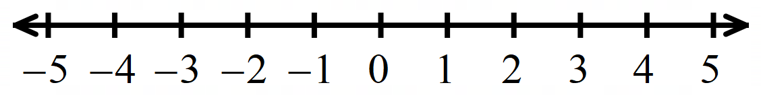

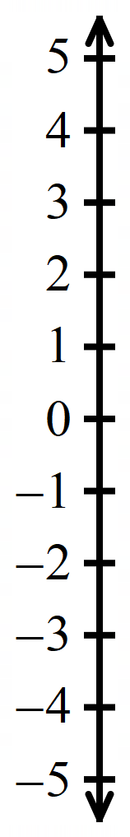

- Cartesian Plane
A Cartesian plane, or number plane, is two number lines at right angles to each other.
The $x$-axis is the horizontal (left to right) number line.
The $y$-axis is the vertical (up and down) number line.
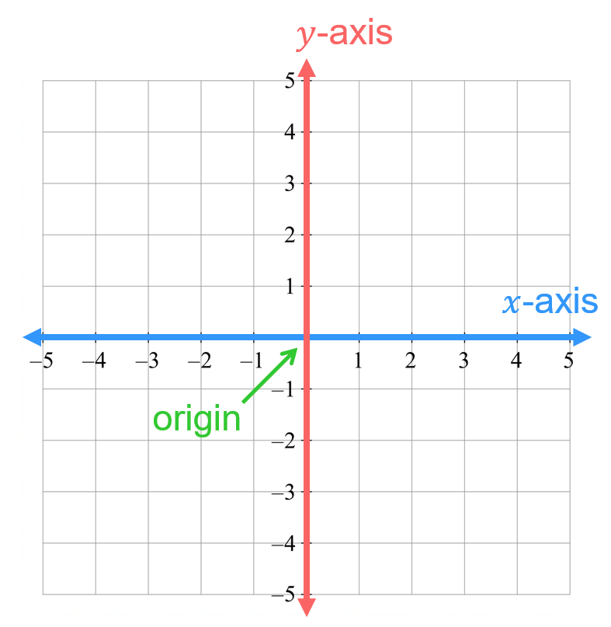
The origin (0,0) is where the $x$-axis and $y$-axis meet.

- Coordinates
A coordinate $\left(x,y\right)$ tells us the position on a Cartesian plane compared to the origin.
The first number is the $x$-coordinate. It is how much to move left or right from the origin.
The second number is the $y$-coordinate. It is how much to move up or down from the origin.
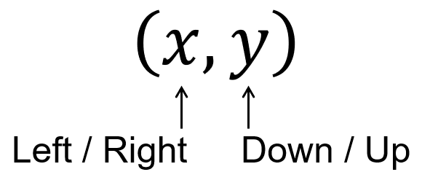

- Interpret Coordinates
$$\left(2, 4\right)$$ | $$\left(2,-4\right)$$ | $$\left(-4, 2\right)$$ | $$\left(-4,-2\right)$$
$$\left(-3, 17\right)$$ | $$\left(0, 11\right)$$ | $$\left(1.5,-17\right)$$ | $$\left(-15,-12\right)$$
$$\left(-26,\frac{4}{3}\right)$$ | $$\left(\frac{1}{2},16\right)$$ | $$\left(-\frac{3}{7},5\right)$$ | $$\left(-2,0\right)$$

- Plotting Points on a Cartesian Plane
- Start at the origin (0,0)
- Move along $x$.
- Move along $y$.
- Draw a point ● where you end up.

- Plot points on a Cartesian plane
- Plot these points on the plane below.  $$A\left(1,3\right)$$  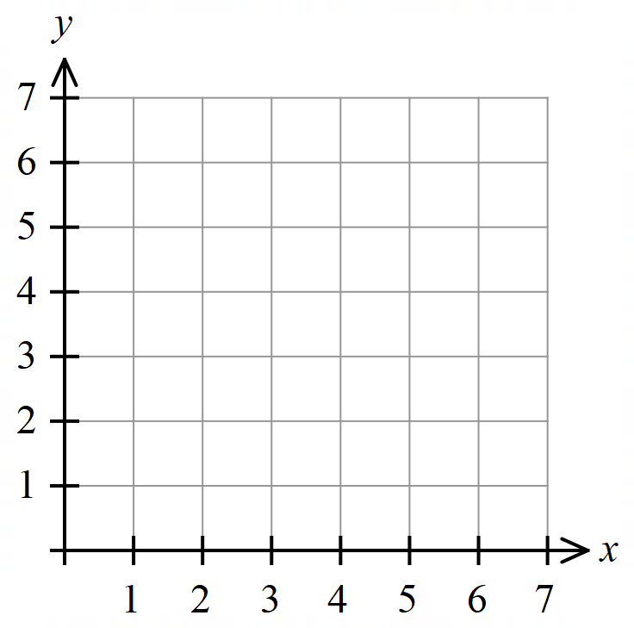  $$B\left(1,4\right)$$  $$C\left(1,6\right)$$  $$D\left(6,1\right)$$  $$E\left(6,7\right)$$  $$F\left(7,6\right)$$ | - Plot these points on the plane below.  $$A\left(1,3\right)$$  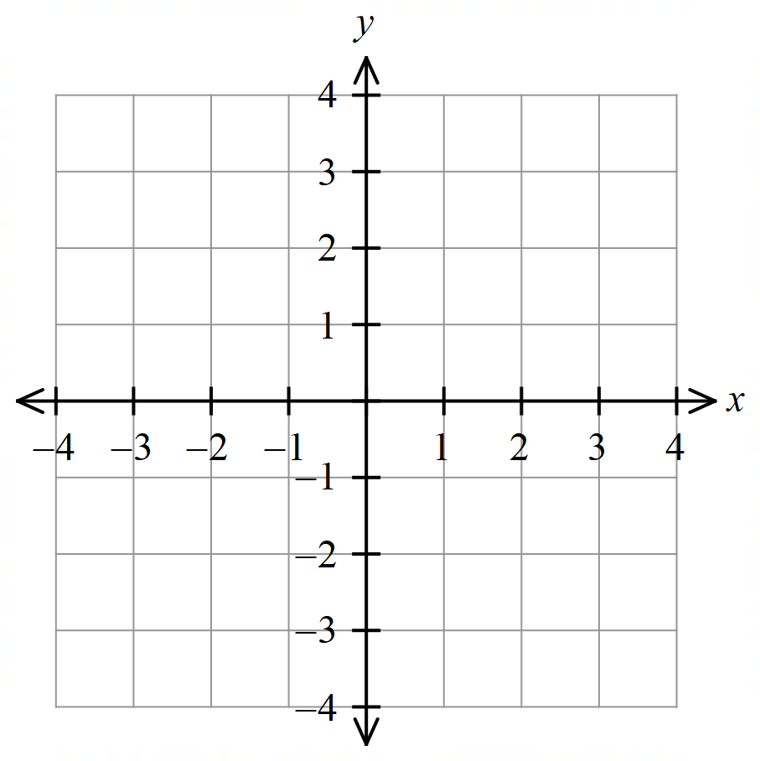  $$B\left(-1,3\right)$$  $$C\left(-1,-3\right)$$  $$D\left(-2,-3\right)$$  $$E\left(-4,-3\right)$$  $$F\left(4,-3\right)$$

- Key Ideas
- A Cartesian plane is a ………………..… number line and a ………………… number line.
- The horizontal number line is the …… axis. The vertical number line is the …… axis.
- We can label a position on a Cartesian plane using ………………….
- The origin (……, ……) is where the two number lines …………
- A coordinate is written as $(x,y)$; it tells us the position of a point compared to the ……………….…
- The first number is called the $x$-coordinate. It tells us how much to move h…………………, the second number is called the …………………… it tells us how much to move ……………………………

Foundation
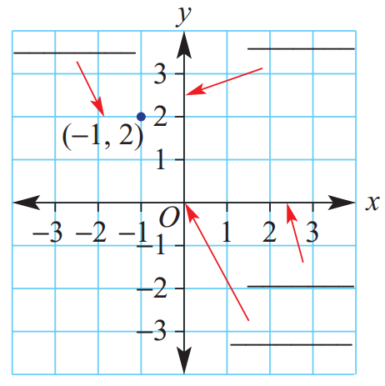
- For the Cartesian plane shown,
label these parts:
y axis
coordinates
- $x$ axis
- Origin
- $y$ axis
- Coordinates
x axis

origin

  - To plot (3, 4) you would start at the origin, move 3 units ……… and 4 units ………
right, up
  - To plot (2, −1) you would start at the ………, move 2 units ……… and 1 unit ………
origin, right, down
  - To plot (−3, 2) you would start at the ………, move 3 units …… and 2 units ………
origin, left, up
  - To plot (−1, −4) you would start at the ………, move 1 unit ………, and 4 units ………
origin, left, down

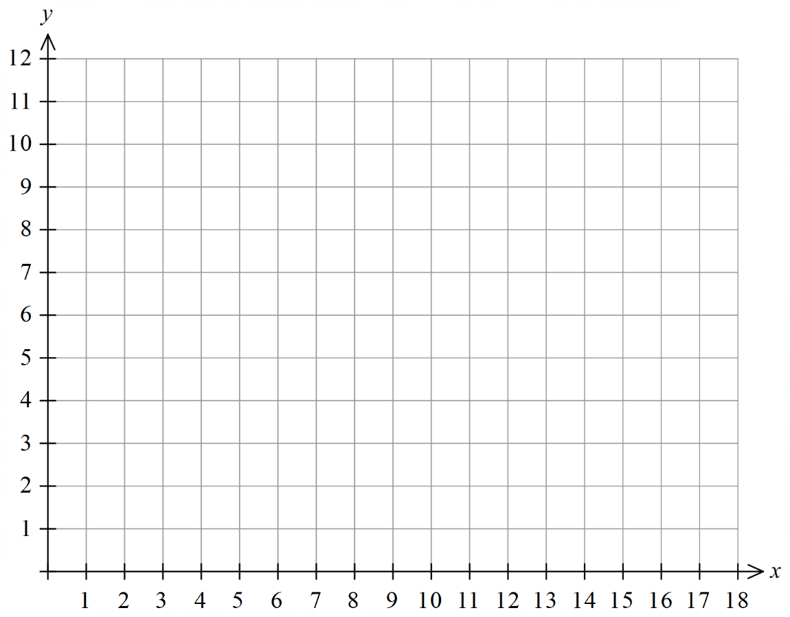
- Plot these points on the Cartesian plane.
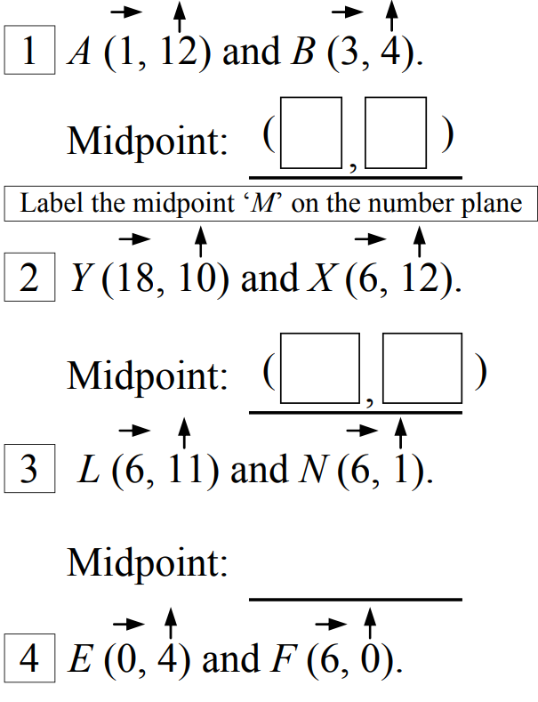

- Plot these points on the Cartesian plane
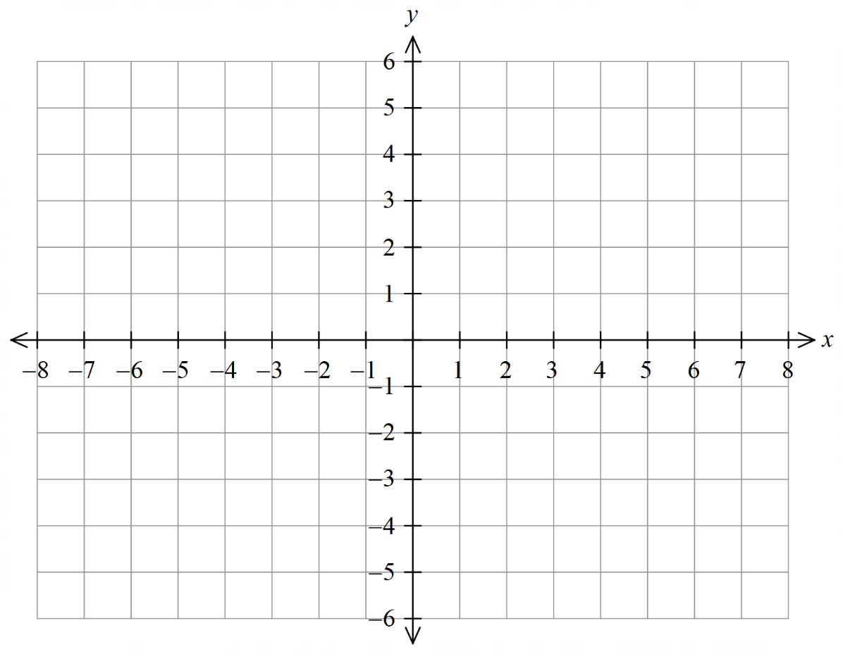
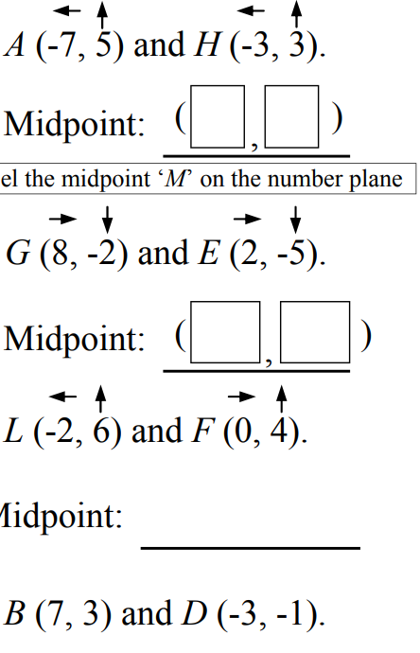

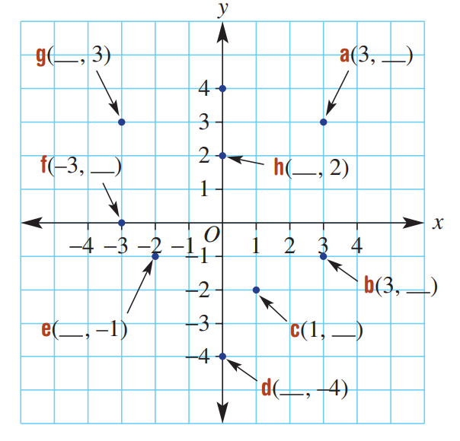
- Write the missing number for each of these coordinates.
$$3$$
$$-3$$

$$0$$
$$0$$

$$-1$$

$$-2$$
$$-2$$
$$0$$

- Identify the coordinates of these points.
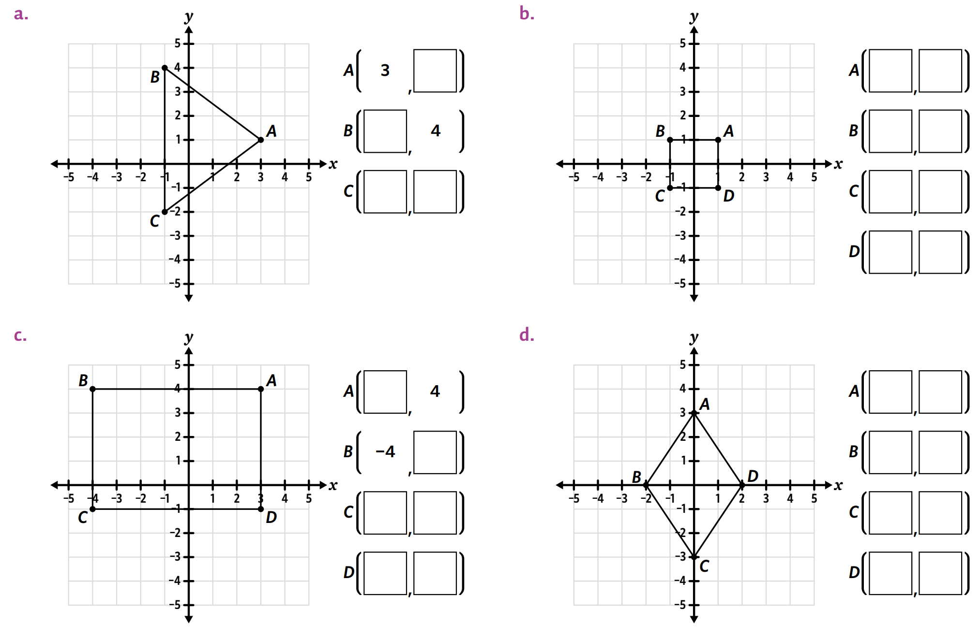  $$-2$$  $$-1$$  $$-1$$  $$1$$ | $$1$$  $$1$$  $$-1$$  $$1$$  $$-1$$  $$-1$$  $$1$$  $$-1$$
$$3$$  $$-1$$  $$-1$$  $$-4$$  $$4$$  $$3$$ | $$0$$  $$-2$$  $$3$$  $$0$$  $$-3$$  $$0$$  $$2$$  $$0$$

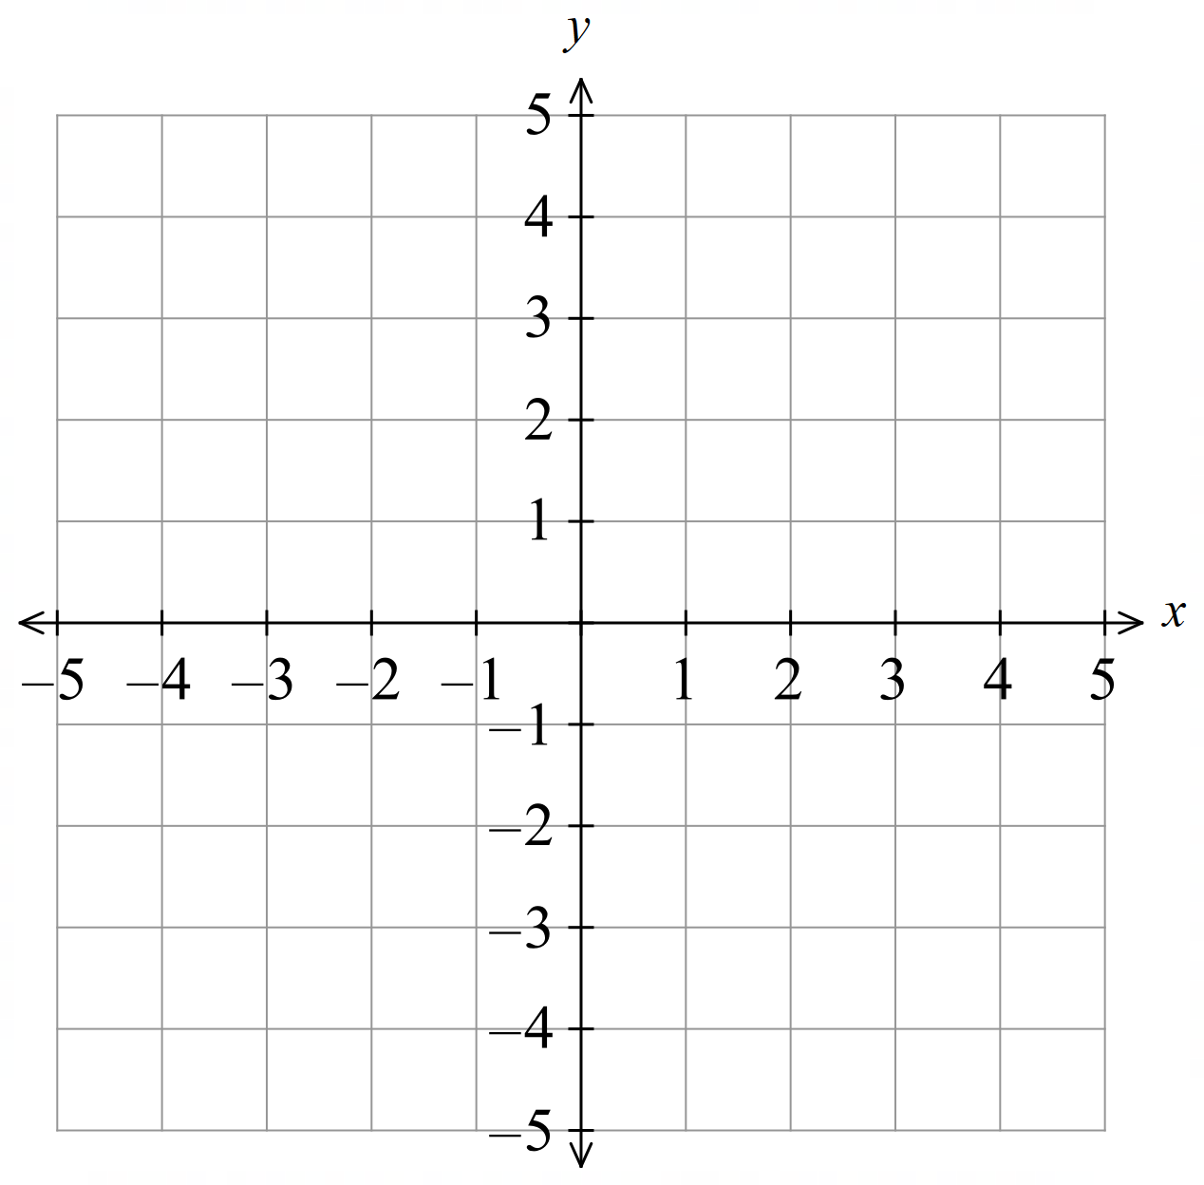
- Plot these points and label the points with the letter.
  - $A\left(2,3\right)$
  - $B\left(-2,3\right)$
  - $C(-2,-3)$
  - $D(2,-3)$

- Plot these points and label the points with the letter.
  - $A(5,0)$
  - $B(0,5)$
  - $C(1.5,-4)$
  - $D\left(-\frac{1}{2},3\right)$

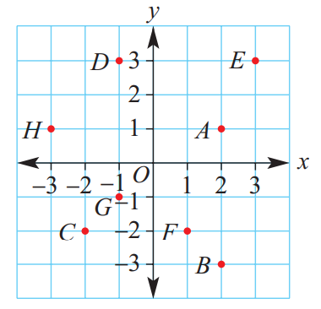
- Match the points A, B, C, D, E, F, G and H with the given coordinates.
- $\left(-1,3\right)$ …………  D | - $\left(2,-3\right)$ …………  B
- $\left(2,1\right)$ …………  A | - $\left(-2,-2\right)$ …………  C
- $\left(3,3\right)$ …………  E | - $\left(-3,1\right)$ …………  H
- $\left(1,-2\right)$ …………  F | - $\left(-1,-1\right)$ …………  G

- Plot these points on the Cartesian plane.
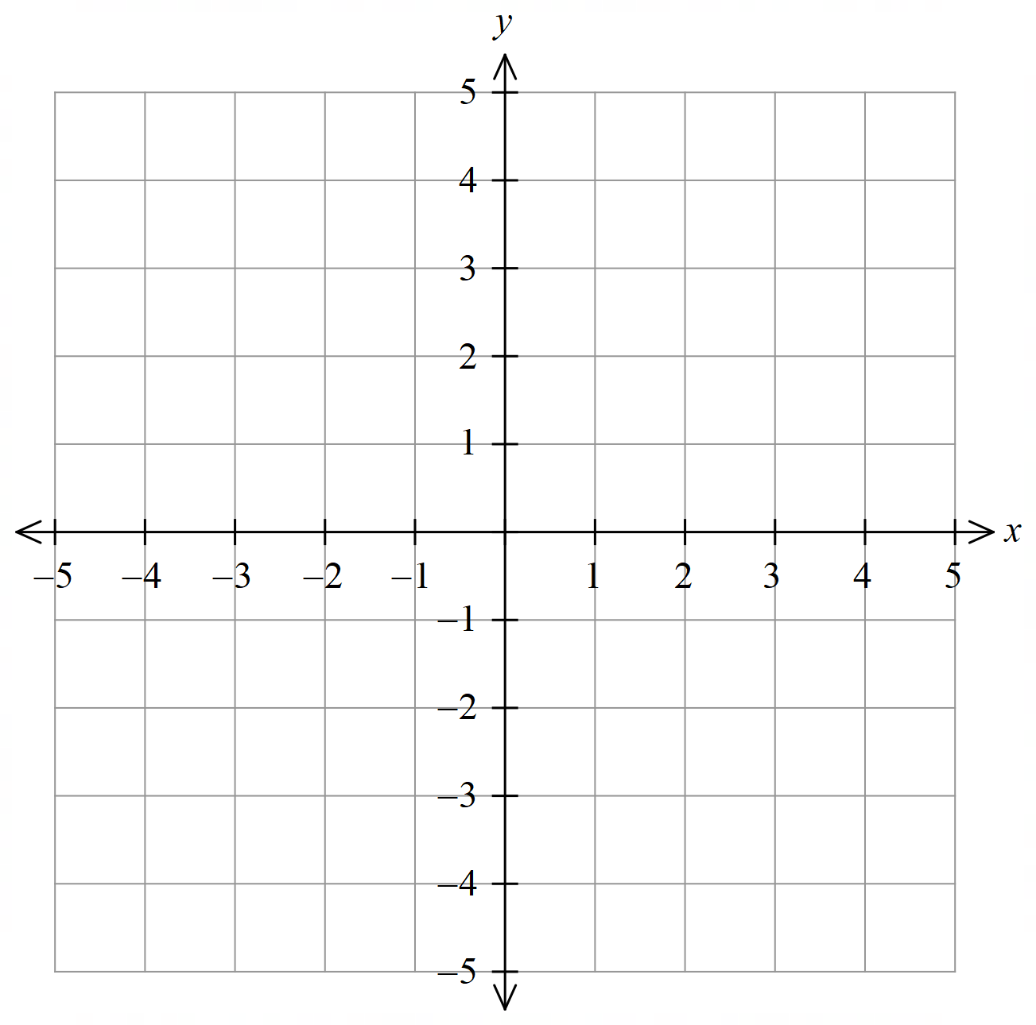
  - A (−3, 2)
  - B (1, 4)
  - C (2, −1)
  - D (−2, −4)
  - E (−1, 4)
  - F (−3, −1)
  - G (1.5, −2.5)
  - H $\left(3.5,-2\frac{1}{2}\right)$
  - I (−2.5, 1.5)
  - J ($-1\frac{1}{2}$, −1.5)
  - K $\left(\frac{1}{3},5\right)$

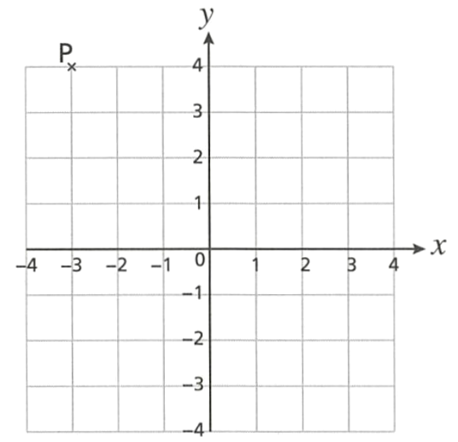
- Chloe, Beca and Ed have each written down the coordinates of point P.
Chloe (4,-3) Beca (-3, 4) Ed (3, 4)
  - Who is correct?
Beca
  - Explain the mistakes the other two have made.

Chloe swapped $x$ and $y$
Ed didn’t use negative for being left of the origin

- Eight points have been plotted on this number plane.
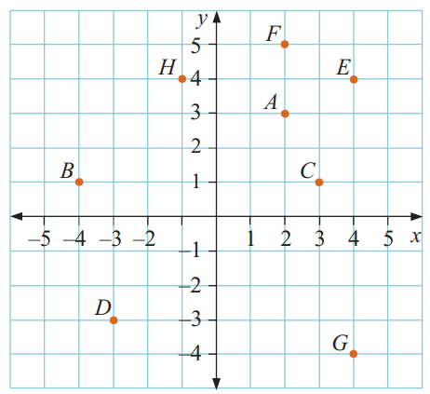
Write the coordinates of the eight points.
  - (…… , ……)
(2,3)
  - (…… , ……)
(–4,1)
  - (…… , ……)
(3,1)
  - (…… , ……)
(–3,–3)
  - (…… , ……)
(4,4)
  - (…… , ……)
(2,5)
  - (…… , ……)
(4,–4)
  - (…… , ……)
(–1,4)
  - Name two points with the same $x$-coordinates.
What do you notice about their positions on the number plane?
A and F. They have the same horizontal position (directly on top of each other)
  - Name two points with the same $y$-coordinates.
What do you notice about their positions on the number plane?
B and C. They have the same vertical position (on the same level as each other)

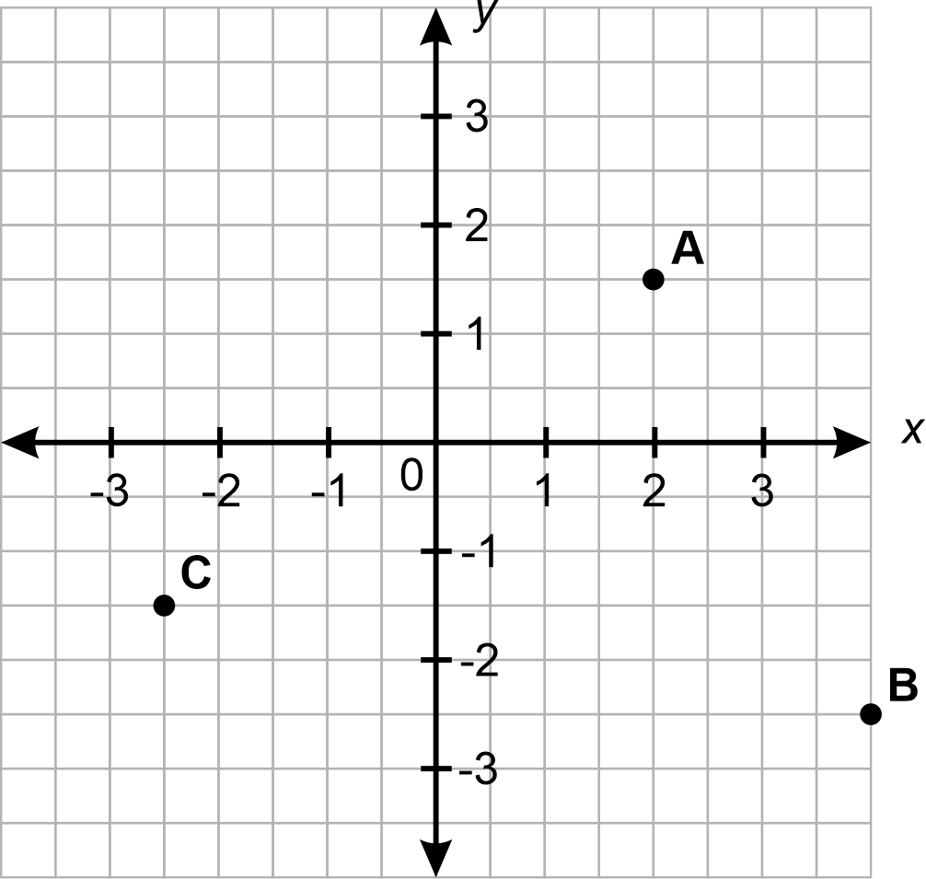
Y, Z
●
  - Identify the coordinates of $A$
(2, 1.5)
  - Identify the coordinates of $B$
(4, –2.5)
  - Identify the coordinates of $C$
(–2.5, –1.5)
  - Label point $Y$ directly above $C$ on the $x$-axis
  - Label the point $Z$ $2\frac{1}{2}$ units left of the origin.
  - Write the coordinates of point $Z$
(–2.5, 0)
- Write down the coordinates of 8 points that lie on this line.
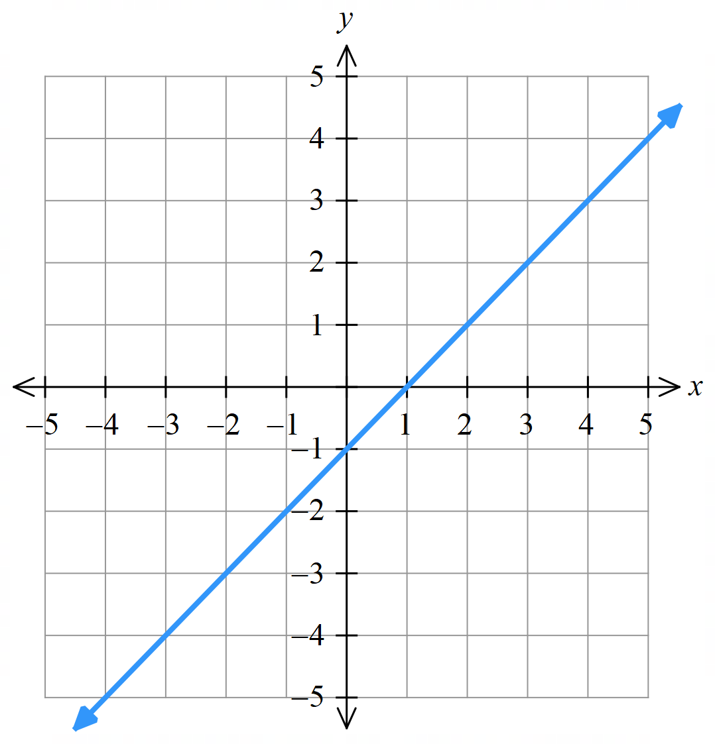
  - (…… , ……)

  - (…… , ……)

  - (…… , ……)

  - (…… , ……)

  - (…… , ……)

  - (…… , ……)

  - (…… , ……)

  - (…… , ……)

Answers will vary.
Describe the relationship between $x$ and $y$.
The $y$ values are 1 less than the $x$ values.
This line can be described by the equation $y=x-1$. Where do you think this equation comes from?
The value of $y$ is $x$ subtract 1.
$$y=x-1$$

- $AB$ is parallel to the $y$-axis. If $AB=3$, $BC=4$, and $AC=5$, what are the coordinates of $C$?
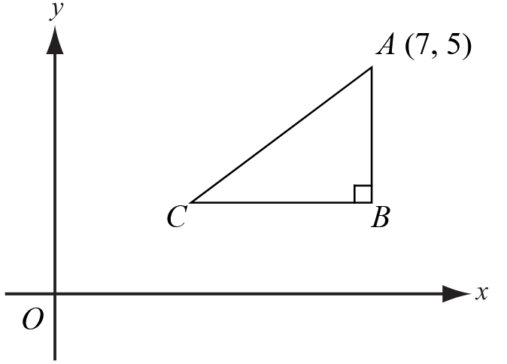

C(3, 2)

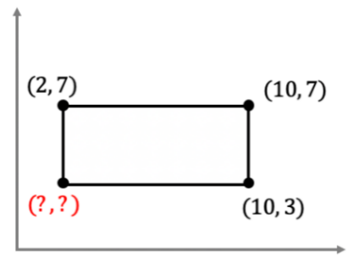  - What is the coordinate of the missing vertex of the rectangle?  (2, 3) | 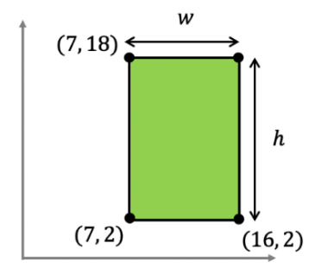  - Determine the height and width of the rectangle.  w: 9, h: 16
- What is the coordinate of the missing vertex of the rectangle?  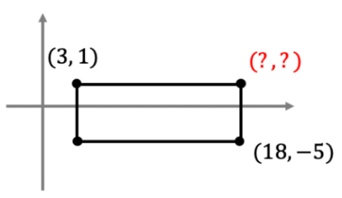  (18, 1) | 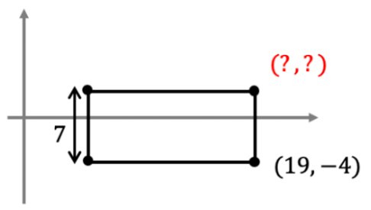  - What is the coordinate of the missing vertex of the rectangle?  (19, 3)
- Find the width of the parallelogram and hence the unknown coordinates.  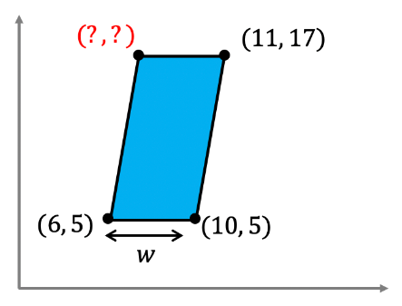  w: 4, (7, 17) | - What are the unknown coordinates on this kite?  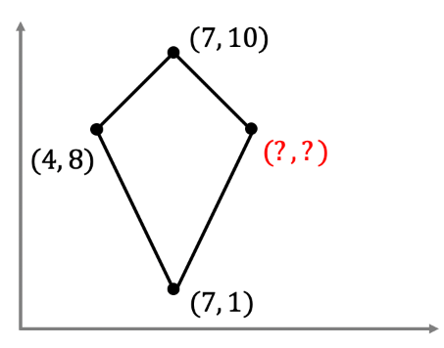  (10, 8)

Constructing a Table of Values

- Review
- Substitute into formulas
- Find the value of $y$ when $x=3$  $y=4x+1$ | - Find the value of $y$ when $x=5$  $y=3x+2$
- Find the value of $y$ when $x=-2$  $y=4x+5$ | - Find the value of $y$ when $x=10$  $y=-5x+1$

- Table of Values
A table of values shows a relationship between $x$ and $y$ using numbers.
To find a $y$ value, substitute $x$ in the equation with the number from the table, then work out the answer.

- Example Construct a table of values
Complete the table of values for $y=3x+1$
 | $$x=0; y=3\left(0\right)+1=1$$  $$x=1; y=3\left(1\right)+1=4$$  $$x=2; y=3\left(2\right)+1=7$$  $$x=3; y=3\left(3\right)+1=10$$
  $$x$$ | 0 | 1 | 2 | 3
  $$y$$ | 1 | 4 | 7 | 10

- Guided Practice
Complete the table of values for these equations
- $y=3x+2$  $2, 5, 8, 11$ | - $y=4x+3$  $$3, 7, 11, 15$$
  $$x$$ | 0 | 1 | 2 | 3
  $$y$$
  $$x$$ | 0 | 1 | 2 | 3
  $$y$$
- $y=3x+2$  $-7, -4, -1, 2$ | - $y=-4x+3$  $$7, 3, -1, -5$$
  $$x$$ | $$-3$$ | $$-2$$ | $$-1$$ | 0
  $$y$$
  $$x$$ | $$-1$$ | 0 | 1 | 2
  $$y$$

Foundation
- Complete these tables of values.
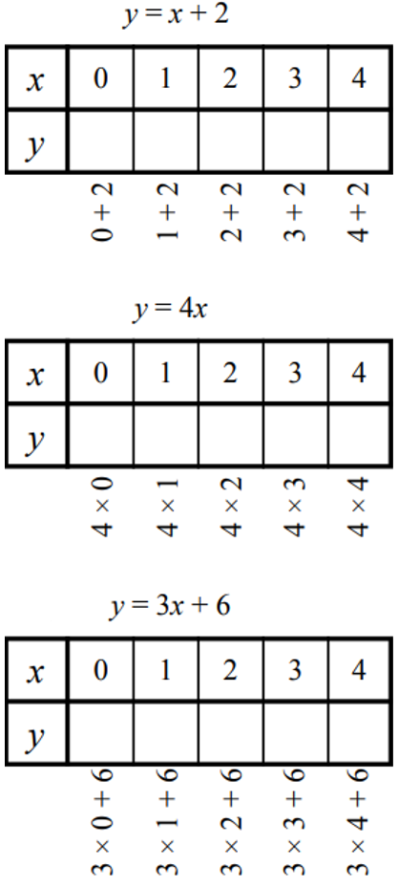  2, 3, 4, 5, 6 | 0, 4, 8, 12, 16 | 6, 9, 12, 15, 18
8, 6, 4, 2, 0 | 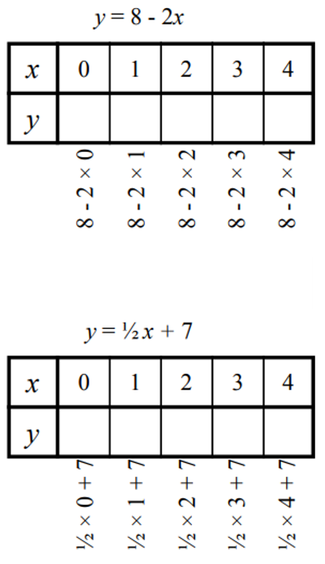  7, 7.5, 8, 8.5, 9

- Construct a table of values for these equations.
- $y=2x$  0, 2, 4, 6 | - $y=2x+1$  1, 3, 5, 7
  $$x$$ | 0 | 1 | 2 | 3
  $$y$$
  $$x$$ | 0 | 1 | 2 | 3
  $$y$$
- $y=2x+5$  5, 7, 9, 11 | - $y=2x-3$  $$-3, -1, 1, 3$$
  $$x$$ | 0 | 1 | 2 | 3
  $$y$$
  $$x$$ | 0 | 1 | 2 | 3
  $$y$$
- $y=x+2$  2, 3, 4, 5 | - $y=3x+2$  2, 5, 8, 11
  $$x$$ | 0 | 1 | 2 | 3
  $$y$$
  $$x$$ | 0 | 1 | 2 | 3
  $$y$$
- $y=5x+2$  2, 7, 12, 17 | - $y=-3x+2$  2, $-1, -4, -7$
  $$x$$ | 0 | 1 | 2 | 3
  $$y$$
  $$x$$ | 0 | 1 | 2 | 3
  $$y$$
- $y=2x+1$  $$1, 3, 5, 7$$ | - $y=\frac{x}{2}+1$  $$1, 1.5, 2, 2.5$$
  $$x$$ | 0 | 1 | 2 | 3
  $$y$$
  $$x$$ | 0 | 1 | 2 | 3
  $$y$$
- $y=2x+5$  $$1, 3, 5, 7$$ | - $y=-3x+5$  $$11, 8, 5, 2$$
  $$x$$ | $$-2$$ | $$-1$$ | $$0$$ | $$1$$
  $$y$$
  $$x$$ | $$-2$$ | $$-1$$ | 0 | $$1$$
  $$y$$

Sketch a Line from a Table of Values

- Review
- Complete the table of values.
- $y=4x+1$ | - $y=3x+5$
  $$x$$ | 0 | 1 | 2 | 3
  $$y$$
  $$x$$ | 0 | 1 | 2 | 3
  $$y$$
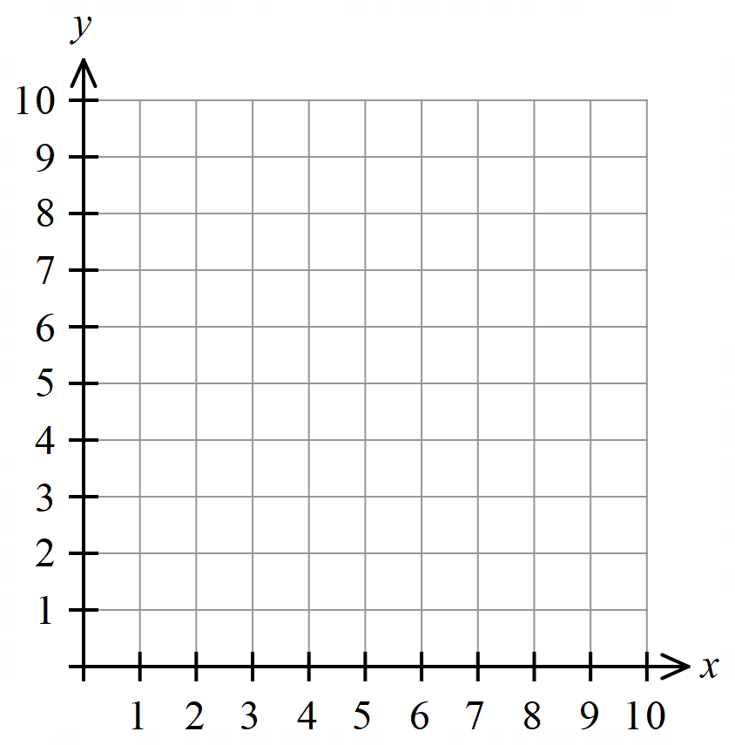
- Plot points on a Cartesian plane

$$x$$ | 0 | 1 | 2 | 3 | 4
$$y$$ | 9 | 7 | 5 | 3 | 1

- Identify a table column as a coordinate
We can show each $(x,y)$ pair from a table of values as coordinates.
Write the coordinates from the table.
  $$x$$ | 0 | 1 | 2
  $$y$$ | 4 | 7 | 10
  $$x$$ | 4 | 7 | 10
  $$y$$ | 7 | 4 | 1
Plot this table of values on the Cartesian plane to the right.
$$x$$ | $$-1$$ | 0 | 1
$$y$$ | $$-1$$ | 1 | 3

- Sketch a Line from a Table of Values
Some equations are called linear relationships because when we plot their $(x,y$) pairs, it forms a straight line.

- Construct a table of values by substituting $x$ values into the equation to find $y$.
- Plot the $\left(x,y\right)$ points on a Cartesian plane.
- Draw a straight line through the points and extend it.

- Example Graph a linear relationship using a table of values
Draw the graph of the equation $y=2x+1$
$$x$$ | 0 | $$1$$ | 2 | 3
$$y$$ | 1 | 3 | 5 | 7
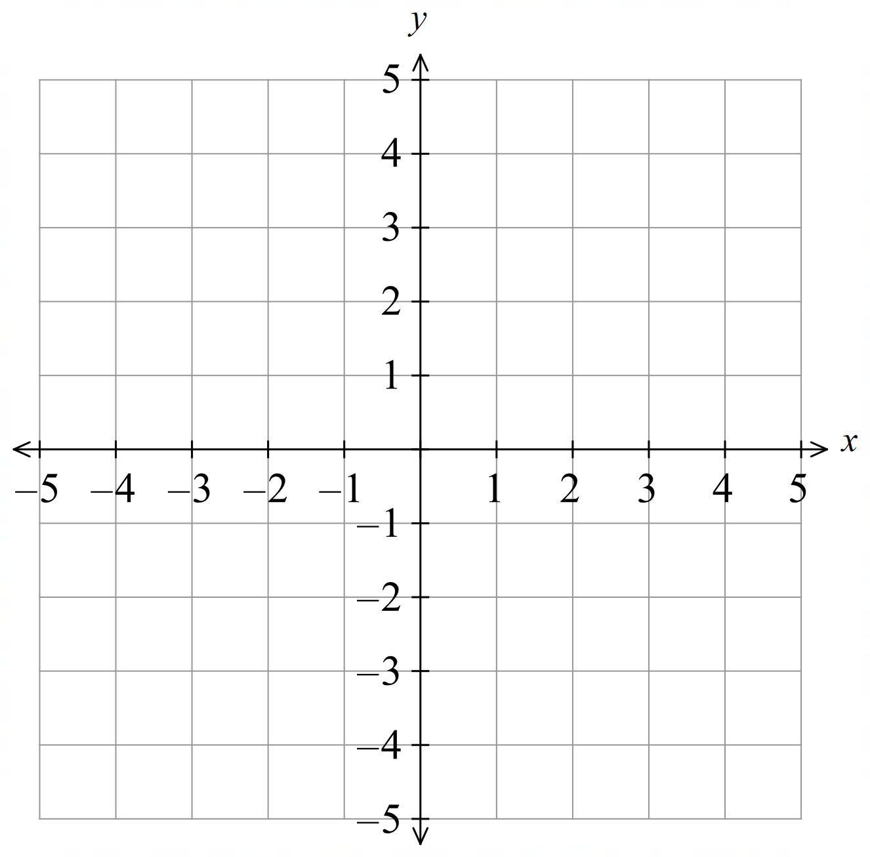

- Guided Practice
Draw the graph of:
- $y=2x-1$ | - $y=4-x$
  $$x$$ | 0 | 1 | 2 | 3
  $$y$$
  $$x$$ | 0 | 1 | 2 | 3
  $$y$$

- Key Ideas
- Each column of a table of values can be written as a ……………………
- When an equation forms points that make a straight line, we call it a ……………… relationship.

Foundation
- Identify the coordinates from the table of values.
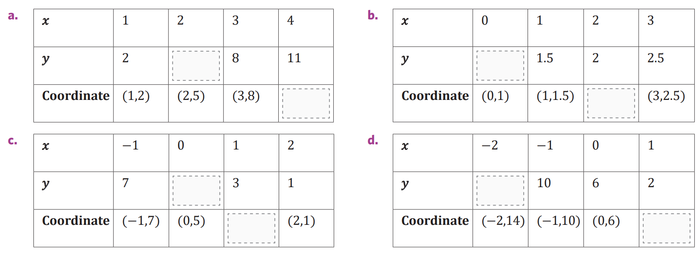  $$5$$  $$\left(4,11\right)$$ | $$1$$  $$\left(2,2\right)$$
$$5$$  $$\left(1,3\right)$$ | $$14$$  $$\left(1,2\right)$$

- Complete the table of values and graph the result.
- $y=x+1$ | - $y=2x+1$  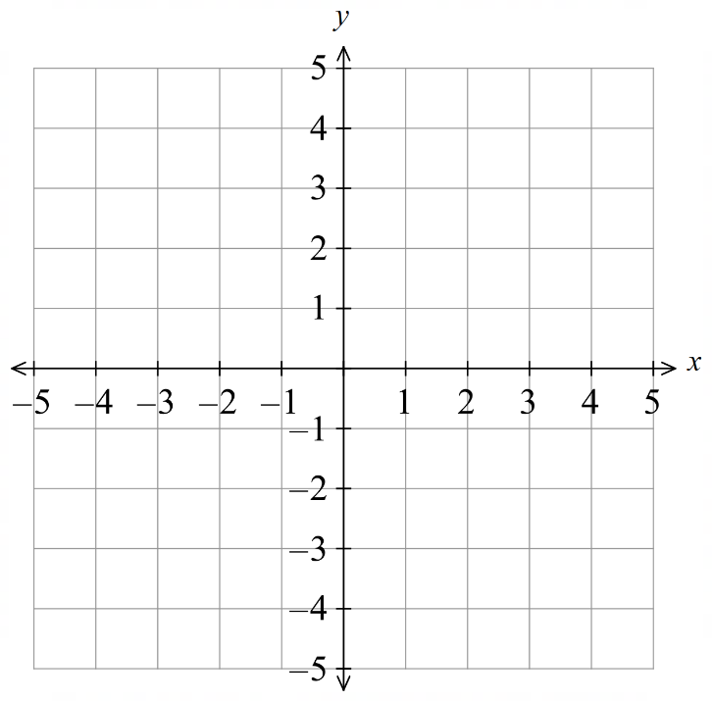
  $$x$$ | 0 | 1 | 2 | 3
  $$y$$
  $$x$$ | 0 | 1 | 2 | 3
  $$y$$
- $y=-x+1$ | - $y=2x$
  $$x$$ | 0 | 1 | 2 | 3
  $$y$$
  $$x$$ | 0 | 1 | 2 | 3
  $$y$$
- $y=x+3$  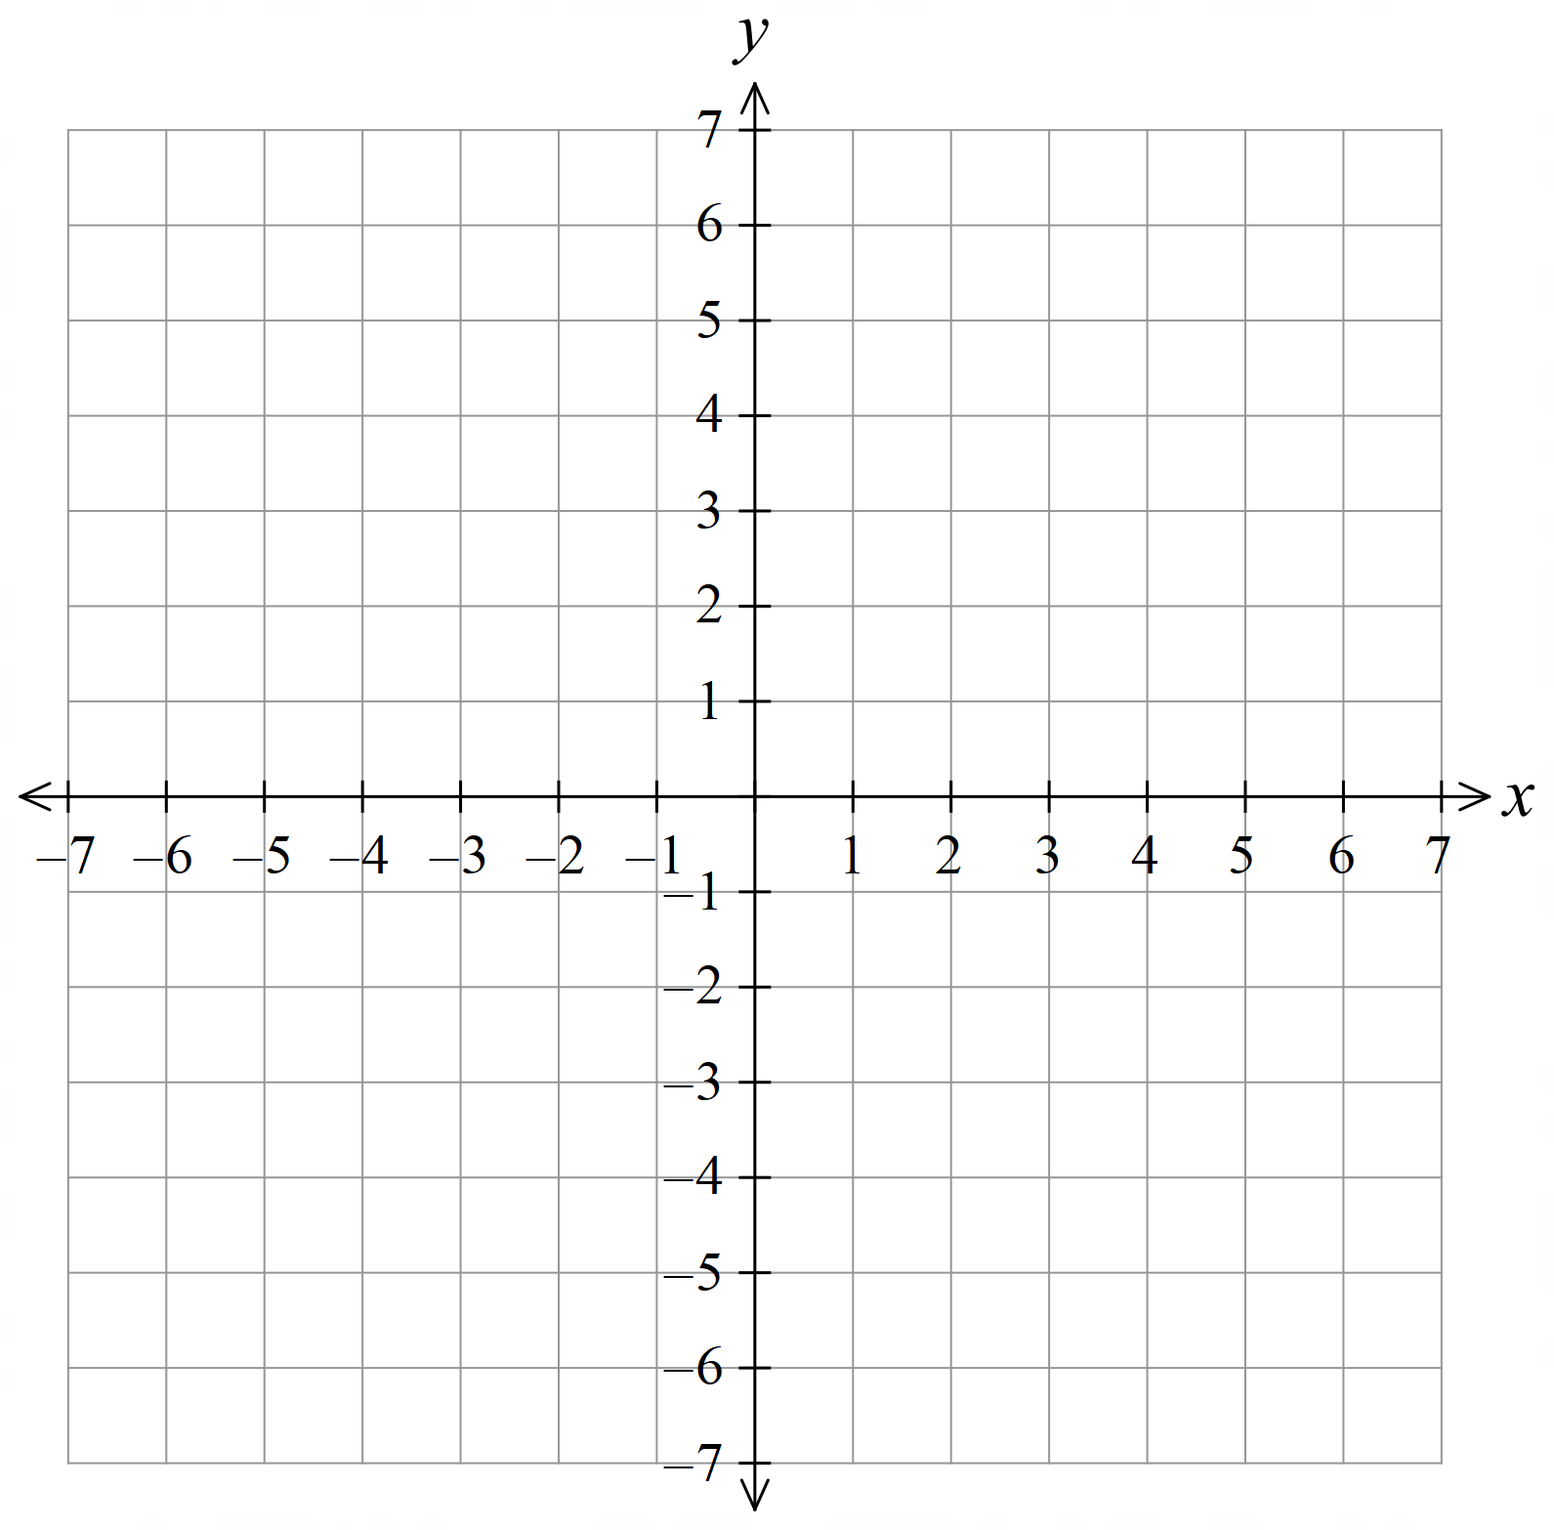 | - $y=3x-1$
  $$x$$ | 0 | $$1$$ | $$2$$ | $$3$$
  $$y$$
  $$x$$ | 0 | $$1$$ | $$2$$ | $$3$$
  $$y$$
- $y=3x$ | - $y=-2x$
  $$x$$ | 0 | $$1$$ | $$2$$ | $$3$$
  $$y$$
  $$x$$ | 0 | $$1$$ | $$2$$ | $$3$$
  $$y$$

- $y=x+3$ | - $y=x-1$
  $$x$$ | $$-2$$ | $$-1$$ | 0 | $$1$$ | $$2$$
  $$y$$
  $$x$$ | $$-2$$ | $$-1$$ | 0 | $$1$$ | $$2$$
  $$y$$
- $y=2x-3$ | - $y=-3x$
  $$x$$ | $$-2$$ | $$-1$$ | 0 | $$1$$ | $$2$$
  $$y$$
  $$x$$ | $$-2$$ | $$-1$$ | 0 | $$1$$ | $$2$$
  $$y$$

- $y=-2x-1$ | - $y=-x+4$
  $$x$$ | $$-2$$ | $$-1$$ | 0 | $$1$$ | $$2$$
  $$y$$
  $$x$$ | $$-2$$ | $$-1$$ | 0 | $$1$$ | $$2$$
  $$y$$
- $y=0.5x-3$ | - $y=1+2x$
  $$x$$ | $$-2$$ | $$-1$$ | 0 | $$1$$ | $$2$$
  $$y$$
  $$x$$ | $$-2$$ | $$-1$$ | 0 | $$1$$ | $$2$$
  $$y$$

Development
- Complete the table of values and graph the result.
- $y=1.5-4x$ | - $y=3-x$
  $$x$$ | $$-2$$ | $$-1$$ | 0 | $$1$$ | $$2$$
  $$y$$
  $$x$$ | $$-2$$ | $$-1$$ | 0 | $$1$$ | $$2$$
  $$y$$
- $y=4-2x$ | - $y=1-\frac{5}{2}x$
  $$x$$ | $$-2$$ | $$-1$$ | 0 | $$1$$ | $$2$$
  $$y$$
  $$x$$ | $$-2$$ | $$-1$$ | 0 | $$1$$ | $$2$$
  $$y$$

Mastery
- Match the rules A-D with the graphs a-d.
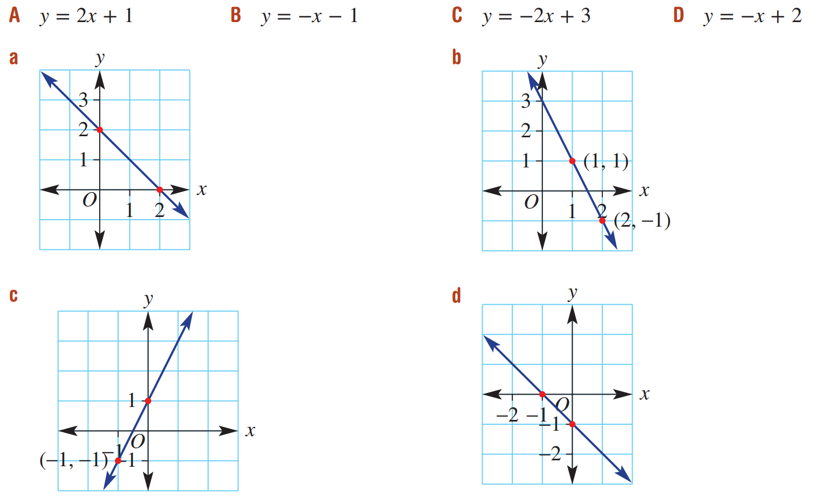

A – c, B – d, C – b, D – a

Finding the Rule from a Table

- Equation of a Linear Relationship
Every linear relationship is in the form:
$$y=mx+c$$

- Identify equation of a linear relationship
✖  $$y=x^{2}$$ | ✔  $$y=2x$$ |  | ✔  $$y=9-12x$$ |  | ✔  $$y=\frac{x}{6}-22$$ |  | ✖  $$y=\frac{6}{x}-22$$
Identify which of the following are linear relationships
$$y=5x+1$$ |  | $$y=1+5x$$ |  | $$y=x^{2}-7$$ |  | $$y=\frac{x}{2}-7$$
$$y=\frac{2}{x}$$ |  | $$y=3^{x}$$ |  | $$y=x$$ |  | $$y=9$$
$$y=3-7x$$ |  | $$y=-12x+6$$ |  | $$y=x^{3}-5$$ |  | $$y=80-\frac{5x}{3}$$

- Equations and Tables
An equation for a table must give the correct $y$-value for every $x$-value in the table.
We say that every column of the table must satisfy the equation.

- Verify whether a table of values satisfies an equation.
- $y=3x$ | - $y=3x$
  $$x$$ | 0 | 1 | 2 | 3
  $$y$$ | 0 | 3 | 6 | 9
  $$x$$ | 0 | 1 | 2 | 3
  $$y$$ | 0 | 3 | 5 | 7
- $y=x+2$ | - $y=4x+1$
  $$x$$ | 0 | 1 | 2 | 3
  $$y$$ | 0 | 3 | 6 | 9
  $$x$$ | 0 | 1 | 2 | 3
  $$y$$ | 1 | 5 | 9 | 13
- $y=-x+2$ | - $y=6x+7$
  $$x$$ | 0 | 1 | 2 | 3
  $$y$$ | 2 | 1 | 0 | $$-1$$
  $$x$$ | 0 | 1 | 2 | 3
  $$y$$ | 7 | 6 | 5 | 4

- Finding the Equation
We can represent $x y$ pairs in a table of values as an equation linking $x$ and $y$.
The equation must work for every column of the table.

- Example Find the equation from a table of values
Every $y$ value is 9 more than the $x$ value.  $y=$ $x+9$ | Every $y$ value is twice the $x$ value plus one.  $y=$ $2x+1$
  $$x$$ | 1 | 3 | 10
  $$y$$ | 10 | 12 | 19
  $$x$$ | 0 | 4 | 10
  $$y$$ | 1 | 9 | 21

- Guided Practice
Find the rule shown in the table.
$$y=x+4$$ | $$y=3x$$
  $$x$$ | 2 | 5 | 6
  $$y$$ | 6 | 9 | 10
  $$x$$ | 12 | 5 | 0
  $$y$$ | 36 | 15 | 0
$$y=2x-1$$ | $$y=\frac{x}{2}$$
  $$x$$ | 2 | 5 | 10
  $$y$$ | 3 | 9 | 19
  $$x$$ | 10 | 6 | 3
  $$y$$ | 5 | 3 | 1.5

- Key Ideas
- When finding the rule from a table, we are looking for an equation that ………………… every column of the table.
- An equation for a table is correct only if it works for …………… column in the table.

Foundation
- Determine the rule shown in the table. Every equation involves a single operation only.
$y=3x$ | $$y=x+3$$ | $$y=x-3$$
  $$x$$ | 5 | 6 | 7
  $$y$$ | 15 | 18 | 21
  $$x$$ | 10 | 11 | 12
  $$y$$ | 13 | 14 | 15
  $$x$$ | 8 | 9 | 10
  $$y$$ | 5 | 6 | 7
$$y=x-2$$ | $$y=\frac{x}{2}$$ | $$y=2x$$
  $$x$$ | 20 | 14 | 6
  $$y$$ | 18 | 12 | 4
  $$x$$ | 8 | 10 | 12
  $$y$$ | 4 | 5 | 6
  $$x$$ | 4 | 5 | 6
  $$y$$ | 8 | 10 | 12
$$y=x+2$$ | $$y=x-5$$ | $$y=x+5$$
  $$x$$ | 4 | 3 | 2
  $$y$$ | 6 | 5 | 4
  $$x$$ | 20 | 14 | 6
  $$y$$ | 15 | 9 | 1
  $$x$$ | 8 | 10 | 12
  $$y$$ | 13 | 15 | 17
$$y=4x$$ | $$y=x+11$$ | $$y=\frac{x}{6}$$
  $$x$$ | 1 | 2 | 3 | 4 | 5
  $$y$$ | 4 | 8 | 12 | 16 | 20
  $$x$$ | 10 | 8 | 3 | 1 | 14
  $$y$$ | 21 | 19 | 14 | 12 | 25
  $$x$$ | 6 | 18 | 30 | 24 | 66
  $$y$$ | 1 | 3 | 5 | 4 | 11

- Describe the relationship between the $x$ and $y$ values of each point on the line.
  - $y=x+1$ The $y$ value is one more than the $x$ value.
  - $y=x+2$ The $y$ value is ………………… the $x$ value.
2 more than
  - $y=x-1$ The $y$ value is ………………… the $x$ value.
1 less than
  - $y=x-4$ The $y$ value is ………………… the $x$ value.
4 less than
  - $y=x+4$ The $y$ value is ………………… the $x$ value.
4 more than
  - $y=2x$ The $y$ value is two times the $x$ value.
  - $y=3x$ The $y$ value is ………………… the $x$ value.
3 times
  - $y=-3x$ The $y$ value is ………………… the $x$ value.
$-3$ times
  - $y=\frac{x}{2}$ The $y$ value is ………………… the $x$ value.
half
  - $y=-\frac{x}{2}$ The $y$ value is ………………… the $x$ value.
Negative one half times

- Determine the equation of the line shown by these tables of values, then complete the table.
$$y = x + 4$$  Missing values: 5, 12 | $$y = 3x$$  Missing values: 0, 36
  $$x$$ | 2 | 5 | 6 | 1 | 8
  $$y$$ | 6 | 9 | 10
  $$x$$ | 12 | 5 | 8 | 0 | 12
  $$y$$ | 36 | 15 | 24
$$y = -2x$$  Missing values: –2, 0 | $$y =\frac{x}{6}$$  Missing values: 4, 11
  $$x$$ | 4 | 3 | 5 | 1 | 0
  $$y$$ | $-8$ | $$-6$$ | $$-10$$
  $$x$$ | 6 | 18 | 30 | 24 | 66
  $$y$$ | 1 | 3 | 5
$$y =\frac{x}{2}$$  Missing values: 10, –10 | $$y = x - 5$$  Missing values: 10, –4
  $$x$$ | 8 | 10 | 12 | 20 | $$-20$$
  $$y$$ | 4 | 5 | 6
  $$x$$ | 20 | 14 | 6 | 15 | 1
  $$y$$ | 15 | 9 | 1

- First figure out the rule, then complete the rest of the table.
$$y=3x$$  12, 30, 72, 3, 14, 33 | $$y=x-9$$  $$84, 5, 21, 43, 9$$
  $$x$$ | 4 | 10 | 13 | 24 |  |  | 5 | 11
  $$y$$ |  |  | 39 |  | 9 | 42 | 15
  $$x$$ | 12 | 93 | 14 | 17 |  | 10
  $$y$$ | 3 |  |  | 8 | 12 | 1 | 34 | 0

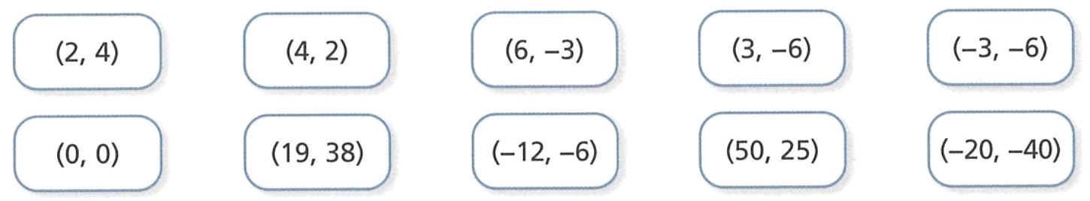
  - In which of these coordinate pairs is the $y$ value twice the $x$ value?

(2,4), (–3, –6), (0,0), (19,38), (–20, –40)
  - The points you identified in part a lie on what line? Give the equation.
$$y=2x$$
  - Will (8, 16) lie on $y=2x?$
Yes
  - Will (9, 20) lie on $y=2x$?
No
- All of these points lie on the same line. (1, 10) (3, 30) (-10,-100) (-5,-50)
Complete this sentence:
  - In each pair of coordinates, the $y$ value is ………………… the $x$ value.
10 times
  - Write the equation of the straight line that passes through all four points.
$$y=10x$$
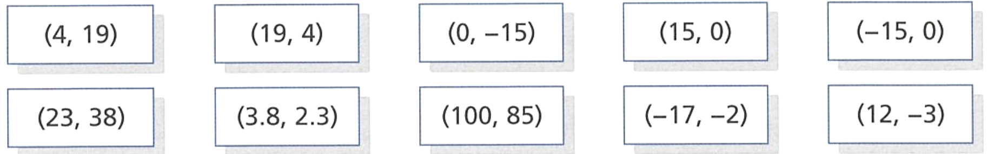
- Here are some pairs of coordinates.

  - Which of the points lie on the line $y=x+15$?

(4, 19), (–15, 0), (23, 38), (–17, –2)
  - Which of the points lie on the line $y=x-15$?

(19, 4), (0,–15), (15, 0), (100, 85), (12, –3)
- These straight line graphs have equations of the form $y=x+c$ or $y=mx$
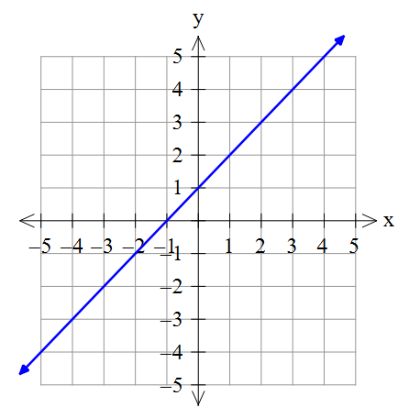  $$(0,1)$$  $$(1,2)$$  $$(2,3)$$  $$(3,4)$$  At each point on the line, the $y$-value is 1 more than the  $x$-value. The equation of the line is ………………  $$y=x+1$$ | 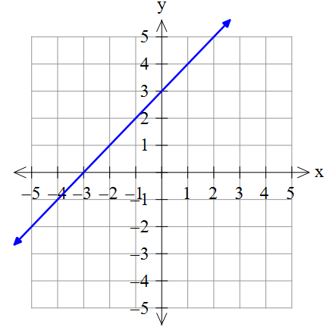  At each point on the line, the $y$-value is ………………… the $x$-value. The equation of the line is ………………  Three more than; $y=x+3$ | 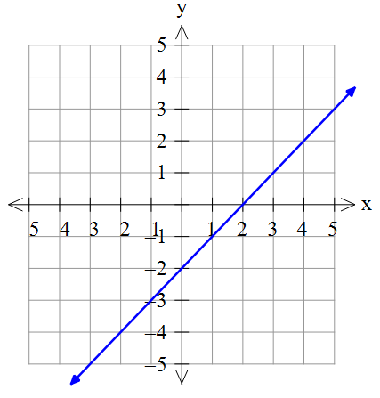  At each point on the line, the $y$-value is ………………… the $x$-value. The equation of the line is ………………  2 less than, $y=x-2$
At each point on the line, the $y$-value is 2 times the $x$-value. The equation of the line is ………………  $$y=2x$$ | At each point on the line, the $y$-value is ………………… the $x$-value. The equation of the line is ………………  Three times, $y=3x$ | 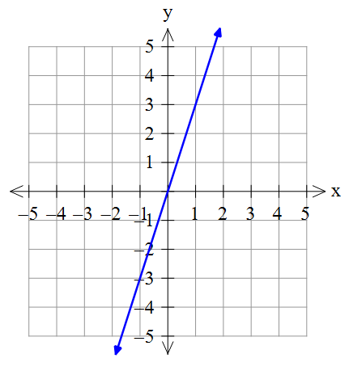  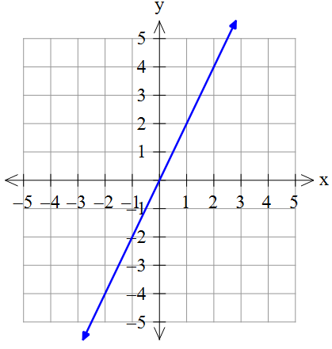  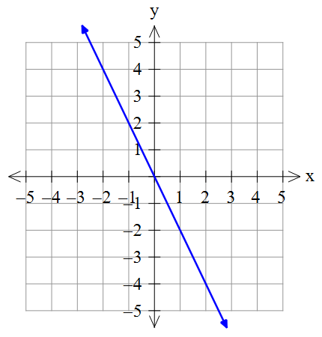  At each point on the line, the $y$-value is ………………… the $x$-value. The equation of the line is ………………  Negative two times, $y=-2x$

Systematically Finding the Rule $y=mx+c$ from a table

- Equation of a Linear Relationship
Every linear relationship is in the form $y=mx+c$.
$$y=mx+c$$
coefficient of $x$ constant term
number $x$ is multiplied by term with no variable
change in $y$ as $x$ increases by 1 value of $y$ when $x=0$

- Identify $m$ from a table of values
$m$ is the coefficient of $x.$ It is how much $y$ changes as $x$ increases by 1.
$$+4$$  $$+4$$  $m=$ ………… | $m=$ ………… | $m=$ …………
  $$x$$ | 2 | 3 | 4
  $$y$$ | 8 | 12 | 16
  $$x$$ | 5 | 6 | 7
  $$y$$ | 30 | 36 | 42
  $$x$$ | 9 | 10 | 11
  $$y$$ | 20 | 18 | 16
$m=$ ………… | $m=$ ………… | Why can’t we find $m$?
  $$x$$ | 201 | 202 | 203
  $$y$$ | 18 | 15 | 12
  $$x$$ | 1 | 2 | 3
  $$y$$ | 905 | 910 | 915
  $$x$$ | 7 | 2 | 11
  $$y$$ | 25 | 15 | 33

- Identify $c$ from a table of values
$c$ is the constant term$.$ It is the value of $y$ when $x=0$.
$c=$ ………… | $c=$ ………… | $c=$ …………
  $$x$$ | 0 | 1 | 2
  $$y$$ | 8 | 9 | 10
  $$x$$ | 0 | 4 | 18
  $$y$$ | 11 | 3 | $$-25$$
  $$x$$ | $$-2$$ | 0 | 15
  $$y$$ | 15 | 23 | 83
$c=$ ………… | $c=$ ………… | Why can’t we find $c$?
  $$x$$ | 0 | 22 | 8
  $$y$$ | $$-5$$ | 127 | $$43$$
  $$x$$ | 5 | $$-3$$ | 0
  $$y$$ | 17 | $$-15$$ | $$-3$$
  $$x$$ | $$-7$$ | 14 | 8
  $$y$$ | 51 | $$-96$$ | $$-54$$

- Finding the Rule from a Table of Values
If we have a table where the value of $x$ increases by 1, and the value of $y$ when $x=0$,
then we can use this method to find the equation $y=mx+c$:
- Find $m$: This is how much $y$ changes by as $x$ increases by 1.
- Find $c$: This is the value of $y$ when $x=0$.
- Write the equation $y=mx+c$ and check it works for every column.
- Check that your rule works for every column.

- Example Find the equation of a linear relationship from a table of values
$$+2$$  $$+2$$  $$+2$$  $$+2$$  $$+2$$  $m=2$, $c=1$  $y=2x+1$ | $m=-3$, $c=7$  $y=-3x+7$
  $$x$$ | 0 | 1 | 2 | 3 | 4 | 5
  $$y$$ | 1 | 3 | 5 | 7 | 9 | 11
  $$x$$ | $$-1$$ | 0 | 1 | 2 | 3 | 4
  $$y$$ | 10 | 7 | 4  $$-3$$  $$-3$$  $$-3$$  $$-3$$  $$-3$$ | 1 | $$-2$$ | $$-5$$

- Guided Practice
Determine the equation that relates $x$ and $y$ from the table of values.
$m=$ ………… $c=$ …………  $y=$ …………  $y=4x+2$ | $m=$ ………… $c=$ …………  ………………  $y=-2x+3$
  $$x$$ | 0  $$+4$$  $$+4$$  $$+4$$  $$+4$$  $$+4$$ | 1 | 2 | 3 | 4 | 10
  $$y$$ | $$2$$ | $$6$$ | $$10$$ | $$14$$ | $$18$$ | $$42$$
  $$x$$ | 0 | 1 | 2 | 3 | 4 | 10
  $$y$$ | 3 | $$1$$ | $$-1$$ | $$-3$$ | $$-5$$ | $$-17$$
$y=3x-6$ | $y=5x-3$
  $$x$$ | 0 | 1 | 2 | 3 | 4 | 10
  $$y$$ | $$-6$$ | $$-3$$ | $$0$$ | $$3$$ | $$6$$ | $$24$$
  $$x$$ | $$-2$$ | $$-1$$ | 0 | 1 | 2 | 3
  $$y$$ | $$-13$$ | $$-8$$ | $$-3$$ | 2 | 7 | 12

- Key Ideas
- Every linear relationship has the equation …… = …………………
- $m$ is the change in $y$ as $x$increases by ……, $c$ is the value of $y$ when $x=$ ………

Foundation
- Determine the change in $y$ as $x$ increases by 1. This is $m$. Find the $y$-value at $x=0$; this is $c$.
Write the equation linking $x$ and $y$ with this information.
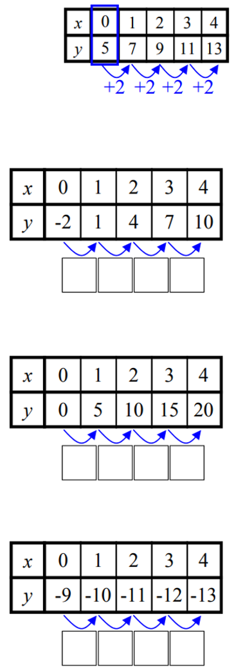  $m=2$ $c=5$  $$y=2x+5$$ | $m=$ …… $c=$ ……  $y=$ ……$x+$ ……  $$y=3x -2$$ | $m=$ …… $c=$ ……  $y=$ ……$x+$ ……  $$y=5x$$
$m=$ …… $c=$ ……  $y=$ ……………  $$y=-x-9$$ | 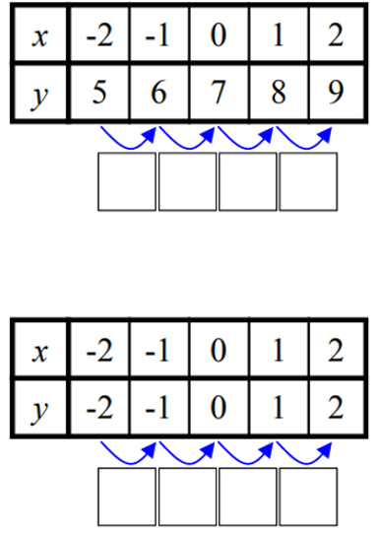  $$y=x+7$$ | $$y=x$$

- Find the equation shown in these tables.
$$y=2x$$ | $$y=2x+3$$
  $$x$$ | 0 | 1 | 2 | 3
  $$y$$ | 0 | 2 | 4 | 6
  $$x$$ | 0 | 1 | 2 | 3
  $$y$$ | 3 | 5 | 7 | 9
$$y=2x-1$$ | $$y=x+1$$
  $$x$$ | 0 | 1 | 2 | 3
  $$y$$ | $$-1$$ | $$1$$ | $$3$$ | $$5$$
  $$x$$ | 0 | 1 | 2 | 3
  $$y$$ | 1 | 2 | 3 | 4
$$y=3x+1$$ | $$y=-2x+1$$
  $$x$$ | 0 | 1 | 2 | 3
  $$y$$ | 1 | 4 | 7 | 10
  $$x$$ | 0 | 1 | 2 | 3
  $$y$$ | 1 | $$-1$$ | $$-3$$ | $$-5$$

- Find the equation shown in these tables.
$$y=2x+4$$ | $$y=-x+1$$
  $$x$$ | $$-2$$ | $$-1$$ | $$0$$ | 1 | 2
  $$y$$ | 0 | 2 | 4 | 6 | 8
  $$x$$ | $$-3$$ | $$-2$$ | $$-1$$ | 0 | 1
  $$y$$ | 4 | 3 | 2 | 1 | 0
$$y=-2x+6$$ | $$y=3x-1$$
  $$x$$ | $$-1$$ | $$0$$ | $$1$$ | $$2$$ | $$3$$
  $$y$$ | $$8$$ | $$6$$ | $$4$$ | $$2$$ | $$0$$
  $$x$$ | $$-2$$ | $$-1$$ | $$0$$ | $$1$$ | $$2$$
  $$y$$ | $$-7$$ | $$-4$$ | $$-1$$ | $$2$$ | $$5$$

- Find the equation for each table, then complete the table.
y = 3x + 3  Missing values: 18, 27 | y = 3x + 1  Missing values: 13, 22
  $$x$$ | 0 | 1 | 2 | 3 |  | 5 | 8
  $$y$$ | 3 | 6 | 9 | 12
  $$x$$ | 0 | 1 | 2 | 3 |  | 4 | 7
  $$y$$ | 1 | 4 | 7 | 10
y = 3x + 5  Missing values: 23, –1 | y = x/2  Missing values: 20, –1.5
  $$x$$ | 0 | 1 | 2 | 3 |  | 6 | $$-2$$
  $$y$$ | 5 | 8 | 11 | 14
  $$x$$ | 0 | 1 | 2 | 3 |  | 40 | $$-3$$
  $$y$$ | 0 | 0.5 | 1 | 1.5
y = –2x – 1  Missing values: –7, –47, 13 | y = –5x + 13  Missing values: 18, –27, –97
  $$x$$ | 0 | 1 | 2 | 3 |  | 23 | $$-7$$
  $$y$$ | $$-1$$ | $$-3$$ | $$-5$$
  $$x$$ | $$-1$$ | 0 | 1 | 2 |  | 8 | 22
  $$y$$ |  | 13 | 8 | 3
y = –10x + 20  Missing values: 30, –70, 60 | $$y=-\frac{x}{2}-\frac{1}{2}$$  Missing values: –2, –6.5, –5.5
  $$x$$ | $$-1$$ | 0 | 1 | 2 |  | 9 | $$-4$$
  $$y$$ |  | 20 | 10 | 0
  $$x$$ | $$0$$ | 1 | 2 | 3 |  | 12 | 10
  $$y$$ | $$-0.5$$ | $$-1$$ | $$-1.5$$

Development
- Find the equation that describes this table of values. Select A, B, C, or D.
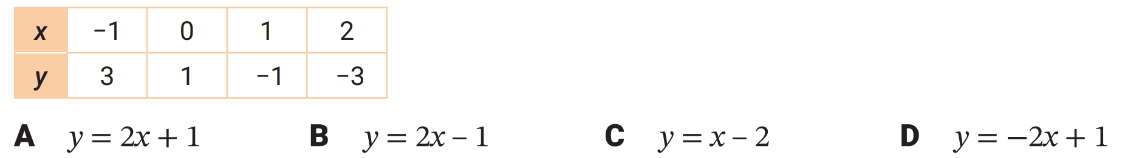

D
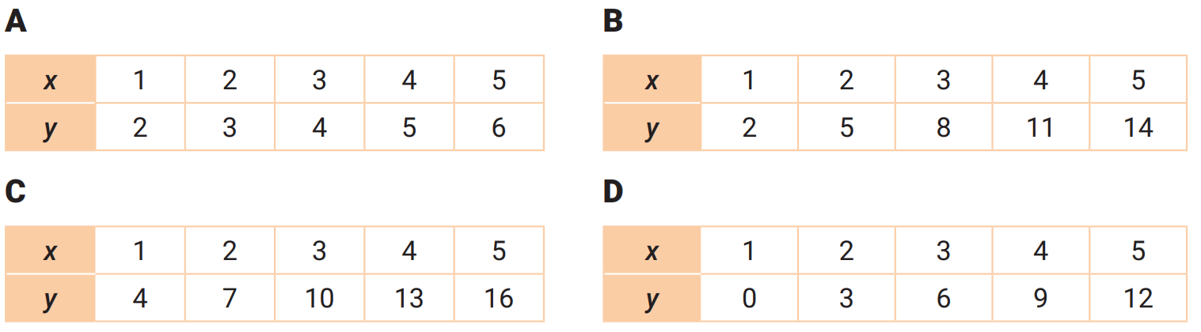
- Which table of values matches $y=3x-1$? Select A, B, C, or D.

B
- Extend the table so that $x=0$ is shown, then find the equation of the line.
$m=$ …… $c=$ ……  $y=$ ……………  $$y=2x+3$$ | 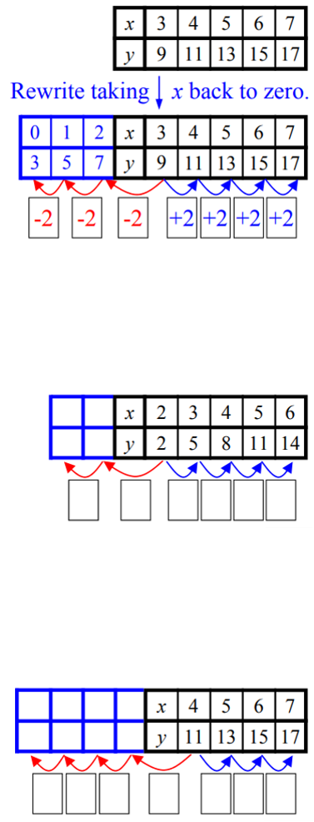  $m=$ …… $c=$ ……  $y=$ ……………  $$y=3x-4$$
$$y=2x+3$$ | 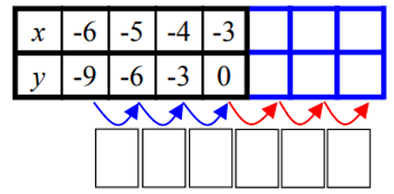  $$y=3x+9$$

- Determine the equation shown in the table.
y = 4x + 2 | y = 4x – 4
  $$x$$ | 1 | 2 | 3 | 4
  $$y$$ | 6 | 10 | 14 | 18
  $$x$$ | 1 | 2 | 3 | 4
  $$y$$ | 0 | 4 | 8 | 12
y = 10x – 3 | y = 2x – 4
  $$x$$ | 2 | 3 | 4 | 5
  $$y$$ | 17 | 27 | 37 | 47
  $$x$$ | 4 | 5 | 6 | 7
  $$y$$ | 4 | 6 | 8 | 10
y = 2x – 3 | y = –x + 4
  $$x$$ | $$-5$$ | $$-4$$ | $$-3$$ | $$-2$$ | $$-1$$
  $$y$$ | $$-13$$ | $$-11$$ | $$-9$$ | $$-7$$ | $$-5$$
  $$x$$ | $$-6$$ | $$-5$$ | $$-4$$ | $$-3$$ | $$-2$$
  $$y$$ | $$10$$ | $$9$$ | $$8$$ | $$7$$ | $$6$$

- Determine the equation for each table, then complete the last two columns.
y = 5x – 3  Missing values: 32, 42 | y = 2x + 2  Missing values: 20, 24
  $$x$$ | 1 | 2 | 3 | 4 |  | 7 | 9
  $$y$$ | 2 | 7 | 12 | 17
  $$x$$ | 3 | 4 | 5 | 6 |  | 9 | 11
  $$y$$ | 8 | 10 | 12 | 14
y = 2x – 2  Missing values: –2, 22 | y = 10x + 1  Missing values: 91, 501
  $$x$$ | 2 | 3 | 4 | 5 |  | $$0$$ | 12
  $$y$$ | 2 | 4 | 6 | 8
  $$x$$ | 3 | 4 | 5 | 6 |  | 9 | 50
  $$y$$ | 31 | 41 | 51 | 61
y = 5x – 1  Missing values: 59, –11 | y = 2x – 6  Missing values: 12, 18
  $$x$$ | 3 | 4 | 5 | 6 |  | 12 | $$-2$$
  $$y$$ | 14 | 19 | 24 | 29
  $$x$$ | 5 | 6 | 7 | 8 |  | 9 | 12
  $$y$$ | 4 | 6 | 8 | 10
y = 4x + 1  Missing values: 29, –11 | y = 2x – 7  Missing values: –7, –13
  $$x$$ | 1 | 2 | 3 | 4 |  | 7 | $$-3$$
  $$y$$ | 5 | 9 | 13 | 17
  $$x$$ | 4 | 5 | 6 | 7 |  | 0 | $$-3$$
  $$y$$ | 1 | 3 | 5 | 7

- These $x$ values don’t increase by 1. You will need to divide to find $m$.
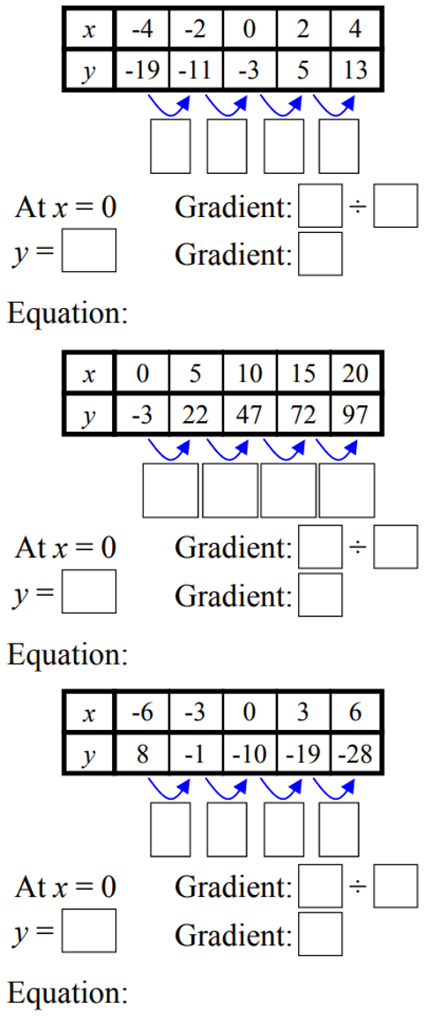  $m=$ $8÷2$ $c=$ ………  $=$ ………  $y=$ ……………  $$y=4x-3$$ | $m=$ ……$÷5$ $c=$ ………  $=$ ………  $y=$ ……………  $$y=5x-3$$ | $$y=-3x-10$$
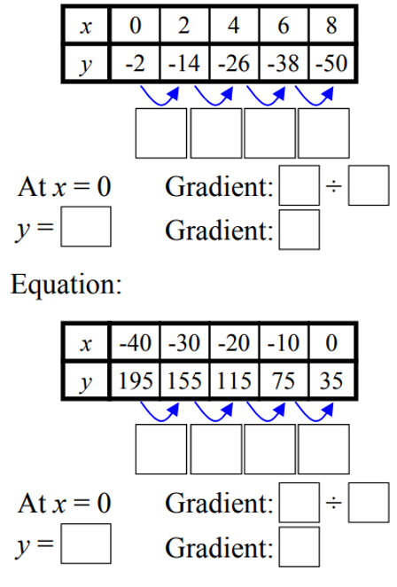  $$y=-6x-2$$ | $$y=-4x+35$$

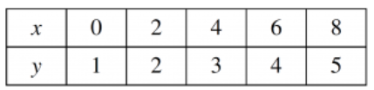
- 2006 HSC Maths Standard 2 Band 4
What equation represents the relationship between $x$ and $y$ in this table?

$$y=\frac{x}{2}+1$$
- These tables need to be extended and the $x$-value steps to be considered.
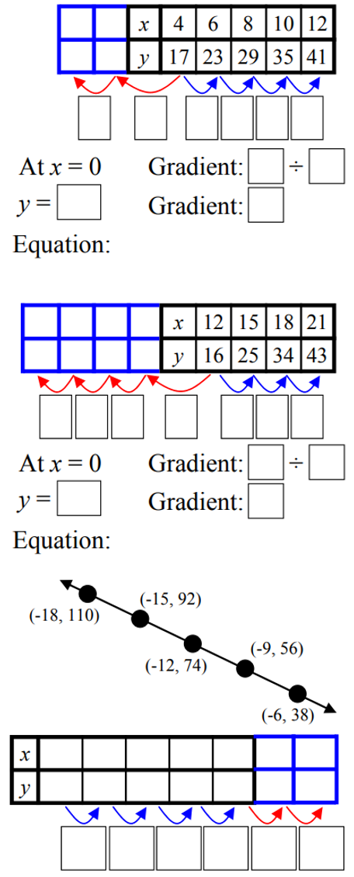  $$y=3x+5$$ | $$y=3x-20$$
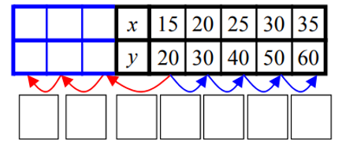  $$y=2x-10$$ | $$y=-6x+2$$

Mastery
- Determine the rule shown in the table. Notice that the $x$ values are not increasing by 1.
$$y=2x+3$$ | $$y=3x-1$$
  $$x$$ | $$-4$$ | $$-2$$ | $$0$$ | $$2$$ | $$4$$
  $$y$$ | $$-5$$ | $$-1$$ | $$3$$ | $$7$$ | $$11$$
  $$x$$ | $$-3$$ | $$-1$$ | $$1$$ | $$3$$ | $$5$$
  $$y$$ | $$-10$$ | $$-4$$ | $$2$$ | $$8$$ | $$14$$
$$y=-2x+3$$ | $$y=-4x-20$$
  $$x$$ | $$-6$$ | $$-3$$ | $$0$$ | $$3$$ | $$6$$
  $$y$$ | $$15$$ | $$9$$ | $$3$$ | $$-3$$ | $$-9$$
  $$x$$ | $$-10$$ | $$-8$$ | $$-6$$ | $$-4$$ | $$-2$$
  $$y$$ | $$20$$ | $$12$$ | $$4$$ | $$-4$$ | $$-12$$

- Describe the relationship between the $x$ and $y$ values at each point on these lines.
- $y=5x+3$  To obtain the $y$-value, we multiply $x$ by 5  then add 3 | - $y=2x+1$  To obtain the $y$-value, we multiply $x$ by ………… then ………………  2, add 1 | - $y=4x-1$  To obtain the $y$-value, we multiply $x$ by ………… then ………………  4, subtract 1
- $y=-3x-9$  To obtain the $y$-value, we multiply $x$ by ………… then ………………  Negative 3, subtract 9 | - $y=\frac{x}{2}+7$  To obtain the $y$-value, we divide $x$ by ………… then ………………  2, add 7 | - $y=\frac{x}{3}-12$  To obtain the $y$-value, we ………… $x$ by ………… then ………………  divide, 3, subtract 12

- Remember that every point on a line is a solution to the equation.
If you know one of either $m$ or $c$, then you can find the equation by substitution.
Example 1 | Example 2
$$m=3$$  $$y=3x+c$$  Sub in any point: $\left(7,10\right)$  $$10=3\left(7\right)+c$$  $$10=21+c$$  $$c=-11$$  $$∴y=3x-11$$ | $$c=5$$  $$y=mx+5$$  Sub in any point, except (0,5): $\left(8,-11\right)$  $$-11=m\left(8\right)+5$$  $$-11=8m+5$$  $$-16=8m$$  $$m=-2$$  $$∴y=-2x+5$$
  $$x$$ | 7 | 8 | 9 | 10
  $$y$$ | 10 | 13 | 16 | 19
  $$x$$ | 0 | 8 | 47 | $$-7$$
  $$y$$ | 5 | –11 | –89 | 19
It is a good idea to double check your rule by using the columns.
- Work out the rule for these tables.
$$y=4x-35$$ | $y=-3x-2$
  $$x$$ | 9 | 10 | 11 | 12
  $$y$$ | 1 | 5 | 9 | 13
  $$x$$ | $$-2$$ | 12 | 0 | 9
  $$y$$ | 4 | $$-38$$ | $$-2$$ | $$-29$$
$$y=2x+33$$ | $$y=\frac{x}{2}+5$$
  $$x$$ | $$-10$$ | $$-9$$ | $$-8$$ | $$-7$$
  $$y$$ | 13 | 15 | 17 | 19
  $$x$$ | 10 | 12 | 14 | 16
  $$y$$ | 10 | 11 | 12 | 13

- Find the rule for these tables of values. Use any strategy you like.
$$y=2x+4$$ | 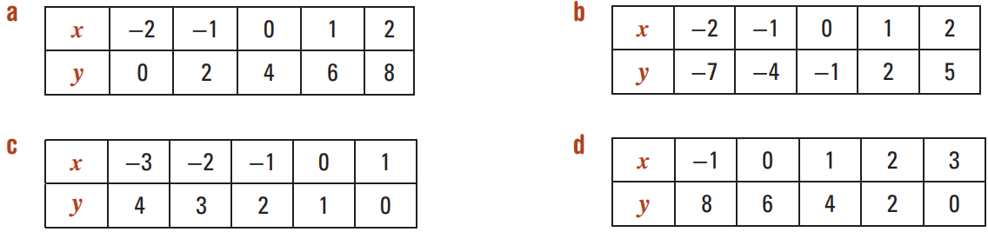  $$y=3x-1$$
$$y=-x+1$$ | $$y=-2x+6$$
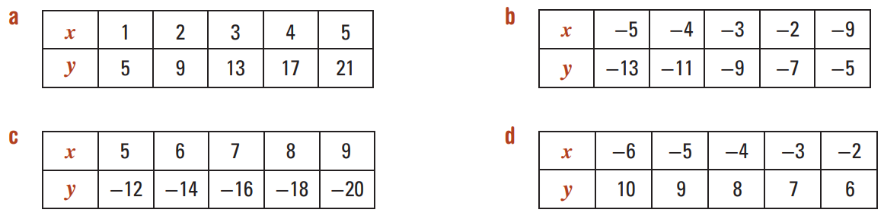  $$y=4x+1$$ | 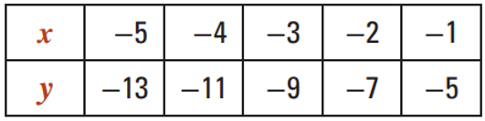  $$y=2x-3$$
$$y=-2x-2$$ | $$y=-x+4$$
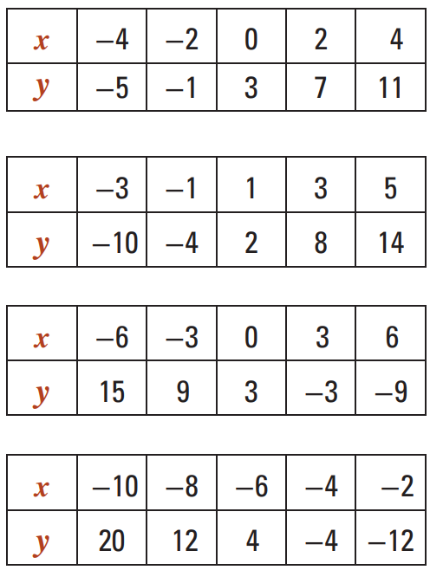  $$y=2x+3$$ | $$y=3x-1$$
$$y=-2x+3$$ | $$y=-4x-20$$
$$y=-3x-10$$ | 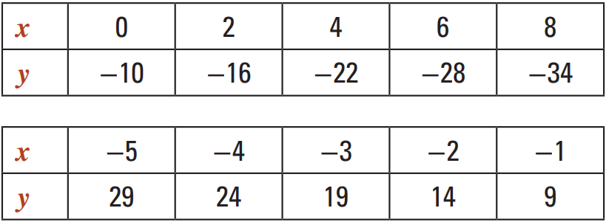  $y=-5x+4$
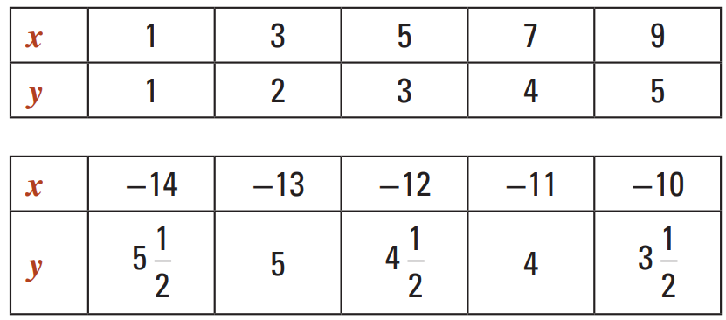  $$y=\frac{x}{2}+\frac{1}{2}$$ | $$y=-\frac{x}{2}-\frac{3}{2}$$

Finding the Rule from the Graph

Foundation
- Change the points to a table of values then find the equation of the line.
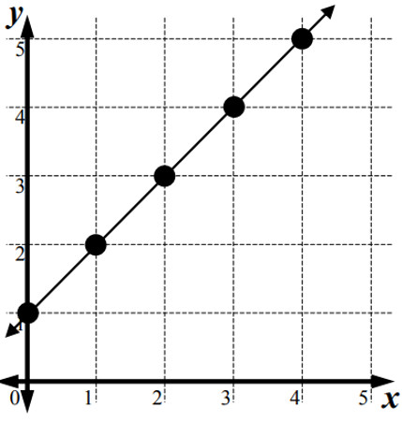  $m=$ ……  $c=$ ……  $y=$ ……………  $$y=x+1$$ | 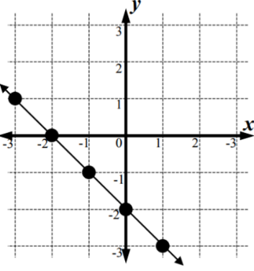  $m=$ ……  $c=$ ……  $y=$ ……………  $$y=-x-2$$  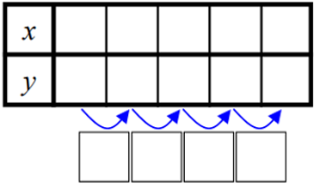
- By first constructing a table of values, find the equations of these lines.
Ensure your $x$ values are in ascending order.
$m=$ ……… $c=$ ………  $y=$ ……………  $$y=x+1$$ | 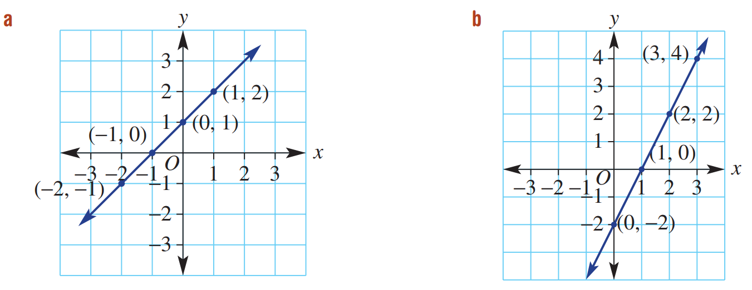  $$y=2x-2$$
  $$x$$ | $$-2$$ | $$-1$$ | $$0$$ | $$1$$
  $$y$$
  $$x$$
  $$y$$
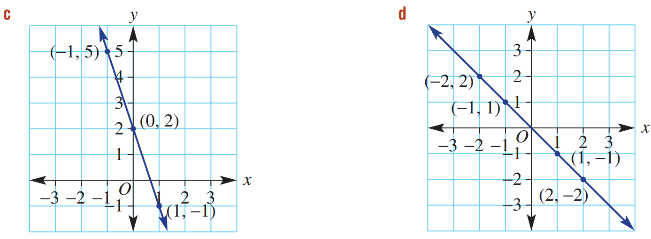  $$y=-x$$ | $$y=-3x+2$$
  $$x$$ | $$-2$$ | $$-1$$ | $$0$$ | $$1$$
  $$y$$
  $$x$$
  $$y$$

Development
- Complete the table for each graph, then find the equation.
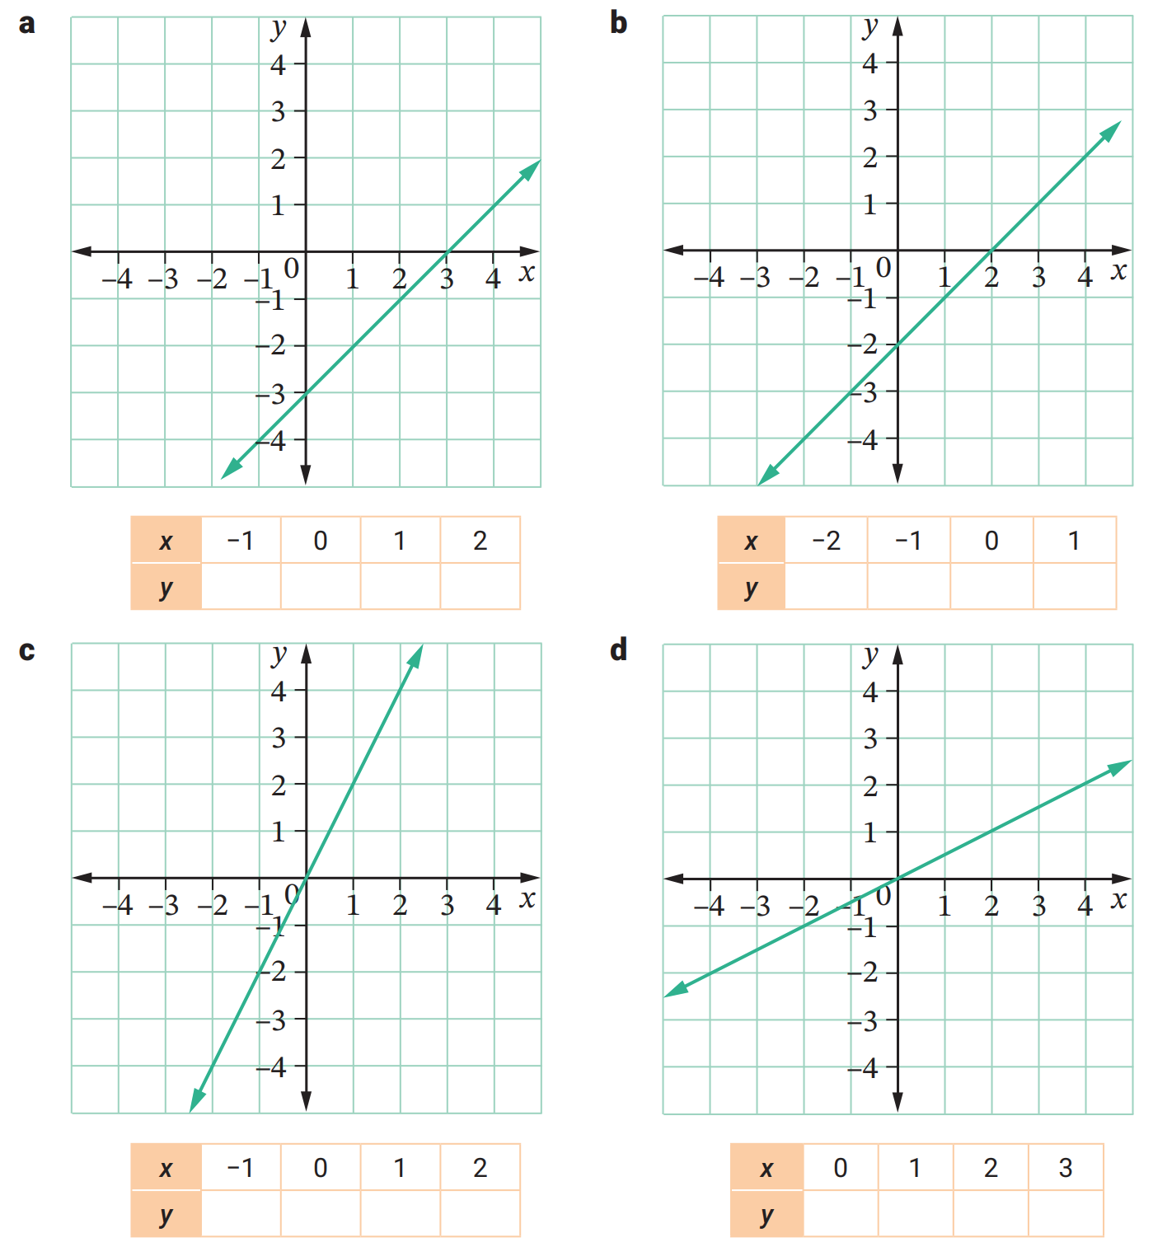  $$y=x-3$$ | $$y=x-2$$ | $$y=2x$$
$$y=\frac{x}{2}$$ | 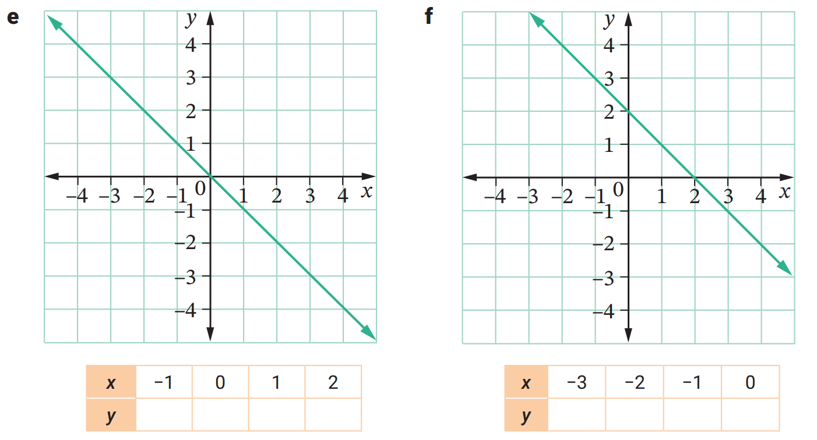  $$y=-x$$ | $$y=-x+2$$
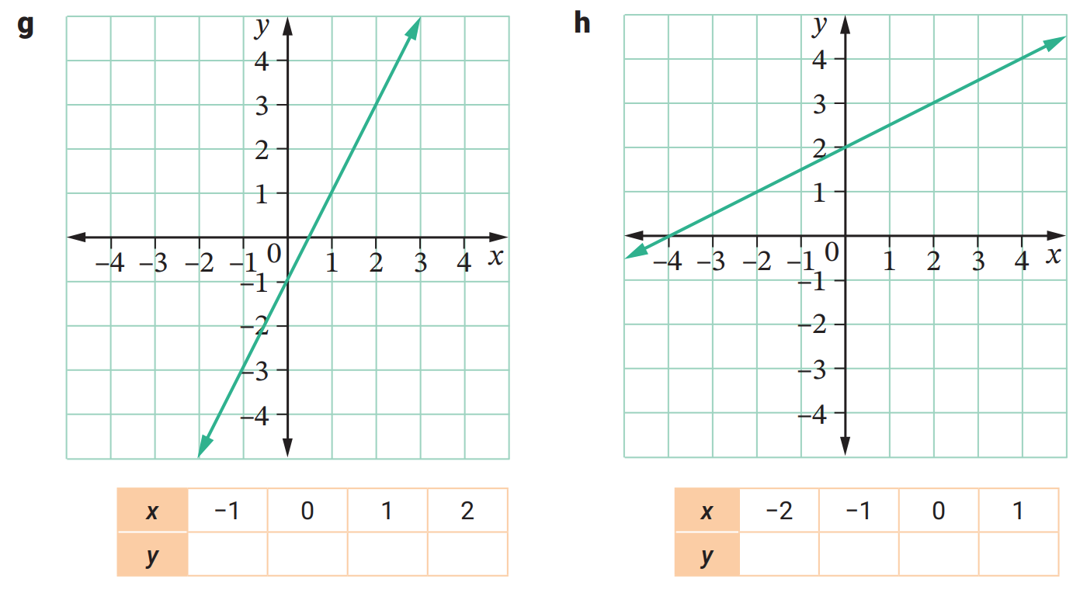  $$y=2x-1$$ | $$y=\frac{x}{2}+2$$

Mastery
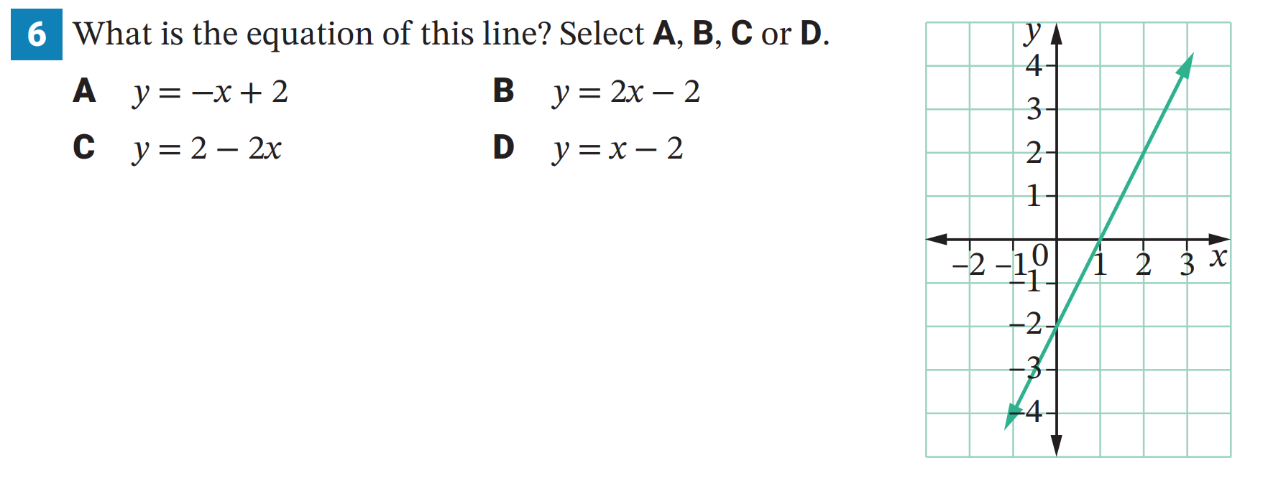
- What is the equation of this line? Select A, B, C, or D.

B
- By first constructing a table of values, find the equations of these lines.
Notice that the $y$-axis scale is different to the $x$-axis scale.
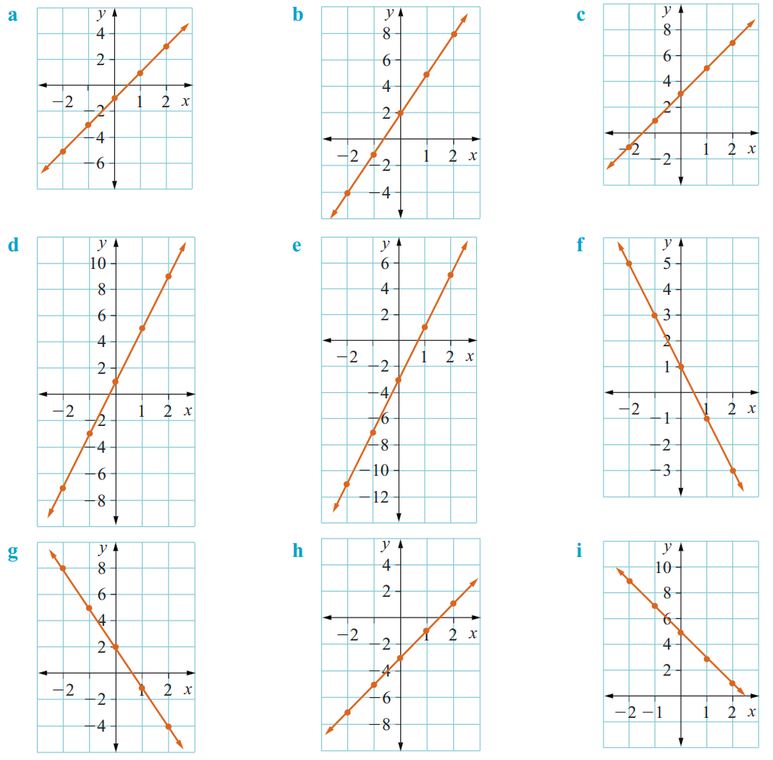  $$y=3x+2$$ | $$y=-3x+2$$
$$y=4x+1$$ | $$y=-2x+1$$

Patterns, Equations, Graphs

- Review
- Complete a table of values from a spatial pattern
Draw the next term in the pattern and fill in the table.
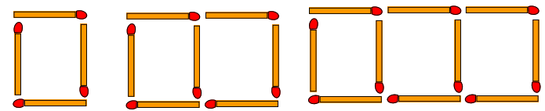

Number of shapes | 1 | 2 | 3 | 4 | 5
Number of matches

- Identify equation relating $x$ and $y$.
  $$x$$ | 0 | 1 | 2 | 3
  $$y$$ | 1 | 4 | 7 | 10
  $$x$$ | 1 | 2 | 3
  $$y$$ | 5 | 7 | 9
  $$x$$ | 1 | 2 | 3
  $$y$$ | 3 | 5 | 7
  $$x$$ | 1 | 2 | 3
  $$y$$ | 6 | 10 | 14
- Plot points on a Cartesian plane

$$x$$ | 0 | 1 | 2 | 3 | 4
$$y$$ | 9 | 7 | 5 | 3 | 1

- Investigation Spatial patterns and linear relationships
Linear relationships show up in simple patterns.
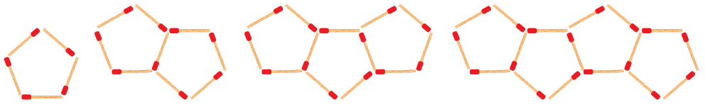

- Complete the table of values.
Number of shapes $x$ | 1 | 2 | 3 | 4
Number of matches $y$

- Determine an equation that relates the two quantities.

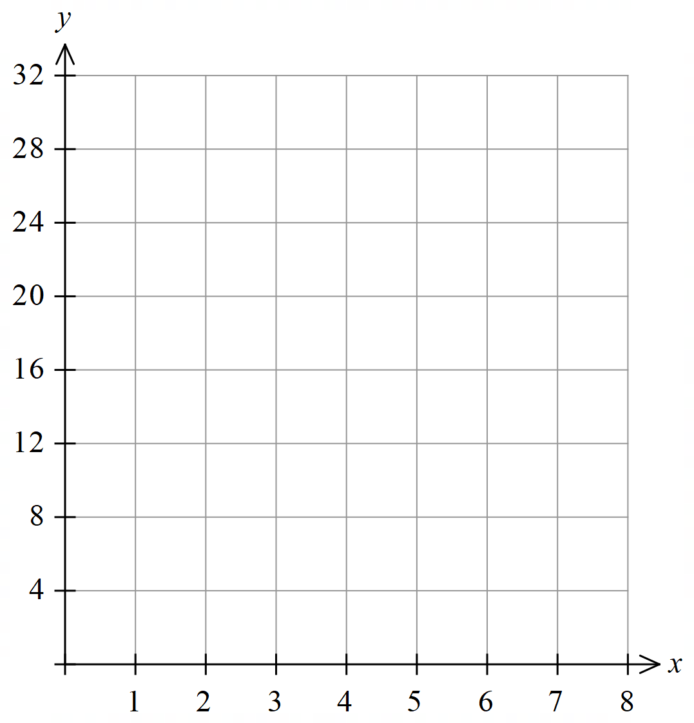
- Graph the relationship on the Cartesian Plane

- Guided Practice

Complete the table of values.
Number of shapes $x$ | 1 | 2 | 3 | 4
Number of matches $y$
4, 7, 10, 13
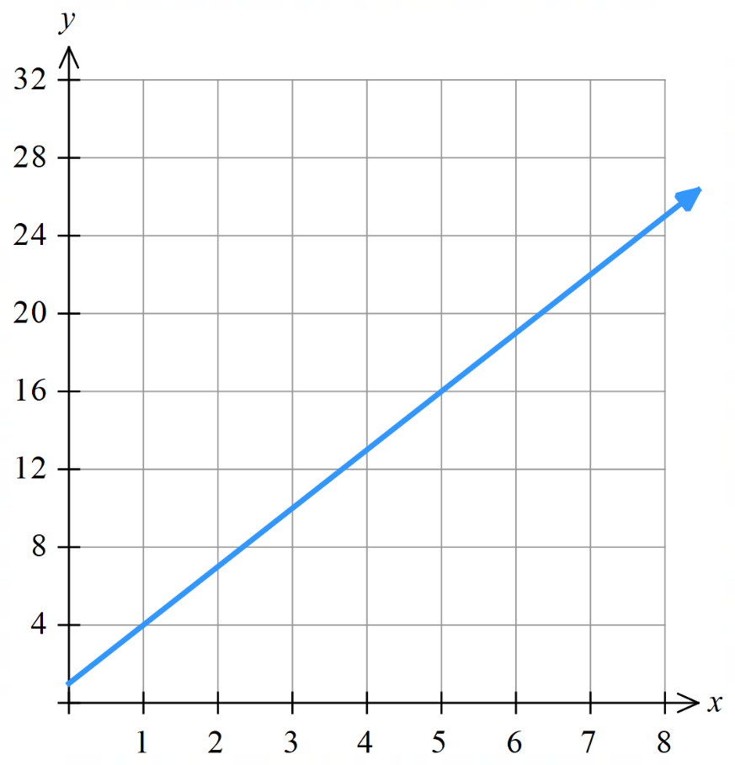
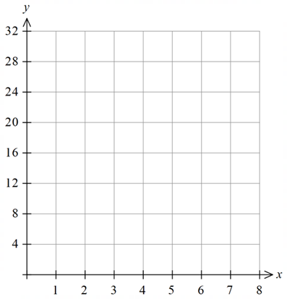
Determine an equation that relates the two quantities.

$y=3x+1$
Graph the relationship on the Cartesian Plane.

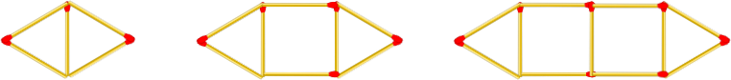

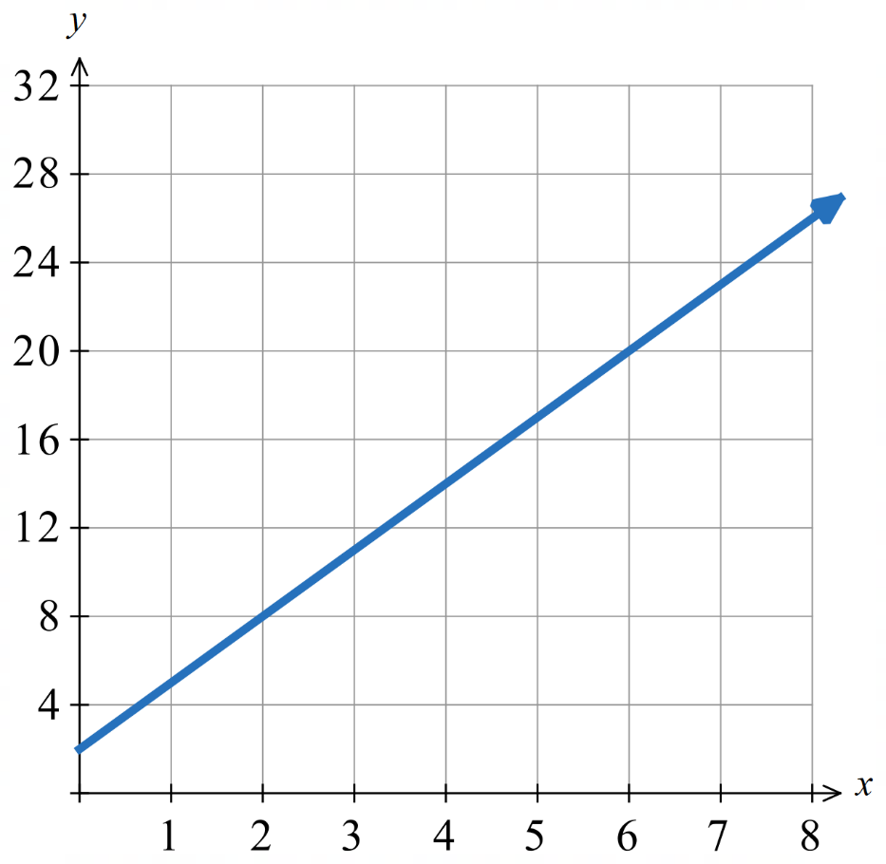
Table: Graph:
$$x$$ | 1 | 2 | 3 | 4
$$y$$
5, 8, 11, 14
Equation:

$y=3x+2$

- Key Ideas
- Linear relationships can be represented by a matchstick pattern.
- $m$ is the number of matches each shape ………, $c$ is the number of matches for ‘………’ shapes.

Foundation

Table: Graph:
$$x$$ | 1 | 2 | 3
$$y$$
$3, 5, 7$
Equation:
………………………………………………………
$y=2x+1$

  - Complete the table of values.
Number of shapes $x$ | 1 | 2 | 3 | 4
Number of matches $y$
5, 10, 15, 20
  - Determine an equation that relates the two quantities.
Number of matches $=$ ………………………………………
$y=$ …………
$$y = 5x$$
  - Graph the relationship
on the Cartesian Plane.

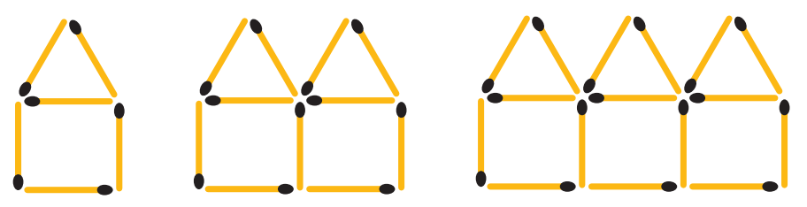

Table: Graph:
$$x$$ | 1 | 2 | 3
$$y$$
$6, 11, 16$
Equation:
………………………………………………………
$$y=5x+1$$

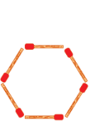
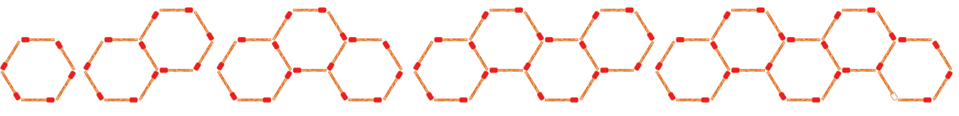
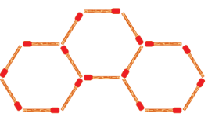

Table: Graph:
$$x$$ | 1 | 2 | 3 | 4
$$y$$
6, 11, 16, 21
Equation:
………………………………………………………
$$y=5x+1$$

- What do you notice about the equation of Q3 and Q4 above?
………………………………………………………………………………………………………………
They are the same.

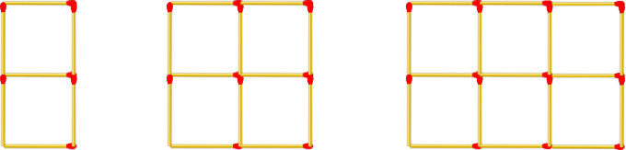

Table: Graph:
$$x$$ | 1 | 2 | 3
$$y$$
7, 12, 17
Equation:
………………………………………………………
$$y=5x+2$$



Table: Graph:
$$x$$ | 1 | 2 | 3
$$y$$
8, 11, 14
Equation:
………………………………………………………
$$y=3x+5$$

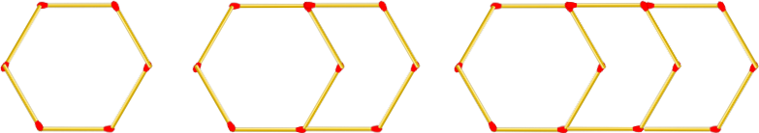

Table: Graph:
$$x$$ | 1 | 2 | 3
$$y$$
6, 10, 14
Equation:
………………………………………………………
$$y=4x+2$$

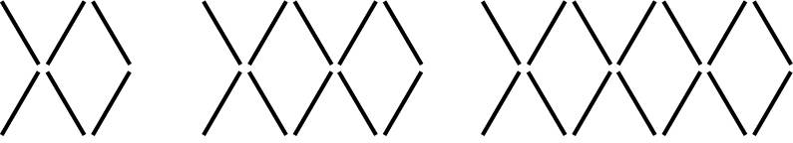

Table: Graph:
$$x$$ | 1 | 2 | 3
$$y$$
6, 10, 14
Equation:
………………………………………………………
$$y=4x+2$$

- $x$ is “number of tables”
$y$ is “number of chairs”
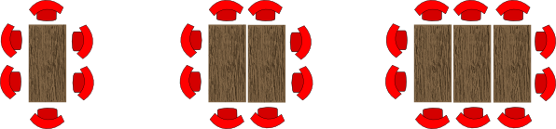

Table: Graph:
$$x$$ | 1 | 2 | 3
$$y$$
6, 8, 10
Equation:
………………………………………………………
$$y=2x+4$$

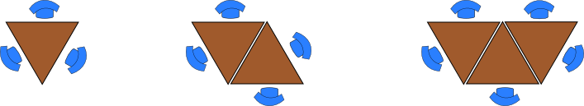

Table: Graph:
$$x$$ | 1 | 2 | 3
$$y$$
3, 4, 5
Equation:
………………………………………………………
$$y=x+2$$

Applying the Equation

- Review
- Substitute into a formula and solve
- $y=3x+5$  Find $y$ when $x=4$ | - $y=4x+3$  Find $y$ when $x=10$
- $y=3x+5$  Find $x$ when $y=35$ | - $y=4x+3$  Find $x$ when $y=23$

- Using the Equation to Make Predictions
We can use the equation to make predictions without having to draw out the entire pattern.
1. Identify whether you are given $x$ or $y$.
2. Substitute into the equation and solve.

- Example Apply the equation of a linear relationship to make predictions
Consider the pattern of pentagons and matches.
The equation is $y=4x+1$
$x$ is number of pentagons
$y$ is number of matches

If we want to make 25 pentagons, how many matches do we need?  Let $x=25$  $y=4x+1$  $=4(25)+1$  $=101$  We need 101 matches to make 25 pentagons. | If we have 73 matches, how many pentagons can we make?  Let $y=73$  $73=4x+1$  $72=4x$  $18=x$  We can make 18 pentagons with 73 matches.
- Guided Practice
The rule relating number of triangles and number of matches is
$$y=2x+1$$
$x$ is number of triangles
$y$ is number of matches

- How many matches do we need to make 36 triangles?  73 | - How many triangles can we make with 27 matches?  13
Find the equation relating $x$ and $y$, then use the equation to find the missing values.

  - Complete the table of values.
Number of tables $x$ | 1 | 2 | 3
Number of chairs $y$
6, 8, 10
  - Determine an equation that relates the two quantities.

$$y=2x+4$$
- If we want 36 tables,  how many chairs do we need?  Let …… $=$ ………  76 | - If we have 42 chairs,  how many tables can we have?  Let …… $=$ ………  19

Foundation
- This matchstick pattern has the equation $y=5x+1$
$x$ is number of ‘houses’
and $y$ is number of matchsticks

- How many matchsticks do you need to make 10 ‘houses’?  $$51$$ | - How many houses can you make with 86 matchsticks?  $$17$$

  - Complete the table of values.
Number of shapes $x$ | 1 | 2 | 3
Number of matches $y$
  - Determine an equation that relates the two quantities.

$$y=3x$$
  - How many matches are needed for a pattern with 14 triangles?
Let …… $=$ ………
…………………………
…………………………
………………………… …………………………………………………………………………
42 matches
  - How many triangles can we make with 120 matches?
Let …… $=$ ………
…………………………
…………………………
………………………… …………………………………………………………………………
$40$ triangles

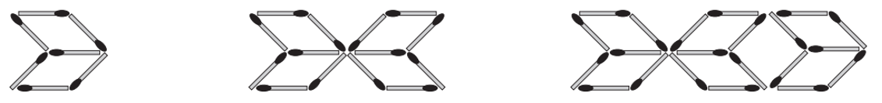

  - Complete the table of values.
$$x$$ | 1 | 2 | 3 | 4 | 5
$$y$$
  - Determine an equation that relates the two quantities.

$$y=7x$$
  - How many matches are needed for a pattern with 10 shapes?
Let …… $=$ ………
…………………………
…………………………
………………………… …………………………………………………………………………
70 matches
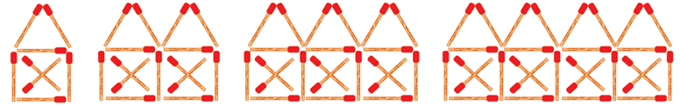

  - Complete the table of values.
$$x$$ | 1 | 2 | 3 | 4 | 5
$$y$$

  - Determine an equation that relates the two quantities.

$$y=7x+1$$
  - How many matches are needed for a pattern with 30 “houses”?
Let …… $=$ ………
…………………………
…………………………
………………………… …………………………………………………………………………
211 matches

Development
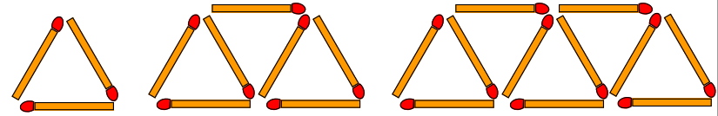

1 wide 2 wide 3 wide
By first finding the equation of the pattern, determine how many matches are needed to make a shape 40 wide.
$$x$$
$$y$$

$$y=4x-1$$
159 matches

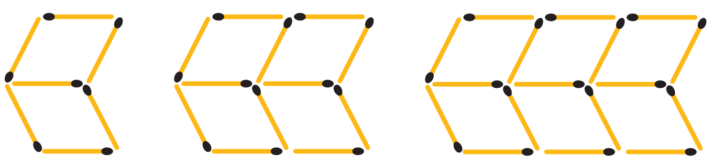

1 shape 2 shapes 3 shapes
By first finding the equation of the pattern, determine how many matches are needed to make 17 shapes.

$$y=5x+2$$
$87$ matches
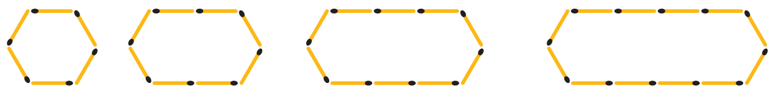

1 wide 2 wide 3 wide 4 wide
  - Determine the equation of the pattern.

$$y=2x+4$$

  - Determine how many matches are needed to make a shape 27 wide.

$$58$$
  - Determine the width of a shape that can be made with 136 matches.

$$66$$
- A pattern of towers is being assembled using blocks shown.


  - Determine the equation of the pattern, relating number of blocks $(y)$ to height $(x)$.

$$y=2x-1$$
  - Determine how many blocks would be needed for a tower 43 high.

85
  - Determine the height of a tower that can be made with 133 blocks.

67

Mastery
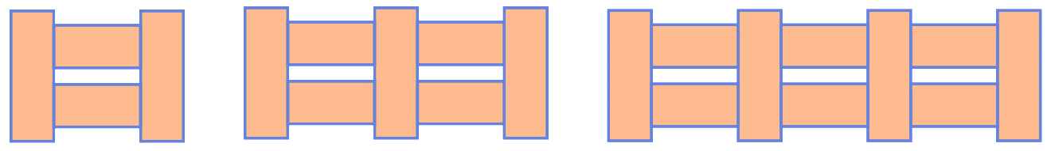
- Consider this fence.

1 section 2 sections 3 sections
  - Determine how many wooden planks are needed to make 20 fence sections.

61
  - Determine how many fence sections can be made with 34 wooden planks.

11

- Consider this table arrangement.

  - Determine how many chairs are needed for 10 tables in a straight line.

32
  - The tables are to be arranged in a single straight line for a picnic.
How many tables are needed to seat 65 people?

21
- 2007 HSC Maths Standard 2 Band 6
Chris started to make this pattern of shapes using matchsticks.
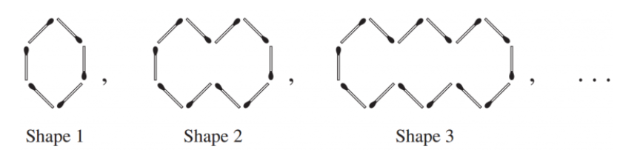

If the pattern of shapes is continued, which shape would use exactly 486 matchsticks?

121st shape
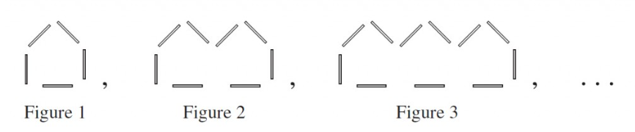
- 2011 HSC Maths Standard 2 Band 5

Is it possible to create a figure in this pattern using exactly 543 sticks?
Show suitable calculations to support your answer.

$$y=3x+2$$
$$543=3x+2$$
$$3x=541$$
$$x=180.333…$$
No, as $x$ is not a whole number.
- A tiling pattern is made from surrounding a row of shaded tiles with unshaded tiles.


1 shaded 2 shaded 3 shaded 4 shaded

  - Determine the total number of tiles needed to make a pattern with 23 shaded tiles.

75
  - Determine the number of shaded tiles in a pattern with 45 total tiles.

13
  - Determine how many unshaded tiles would be in a pattern with 17 shaded tiles.

40
  - Determine how many unshaded tiles would be in a pattern with 72 total tiles.

50

Multiple Representations of Linear Relationships

- Linear Relationships
A linear relationship can be a pattern, a table of values, an equation, and coordinates forming a straight-line graph on a Cartesian plane.
Pattern | Table
  Pentagons $x$ | 1 | 2 | 3 | 4
  Matches $y$ | 5 | 9 | 13 | 17
Equation  $$y=4x+1$$ | 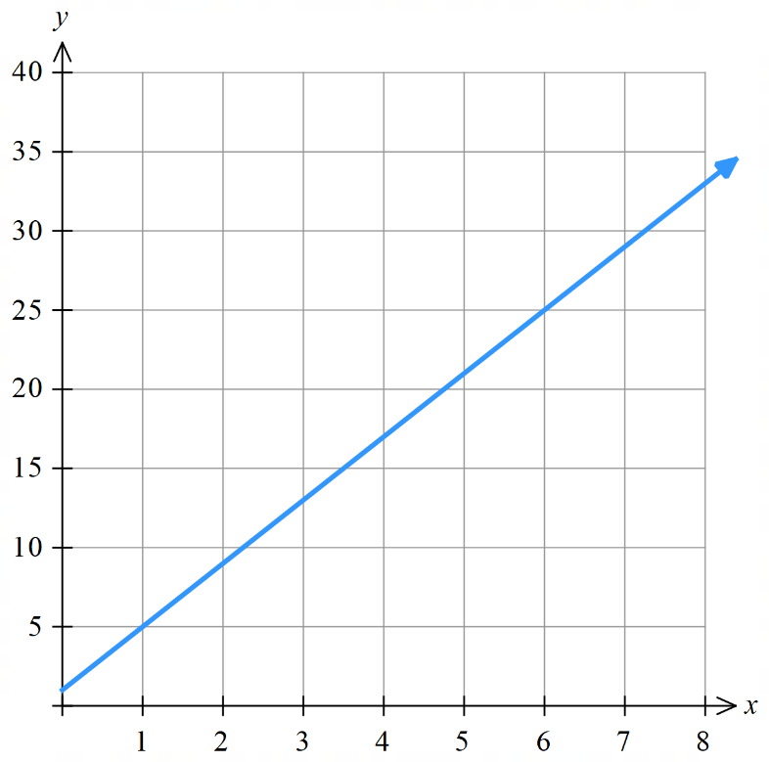  Straight-line Graph

Foundation

Pattern: | Table:
  Squares $x$ | 0 | 1 | 2 | 3 | 4
  Matches $y$ | 1 | 4 | 7 | 10 | 13
Equation:  $$y=3x+1$$ | 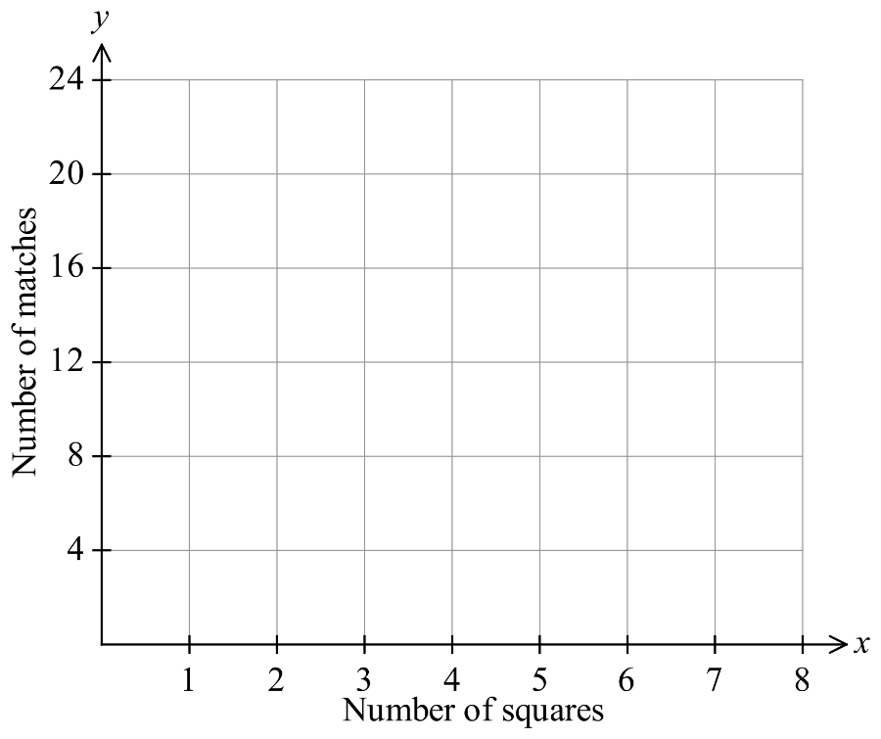  Graph:

Sequence: | Table:
  $$x$$ | 0 | 1 | 2 | 3 | 4
  $$y$$ | 0 | 5 | 10 | 15 | 20
Equation:  $$y=5x$$ | 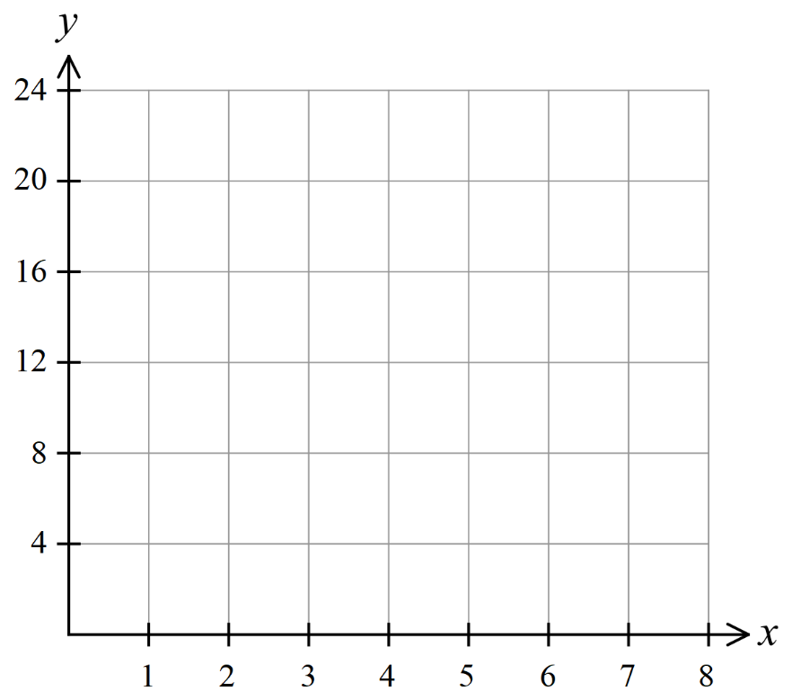  Graph:

Pattern:  1st term 2nd term 3rd term 4th term | Table:
  Term $x$ | 0 | 1 | 2 | 3 | 4 | 5 | 43
  Value $y$ | 1 | 2 | 3 | 4 | 5 | 6 | 44
Equation:  $$y=x+1$$ | 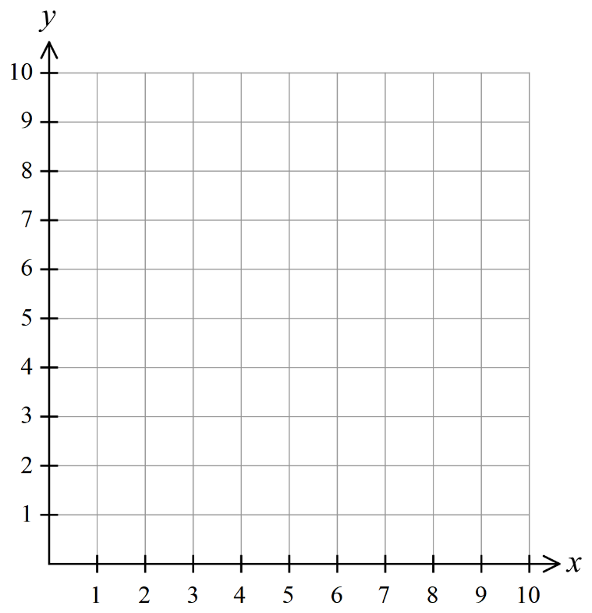  Graph:

Pattern:  1st term 2nd term 3rd term 4th term | Table:
  $$x$$ | 0 | 1 | 2 | 3 | 4 | 5 | 17
  $$y$$ | –2 | 0 | 2 | 4 | 6 | 8 | 32
Equation:  $$y=2x-2$$ | Graph:  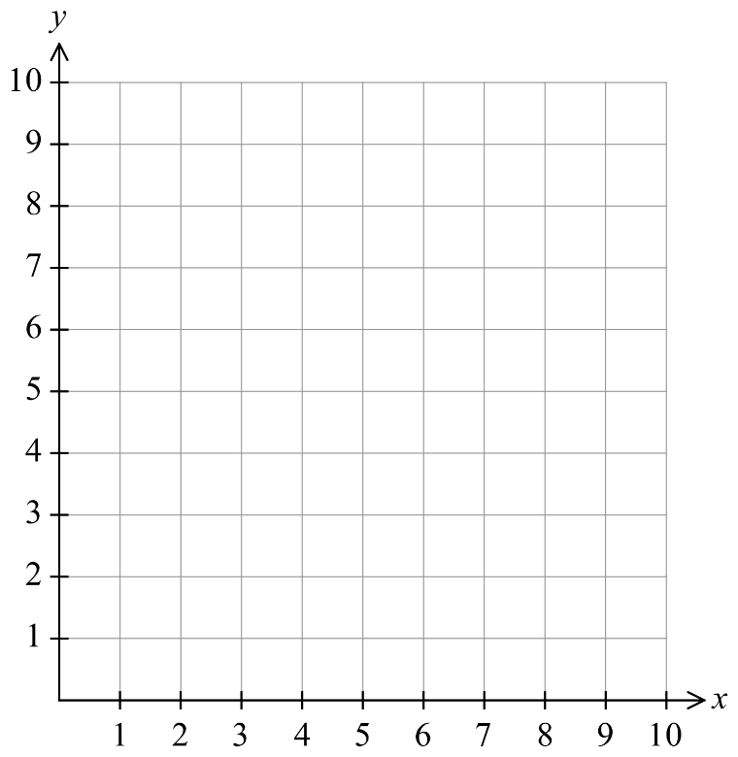

Pattern:  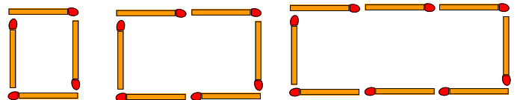  1st term 2nd term 3rd term | Table:
  $x$ | 0 | 1 | 2 | 3 | 4 | 5 | 18
  $y$ | 2 | 4 | 6 | 8 | 10 | 12 | 38
Equation:  $$y=2x+2$$ | Graph:

Pattern:    1st term 2nd term 3rd term 4th term | Table:
  $x$ | 0 | 1 | 2 | 3 | 4 | 5 | 17
  $y$ | 7 | 6 | 5 | 4 | 3 | 2 | $$-10$$
Equation:  $$y=-x+7$$ | Graph:

Development

Pattern:  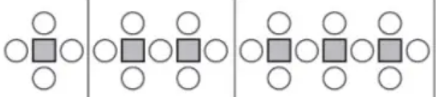 | Table:
  $$x$$ | 0 | 1 | 2 | 3 | 4 | 5 | 9
  $$y$$ | 1 | 4 | 7 | 10 | 13 | 16 | 28
Equation:  $$y=3x+1$$ | Graph:
- For this question, fill in every section by first looking at the table.
Table:  Equation:  $$y=4x$$ | Graph:
  $$x$$ | 0 | 1 | 2 | 3 | 4 | 21 | 19
  $$y$$ | 0 | 4 | 8 | 12 | 16 | 84 | 76
- Fill in every section by first looking at the table.
Table:  Equation:  $$y=3x+2$$ | Graph:
  $$x$$ | 0 | 1 | 2 | 3 | 4 | 81 | 60
  $$y$$ | 2 | 5 | 8 | 11 | 14 | 245 | 182

- Fill in every section by first looking at the table.
Table:  Equation:  $$y=-4x+17$$ | Graph:
  $$x$$ | 0 | 1 | 2 | 3 | 4 | $$-4$$ | $$-17$$
  $$y$$ | 17 | 13 | 9 | 5 | 1 | 33 | $$85$$

- Fill in every section by first looking at the graph.
Table:  Equation:  $$y=2x+1$$ | 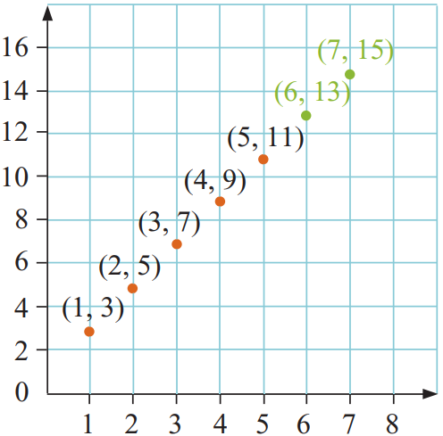  Graph:
  $$x$$ | 1 | 2 | 3 | 4 | 5 | 6 | 7
  $$y$$ | 3 | 5 | 7 | 9 | 11 | 13 | 15

- Fill in every section by first looking at the graph.
Table:  Equation:  $$y=3x-2$$ | 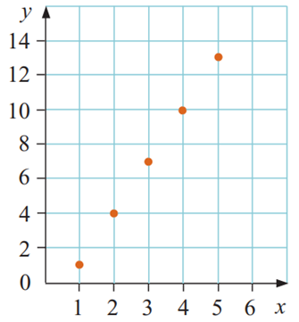  Graph:
  $$x$$ | 1 | 2 | 3 | 4 | 5
  $$y$$ | 1 | 4 | 7 | 10 | 13

- Fill in every section by first looking at the graph.
Table:  Equation:  $$y=-2x+6$$ | 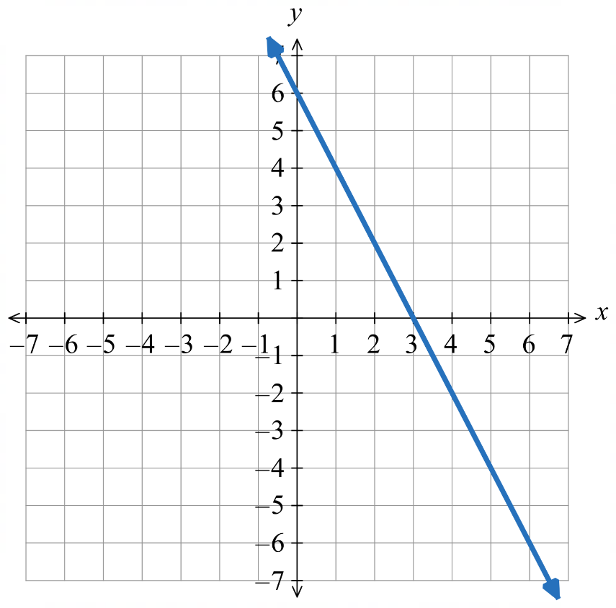  Graph:
  $$x$$ | 0 | 1 | 2 | 3
  $$y$$ | 6 | 4 | 2 | 0

- Fill in every section by using the equation
Table:  Equation:  $$y=5x-3$$ | 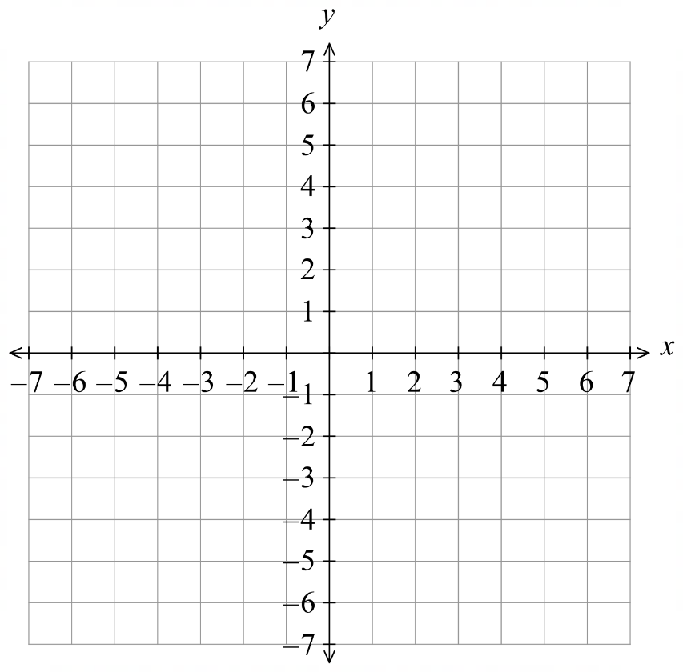  Graph:
  $$x$$ | 0 | 1 | 2 | 3 | 4
  $$y$$ | $$-3$$ | 2 | 7 | 12 | 17

- Fill in every section by using the equation
Table:  Equation:  $$y=-2x+1$$ | Graph:
  $$x$$ | 0 | 1 | 2 | 3 | 4
  $$y$$ | $$1$$ | $$-1$$ | $$-3$$ | $$-5$$ | $$-7$$

Linear Relationships in Real Life Contexts

- Variables
A variable is a quantity that can change.
Examples: Weight $w$, cost $c$, time $t$, distance $d$, speed $s$

The dependent variable depends on another variable.
It is the second row of a table of values.
It is the $y$ axis of a graph.
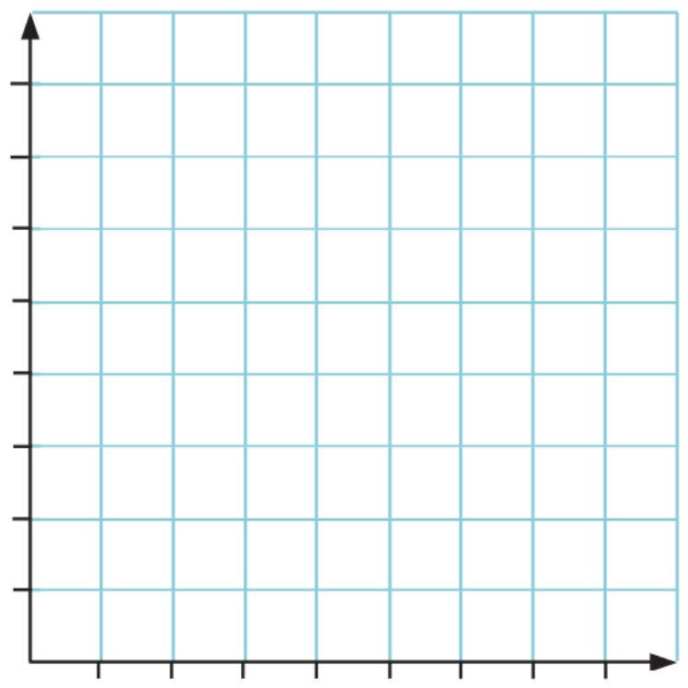
Independent Variable
Dependent Variable
The independent variable does not depend on anything.
It is the first row of a table of values.
It is the $x$ axis of a graph.

Independent variable $x$ | 0 | 1 | 2 | 3
Dependent variable $y$ | 3 | 5 | 7 | 9

- Key Ideas
- The independent variable is the first ………… of a table of values and always goes on the …… axis.
- The dependent variable is the second …………… of a table of values and always goes on the …… axis.
- For matchstick patterns:
  - The number of matches was the ………………… variable.
  - The number of shapes was the ………………… variable.
- For age and height:
  - ………… is the dependent variable, since it changes based on ……………
  - ………… is the independent variable, since it doesn’t depend on anything.
- If you graph the dependent and independent variable, and you can draw a straight line through all the coordinates, then we say that the variables have a …………… relationship.

- Investigation Real life contexts and linear relationships
A taxi has a $10 hiring fee (also called a ‘flag fall’ fee) and costs $4 per kilometre.

Independent variable $x$: ………………………………………………
Dependent variable $y$: ………………………………………………

Complete the table of values.
Distance travelled $x$ | 0 | 1 | 2 | 3 | 4
Cost $y$

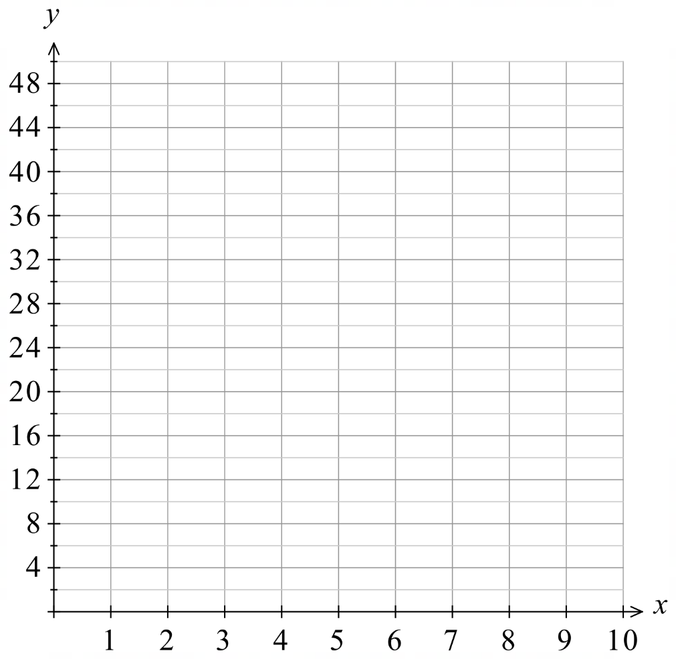
Determine an equation that relates the two quantities.

Graph the relationship on the Cartesian Plane

Find the cost of a journey of 25 km in distance.

Find how far you can travel for $70.

- Guided Practice
The cost of a taxi is $5 to start and $3 per kilometre.
Independent variable  Distance in km  Dependent variable  Cost in $ | 5, 35, 65, 95
  ……………… $x$ | 0 | 10 | 20 | 30
  ……………… $y$
Equation  $$y=3x+5$$  Find the cost of travelling 15 km.  $50  Find how far you could travel with $80  25 km | Graph  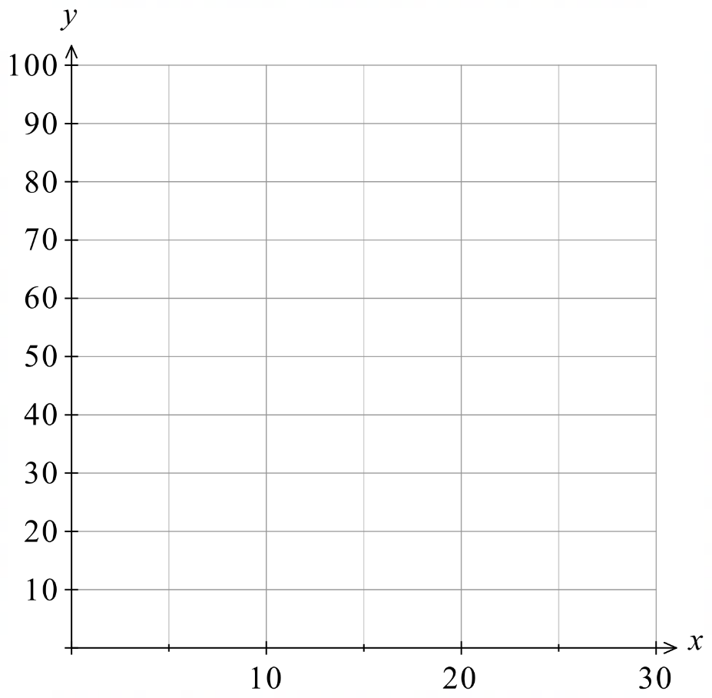
A candle starts at 100 cm and decreases in height by 4 cm per hour.
Independent variable  Time in hours  Dependent variable  Height in cm | 100, 96, 92, 88
  ……………… $x$ | 0 | 1 | 2 | 3
  ……………… $y$
Equation  $$y=-4x+100$$  Find how long it takes for the candle to completely burn out.  25 hours  Find the height of the candle after 15 hours.  40 cm | Graph

Foundation

Scenario:  The cost of travelling in a hire car is $10 booking fee plus $6 per kilometre.  Independent variable  Distance (km)  Dependent variable  Cost ($) | Graph:  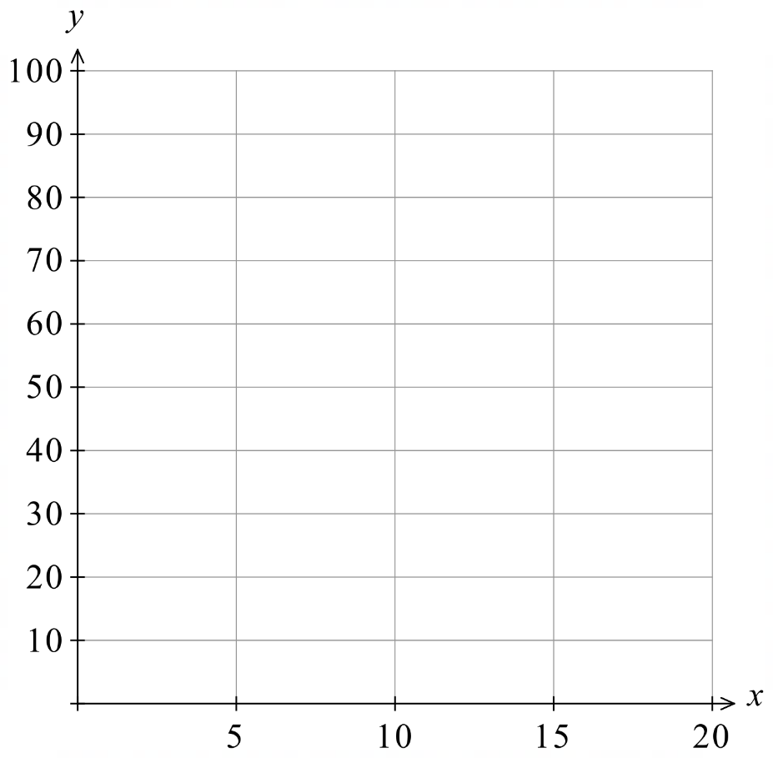
Table:
………… $x$  Distance (km) | 0 | 5 | 10 | 15
………… $y$  Cost ($) | 10 | 40 | 70 | 100

Equation:
$$y=6x+10$$
- Find the cost of a 25 km journey.  $160 | - How far can the car be driven for $60?  8.333… km

Scenario:  Oranges are sold for $3.00 per kilogram  Independent variable  Mass (kg)  Dependent variable  Cost ($) | 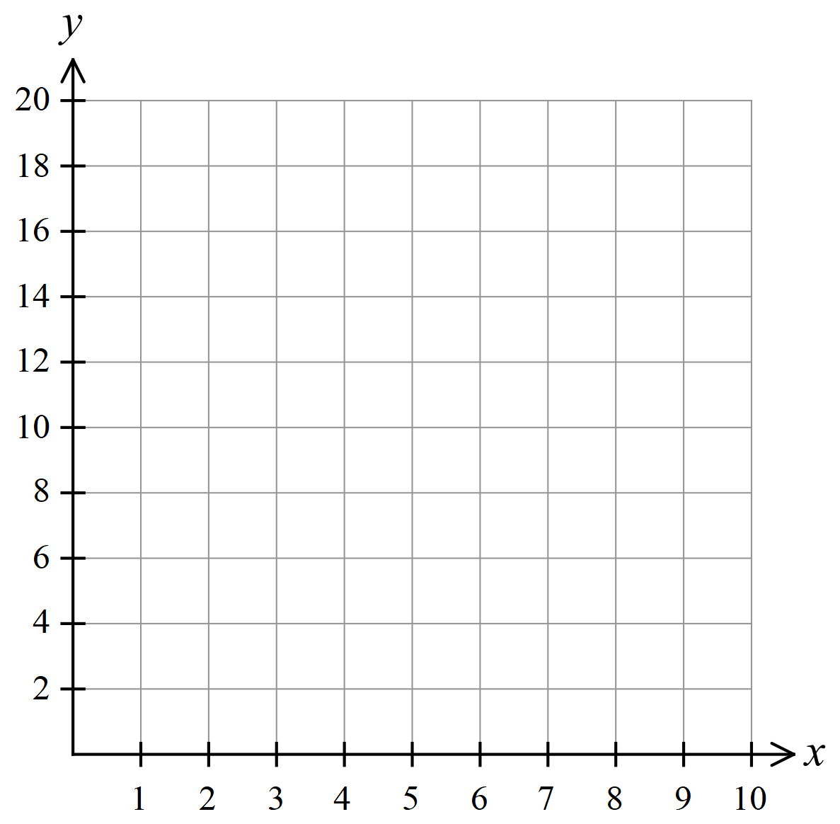  Graph:
Table:
………… $x$  Mass (kg) | 0 | 1 | 2 | 3 | 4
………… $y$  Cost ($) | 0 | 3 | 6 | 9 | 12

Equation:

$$y=3x$$
- Find the cost of 17 kg of oranges.  $51 | - Find how many kilograms of oranges could be purchased for $21.90  7.3 kg

Development

Scenario:  The cost of hiring a plumber is $80 call out fee and $240 per hour.  Independent variable  Time (hours)  Dependent variable  Cost ($) | 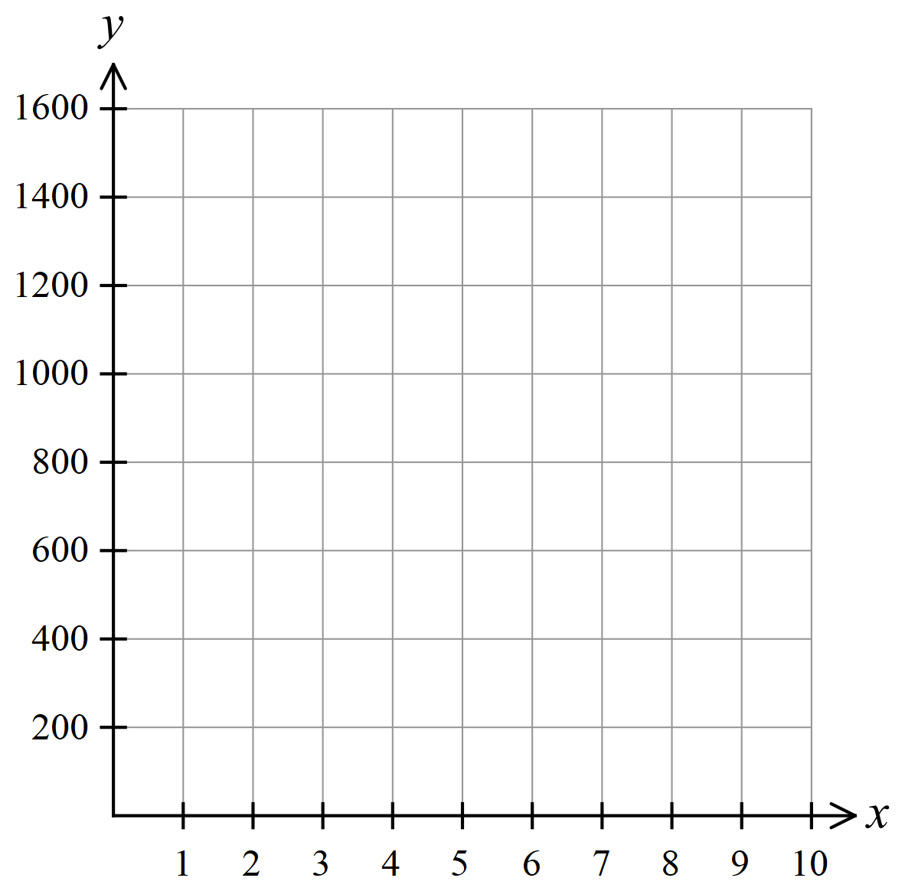  Graph:
Table:
………… $x$  Time (h) | 0 | 1 | 2 | 3 | 4
………… $y$  Cost ($) | 80 | 320 | 560 | 800 | 1040

Equation:
$$y=240x+80$$
- How much does it cost for a 3.5-hour job?  $920 | - How long can you afford the plumber for if you have $200?  30 minutes

Scenario:  A car uses 3 L of fuel per hour.  Its fuel tank initially holds 32 L.  Independent variable  Time (h)  Dependent variable  Fuel (L) | 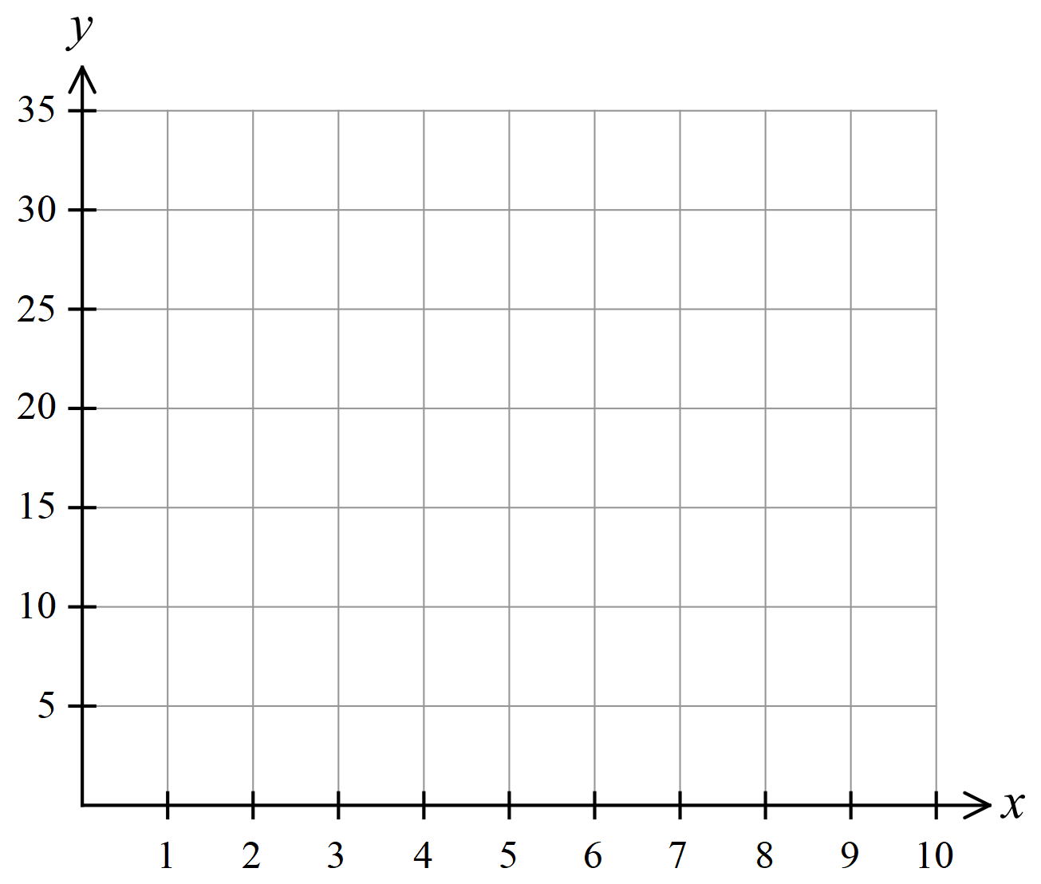  Graph:
Table:
………… $x$  Time (h) | 0 | 1 | 2 | 3 | 4
………… $y$  Fuel (L) | 32 | 29 | 26 | 23 | 20

Equation:
$y=-3x+32$ or $y=32-3x$
- How much fuel would be left after  4 hours 30 minutes?  18.5 L | - When exactly, to the nearest minute, will the car run out of fuel?  10 h 40 min

Scenario:  A candle starts off 3 cm tall and decreases by half a centimetre every minute.  Independent variable  Time (min)  Dependent variable  Height (cm) | Graph:  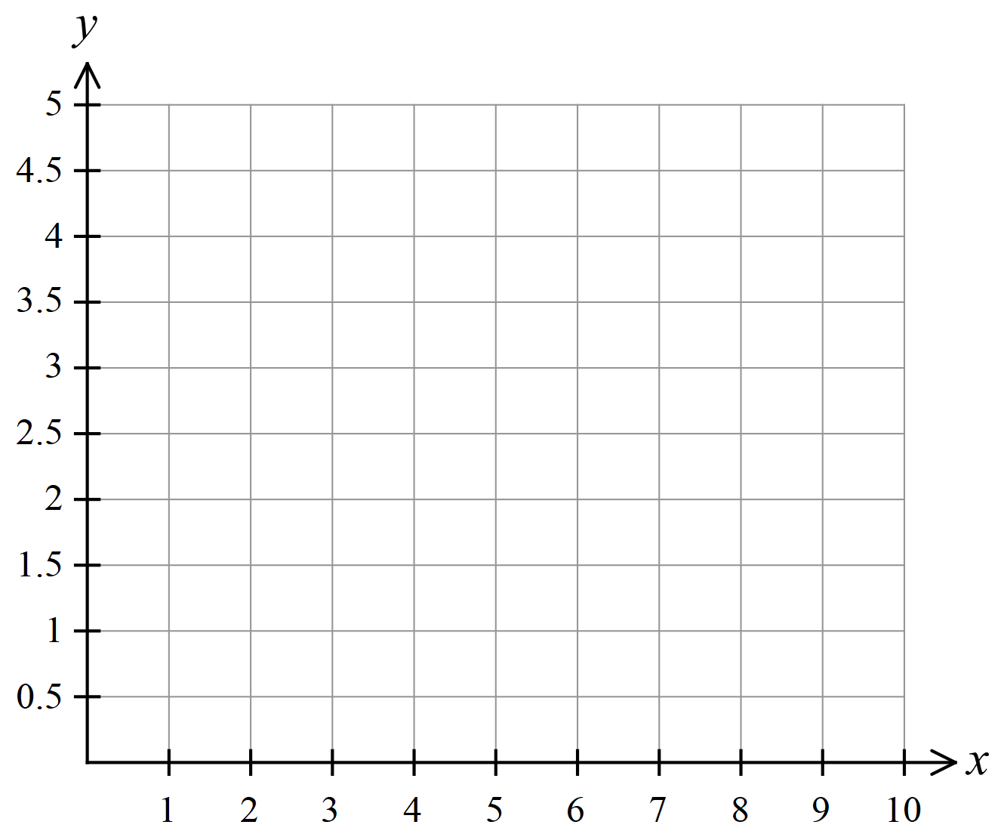
Table:
………… $x$  Time (min) | 0 | 1 | 2 | 3 | 4
………… $y$  Height (cm) | 3 | 2.5 | 2 | 1.5 | 1

Equation:
$$y=-\frac{x}{2}+3 or y=3-\frac{x}{2}$$
- How tall is the candle after 15 minutes?

–4.5 cm
- Based on your answer to part a, what might be a limitation of this model?
The formula predicts a negative height, which is not possible.
This model is only valid for positive values of $x$ and $y$

Scenario:  A water tank initially holds 20 L of water. During a rainstorm, its volume increases by  4 L per hour.  Independent variable  Time (hr)  Dependent variable  Volume (L) | Graph:  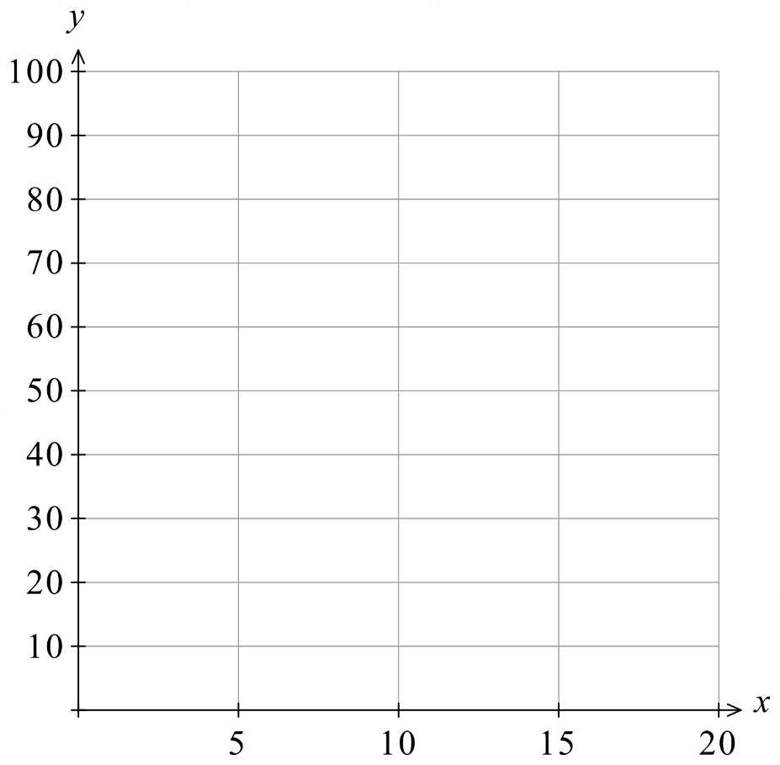
Table:
………… $x$  Time (hr) | 0 | 5 | 10 | 15 | 20
………… $y$  Volume (L) | 20 | 40 | 60 | 80 | 100

Equation:
$$y=4x+20$$
- How long would it take to fill to 100 L?

20 hours
- Why might your answer to part a not be accurate in real life?

The water tank may not hold 100 L, and the rain may not last that long.

Mastery
- Write an equation for the following situations. Make the first listed pronumeral the subject.
  - $$D$ given $c$ cents
$$D=\frac{c}{100}$$
  - $d$ cm given $e$ metres
$$d=100e$$
  - The discounted price $$D$ that is 30% off the marked price $$M$
$$D=0.7M$$
  - The value of an investment $$V$ that is 15% more than the initial amount $$P$
$$V=1.15P$$
  - The cost $$C$ of hiring a car at $50 upfront plus $18 per hour for $t$ hours
$$C=50+18t$$
  - The distance $d$ km remaining in a 42 km marathon after $t$ hours if the running speed is 14 km/h
$$d=42-14t$$
  - The price $$P$ of a bottle of soft drink if $b$ bottles cost $$c$
$$P=\frac{c}{b}$$

- NAPLAN A
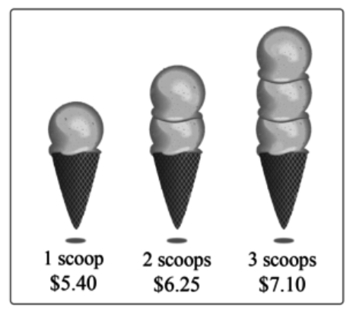
Each extra scoop of ice cream costs the same amount of money.
How much will an ice cream with 7 scoops cost?

each scoop costs $0.85
The equation is $y=0.85x+4.55$
$$∴\$10.50$$

- NAPLAN A
Sabre is saving to buy a new skateboard. After one week she has saved $11.
She then saves the same amount of money each week.
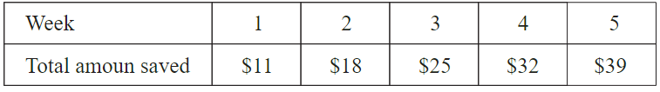

How much money will she have saved by the end of week 10?

$$y=7x+4$$
$$\$74$$
- NAPLAN A
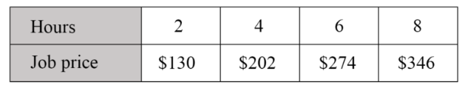
A plumber calculates the price of a job using a call out fee and an amount per hour.
This table shows some of the job prices. Determine the call out fee and amount per hour.

Amount per hour: $36
Call out fee: $58
- 2020 HSC Maths Standard 2 Band 5
A plumber charges a call-out fee of $90 as well as $2 per minute while working.
Suppose the plumber works for $t$ hours.
Which equation expresses the amount the plumber charges ($$C$) related to time ($t$ hours)?
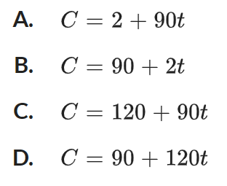

D

Comparing Linear Relationships

- Equation of a Linear Relationship
We have special words to describe parts of a linear equation.

$$y=mx+c$$
coefficient of $x$ constant term
gradient $y$-intercept
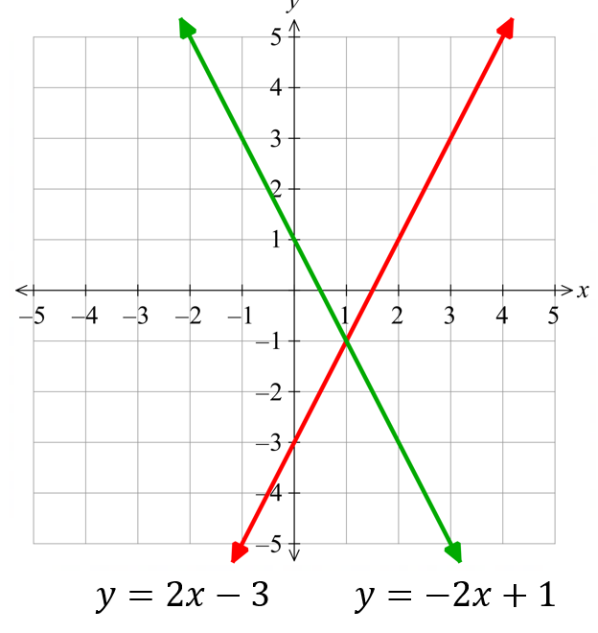
(steepness) (where the line crosses the $y$-axis)
If the coefficient of $x$ is positive,
the graph slopes upwards from left to right;
increasing graph.
If the coefficient of $x$ is negative,
the graph slopes downwards from left to right;
decreasing graph.

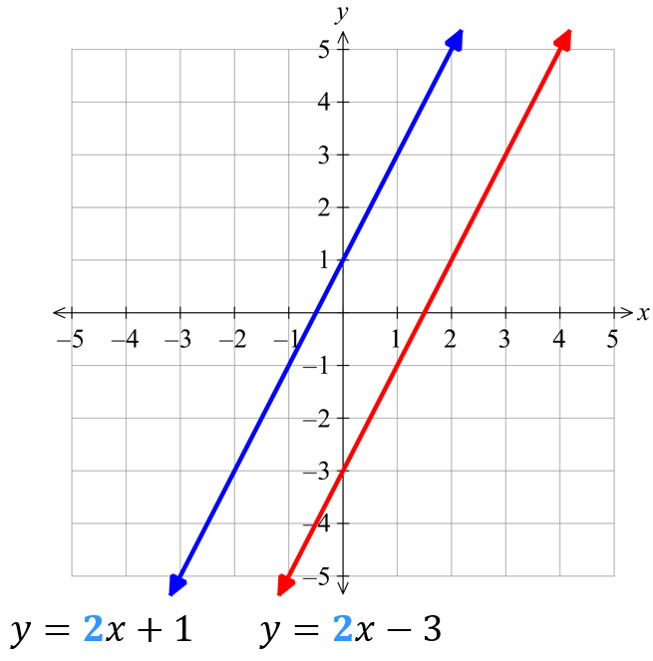
If two equations have the same coefficient,
then the lines are parallel.

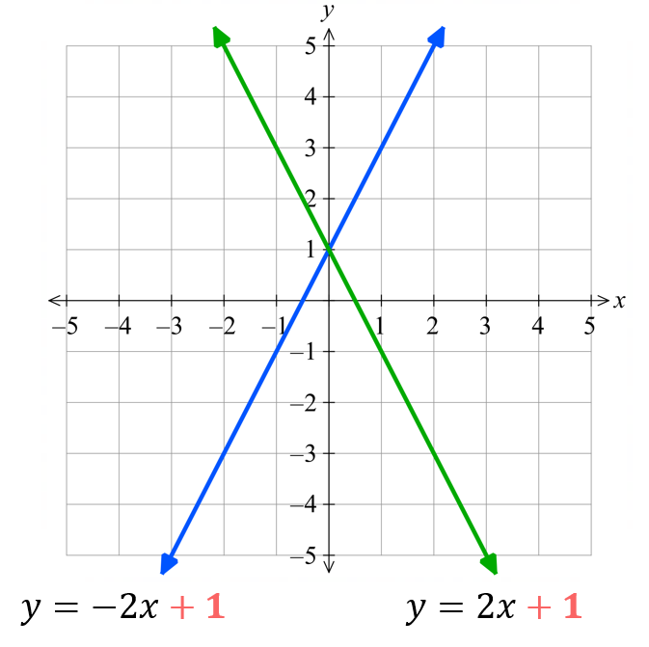
If two equations have the same constant term,
then the $y$-intercepts are the same.

- Identify Increasing and decreasing lines
When $m$ is positive, the line is increasing; it slopes up from left to right.
When $m$ is negative, the line is decreasing; it slopes down from left to right.
Decreasing  $$y=-2x+1$$  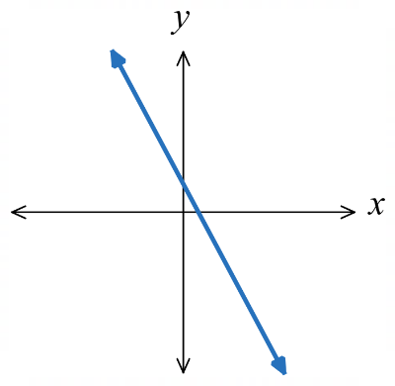 | 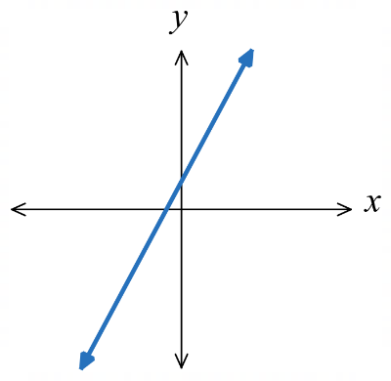  Increasing  $$y=2x+1$$ |  | 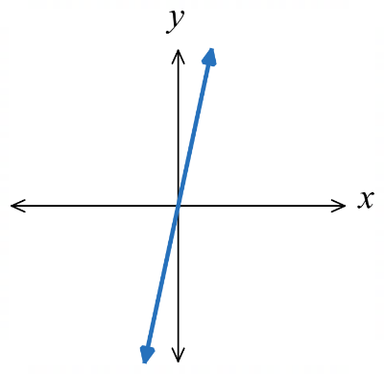  Increasing  $$y=5x$$ | 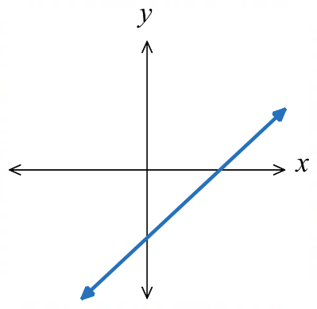  Increasing  $$y=x-3$$ |  | 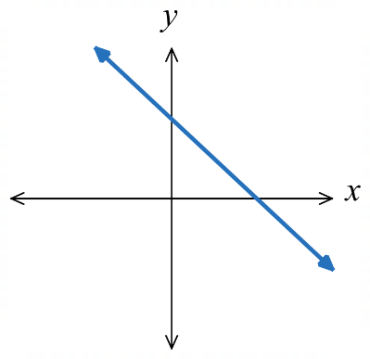  Decreasing  $$y=3-x$$
Identify whether these equations have increasing or decreasing graphs.
- $y=5x-12$ |  | - $y=-5x+12$ |  |  | - $y=12-5x$
- $y=-3x+11$ |  | - $y=$ $\frac{x}{2}$ $+4$ |  |  | - $y=-6+7x$

- Identify Parallel lines
Two lines with the same gradient $m$ are parallel; same direction and never meet.
Not parallel  $$y=2x+1$$  $$y=3x+1$$  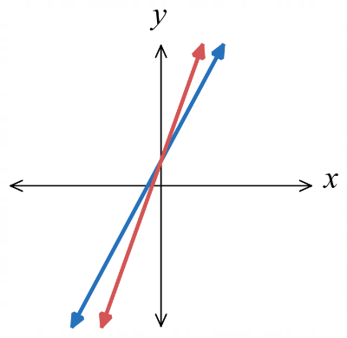 | 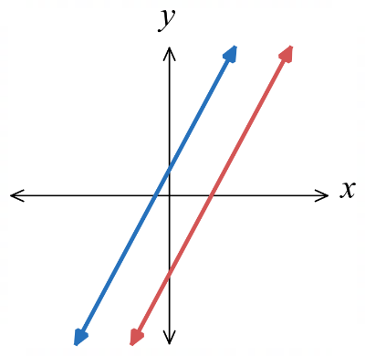  Parallel  $$y=2x+1$$  $$y=2x-3$$ |  | 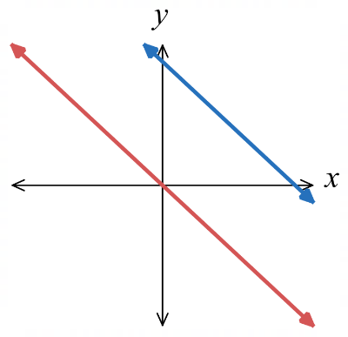  Parallel  $$y=5-x \\ y=-x$$ | 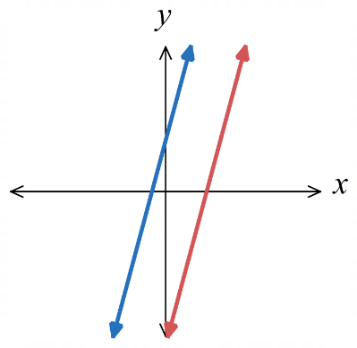  Parallel  $$y=4x+2 \\ y=-6+4x$$ |  | 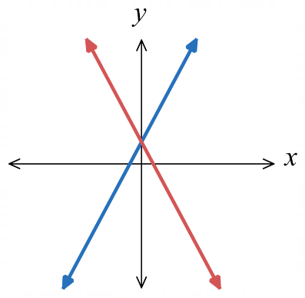  Not parallel  $$y=2x+1 \\ y=-2x+1$$
Decide whether these lines are parallel.
- $y=5x-12$  $$y=5x+48$$ |  | - $y=-5x+1$  $$y=5x+1$$ |  |  | - $y=\frac{x}{2}+11$  $$y=x+11$$
- $y=6-2x$  $$y=-2x$$ |  | - $y=4x+1$  $$y=4x$$ |  |  | - $y=12x-1$  $$y=21x+45$$
- Investigation Graphing software
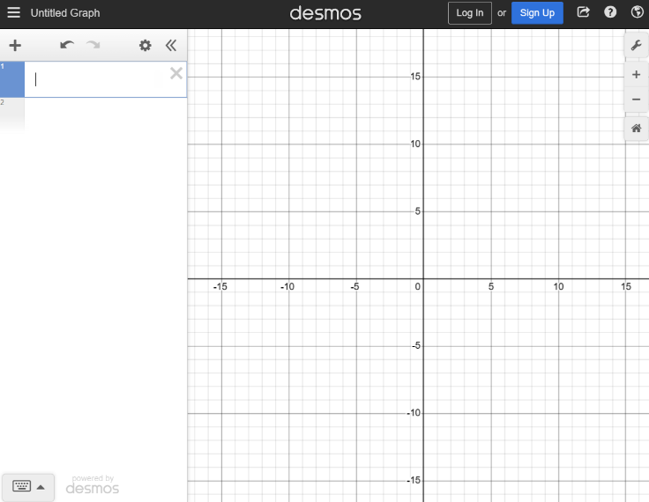
Go to
- www.desmos.com/calculator
your screen should look like the image.

On the left, type in $y=2x+1$
This will graph the equation. Use the mouse wheel to zoom in and out and hold down left click to move around.
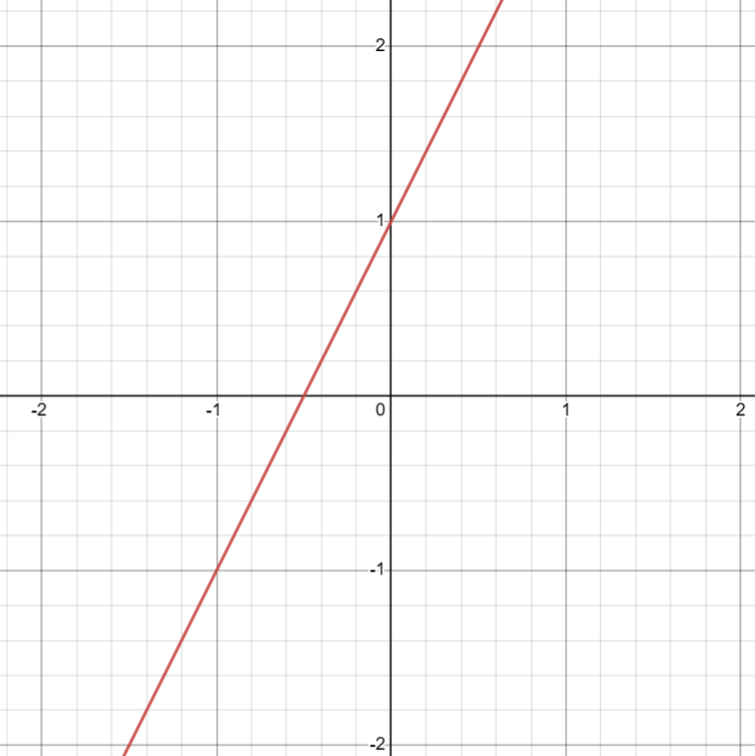
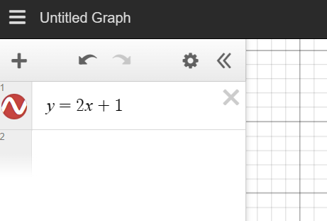

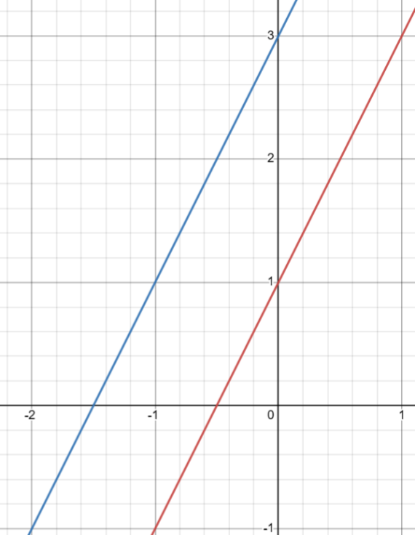
Below the first equation, type $y=2x+3$
This will graph both equations in different colours.
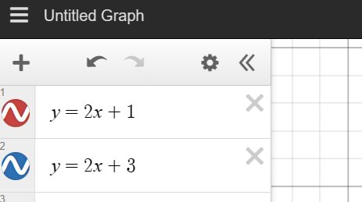

You can use the X button to remove the graphs.

Foundation
Using DESMOS, draw a sketch and explain the similarities and differences between the set of lines.
Use these words to describe the lines: gradient, parallel, increasing/decreasing, $y$-intercept
Use these words to describe the equations: coefficient, constant term

$y=4x+1$

$y=4x-3$

$y=4x$

These lines are all ………………… because the ………………… of $x$ are the same.
parallel, coefficient
The lines have different …………………… because the constant terms are different.
y-intercept

$y=2x+2$

$y=4x+2$

$y=7x+2$

The lines have the same ………………… because the …………… ………… are the same.
y-intercept, constant term
The lines have different ………………… because the …………………… of $x$ are not the same.
gradient, coefficient

$y=3x+1$

$y=-3x+1$

The lines both have the same ……………………………………………………………………………
y-intercept
because ……………………………………………………………………………………………………
the constant terms are the same
The lines have different ………………………………………………………………………………….
gradient
because ……………………………………………………………………………………………………
the coefficients of $x$ are different

$y=2x$

$y=-2x$

$y=2x$ is an increasing graph because the …………………… of $x$ is positive.
coefficient
$y=-2x$ is a …………… graph because ………………………………………………………………
decreasing, coefficient of $x$ is negative

$y=-2x+2$

$y=-2x+1$

$y=-2x-3$

The lines are all ………………… because they have the same ……………… of $x$.
parallel, coefficient
The lines are all decreasing because their coefficients are ……………………
negative
The lines have different ……………… because ………………… ………… are different.
y-intercept, constant terms are different

- Complete each statement:
  - All equations of a line have the form: ……………………
$$y=mx+c$$
  - $m$ is the c……………… of $x$ and represents the g………………., or steepness of the line.
coefficient, gradient
  - $c$ is the c………………… t……………… and represents the …-…………………, or where the line cuts the ……-axis.
constant term, y-intercept, y
  - The equations of parallel lines have the same ………………………
coefficient of $x$
  - Equations with the same ……………… ……… have graphs with the same $y$-intercept.
constant term
  - Linear equations with a positive coefficient of $x$ have graphs that are ………………………
increasing
  - Linear equations with a ………… coefficient of $x$ have graphs that are decreasing.
negative

Development
- Consider these three lines.
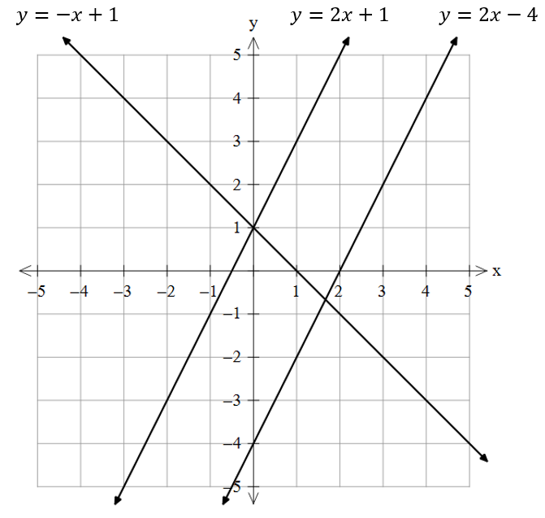
  - Which two lines are parallel?
What part of the equation tells you this?

$$y=2x+1, y=2x-4$$
Coefficients of $x$ are the same
  - Which two lines have the same $y$-intercept? What part of the equation tells you this?
$$y=-x+1, y=2x+1$$
Constant terms are the same

- Consider these lines.
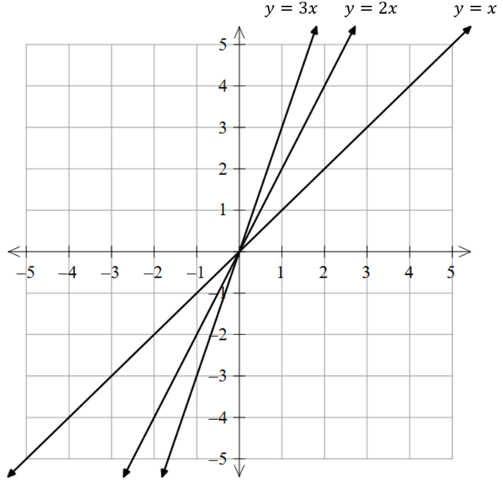  Which line is the steepest? ………………  $$y=3x$$  Which line is the least steep? ………………  $$y=x$$  How does the coefficient of $x$ tell you the steepness of a graph?  The larger the magnitude of the coefficient of $x$, the steeper | 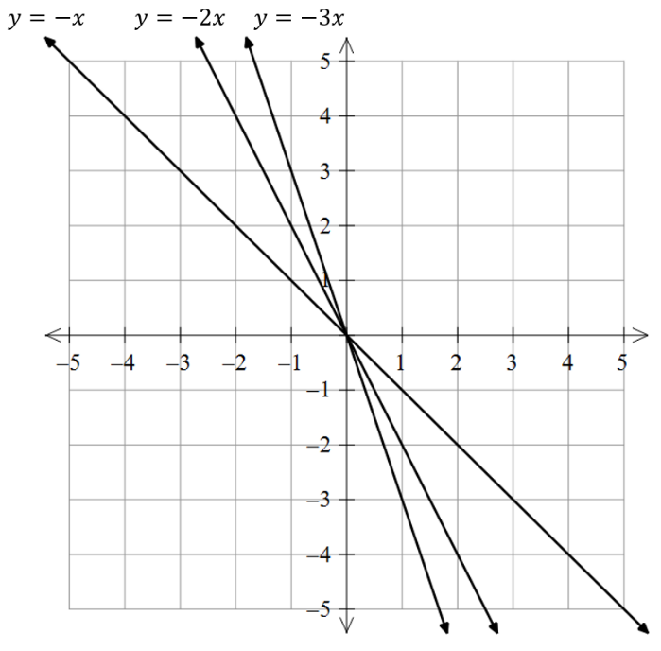  All the graphs in part a are increasing.  All the graphs shown here are decreasing.  What part of the equation tells you whether a graph is increasing or decreasing?  The sign of the coefficient of $x$
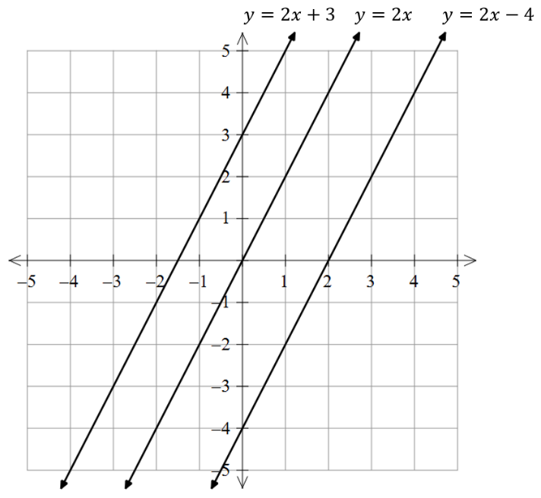  All of the lines are parallel.  What part of the equation tells you whether two or more lines will be parallel?  The coefficients of $x$ are the same  Write down the equation of any other line that is parallel to these lines.  Any other line in the form $y=2x+c$ | 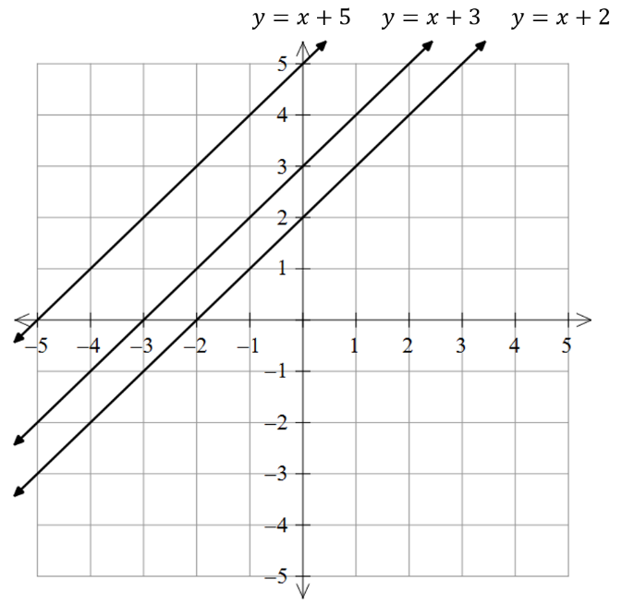  All these lines have a positive $y$-intercept. Describe what this means.  The lines meet the $y$-axis above the $x$-axis.  What part of the equation tells you the  $y$-intercept will be positive?  The constant terms are positive
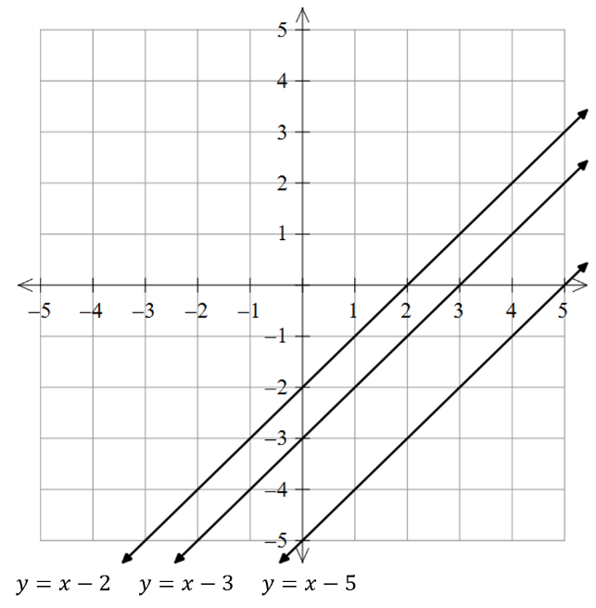  All these lines have a negative $y$-intercept. Describe what this means.  The lines meet the $y$-axis below the $x$-axis.  What part of the equation tells you the  $y$-intercept will be negative?  The constant terms are negative | 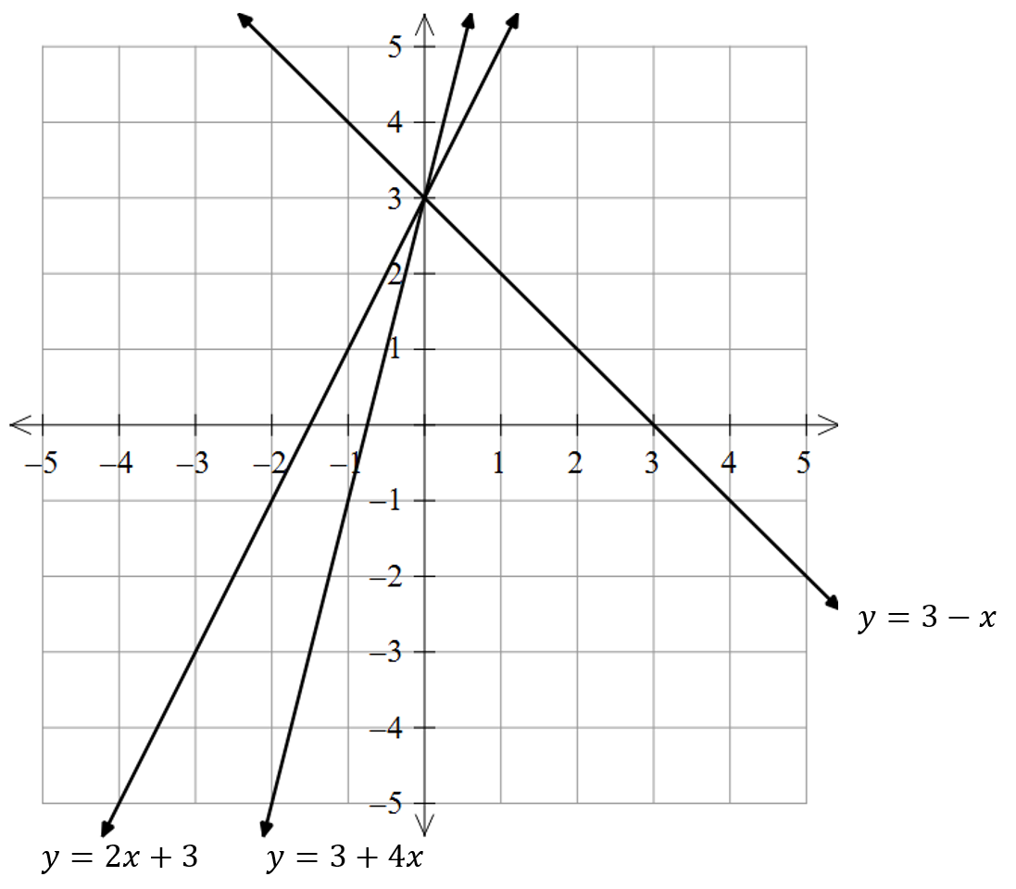  All of the lines have the same $y$-intercept. Explain what part of the equation tells you this.  The constant terms are the same  Write down the equation of any other line that has the same $y$-intercept.  Any other line in the form $y=mx+3$

Mastery
- Consider the lines:
$$y=2x+3, y=2x-4, y=-x+1, y=4x+3$$
  - Which lines are parallel?

$y=2x+3, y=2x-4$.
  - Which lines are increasing?

$$y=2x+3, y=2x-4, y=4x+3$$
  - Which lines have the same $y$-intercept?

$$y=2x+3, y=4x+3$$
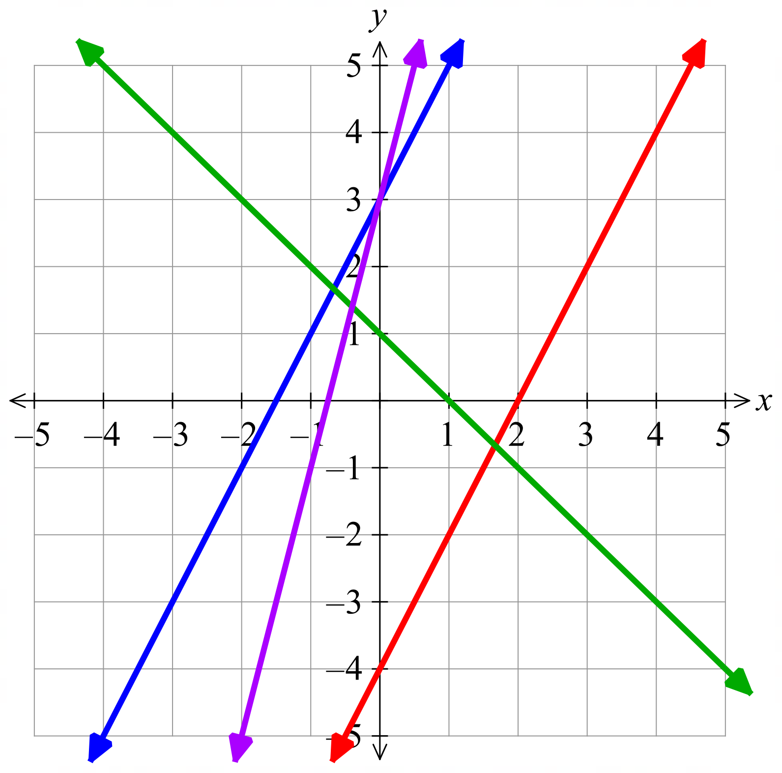
  - Label the four lines shown using the equations above.

Green: $y=-x+1$
Blue: $y=2x+3$
Purple: $y=4x+3$
Red: $y=2x-4$

- Consider the graph of $y=x+2$. Using DESMOS, or the rules, describe what is the same and what is different between that graph and these graphs.
Comparison | Same | Different
$y=x+2$  $y=x+1$ | Gradient | y-intercept
$y=x+2$  $y=2x+2$ | y-intercept | Gradient
$y=x+2$  $y=-x+2$ | y-intercept | Gradient
$y=x+2$  $y=x$ | Gradient | y-intercept
$y=x+2$  $y=x-2$ | Gradient | y-intercept

Solving Equations Graphically

- Review
- Verify whether a value is a solution to an equation
- Is $x=3$ a solution of  $2x+1=7$? | - Is $x=2$ a solution of $2x+1=7$? | - Is $x=2$, $y=5$ a solution to $y=2x+1$?
- Read a graph
The graph shows $y=2x+1$.
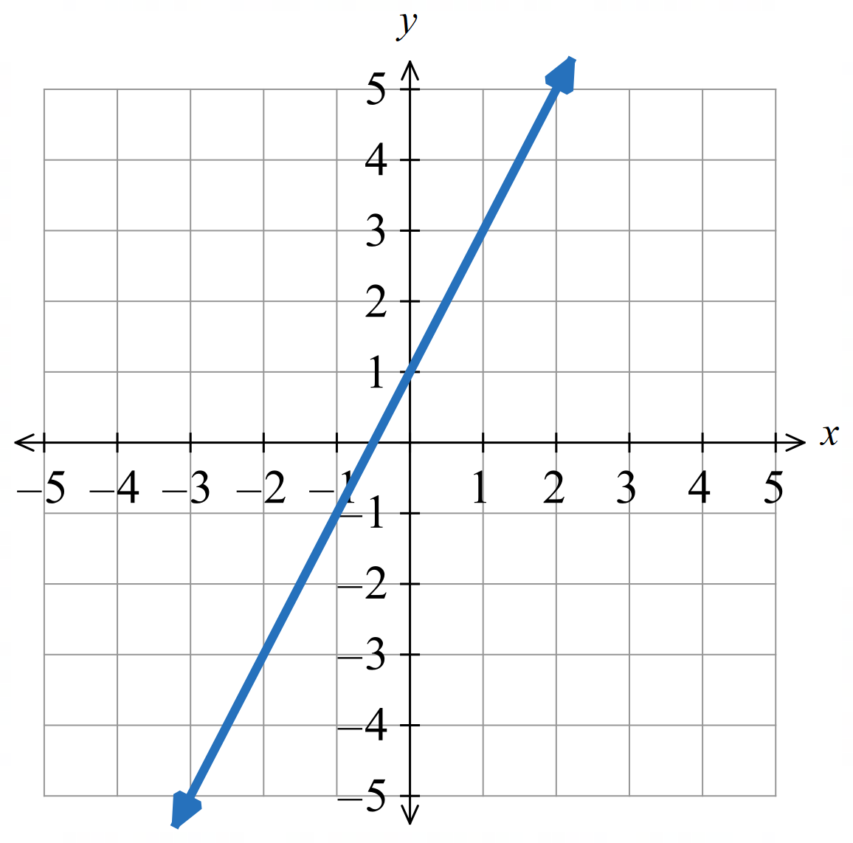
What is the value of $y$ when $x=1$?

What is the $x$ value when $y=3$?

- Every Point on a Line is a Solution to the Equation
We draw a line using points formed by the equation.
Therefore, every point $\left(x,y\right)$ that lies on a line makes the equation true.
We say that every point on the line satisfies the equation.

- Investigation Every point on a line is a solution to the equation
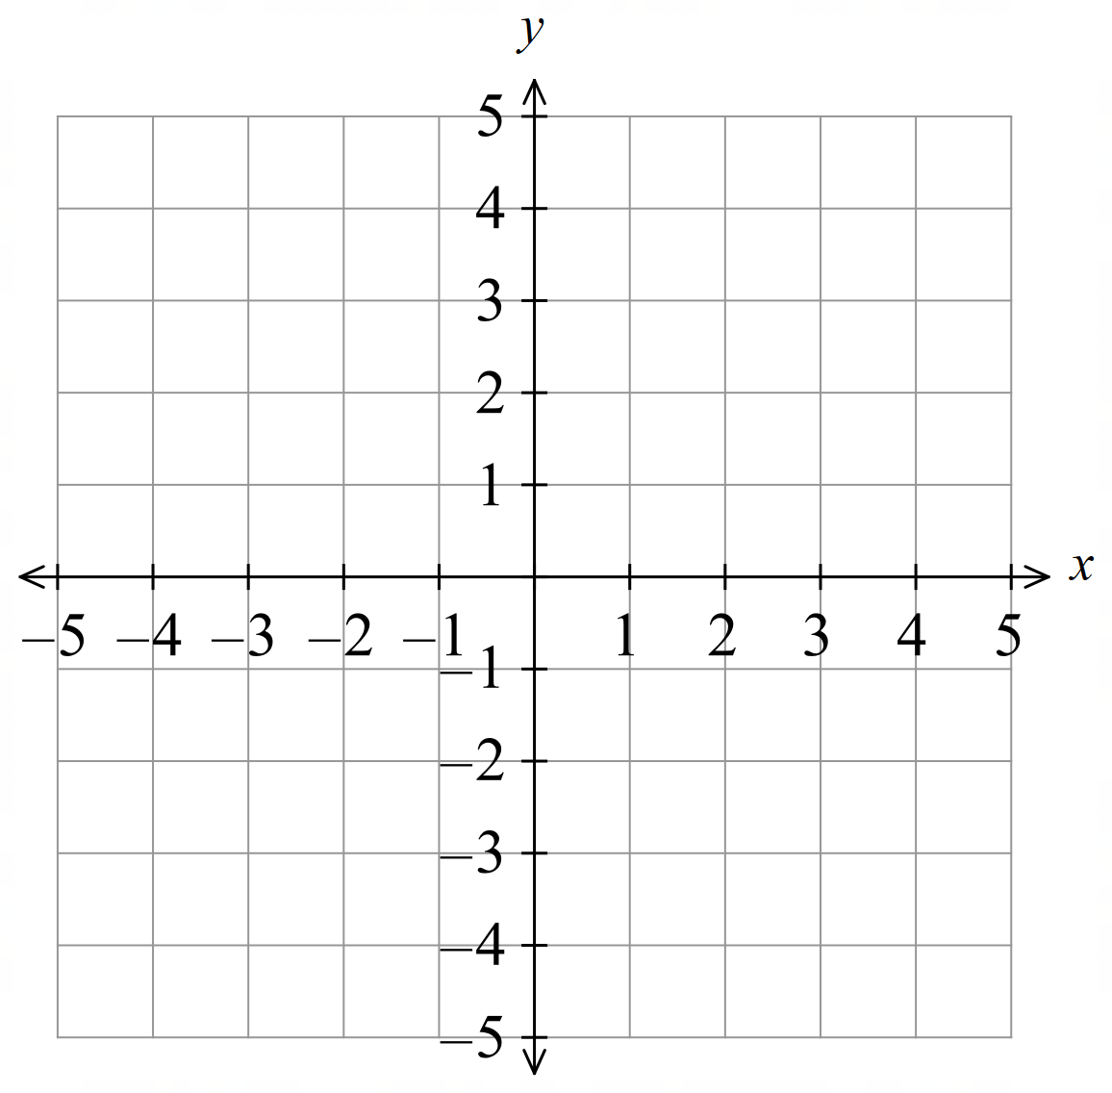
Consider the equation $y=2x+1.$
Construct a table of values and sketch the line.
$$x$$ | 0 | 1 | 2 | 3 | 4
$$y$$

Consider the point $\left(1,3\right)$  Does $\left(1,3\right)$ lie on the line? …………  Show that $x=1, y=3$ is a solution to  $$y=2x+1.$$ | Consider the point $\left(2,4\right)$  Does $\left(2,4\right)$ lie on the line? …………  Show that $x=2, y=4$ is not a solution to  $$y=2x+1$$
Complete the sentence:
Every point that l……… o… the line is a s……………………… to the equation.
Using the graph, what is the $x$ value when $y=5$?  Solve $2x+1=5$ algebraically | Using the graph, what is the $x$ value when $y=-3?$  Solve $2x+1=-3$ algebraically

- Investigation Every point on a line is a solution to the equation
Consider the equation $y=2x+1.$
This represents this pattern:

$x$ represents number of …………………
$y$ represents number of …………………
This graph shows $y=2x+1$.  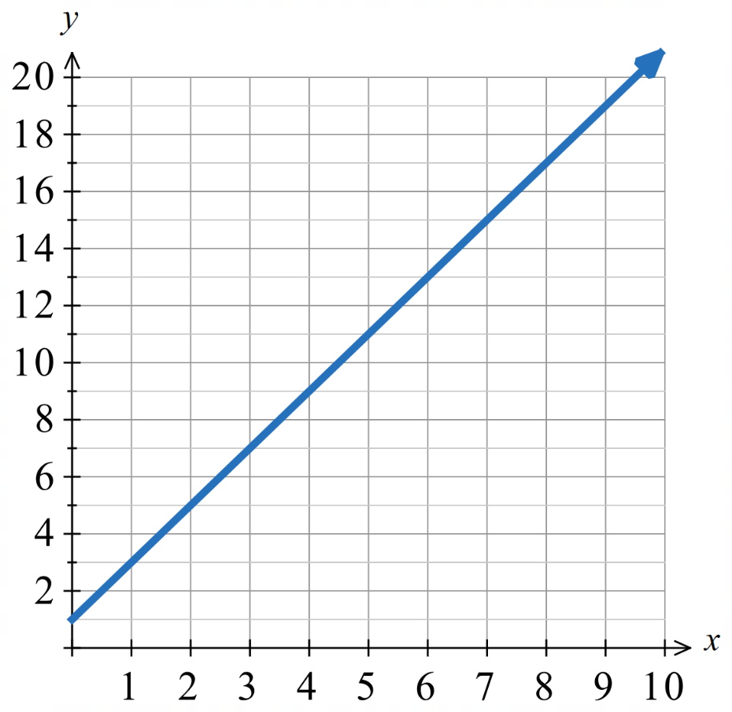 | If we are asked to solve $13=2x+1$  This means find how many triangles can be made with 13 matchsticks. Use the graph to solve this.  If we are asked to solve $17=2x+1$  This means ……………………………………  ……………………………………………………  Use the graph to solve this.
This graph shows $y=x-2$  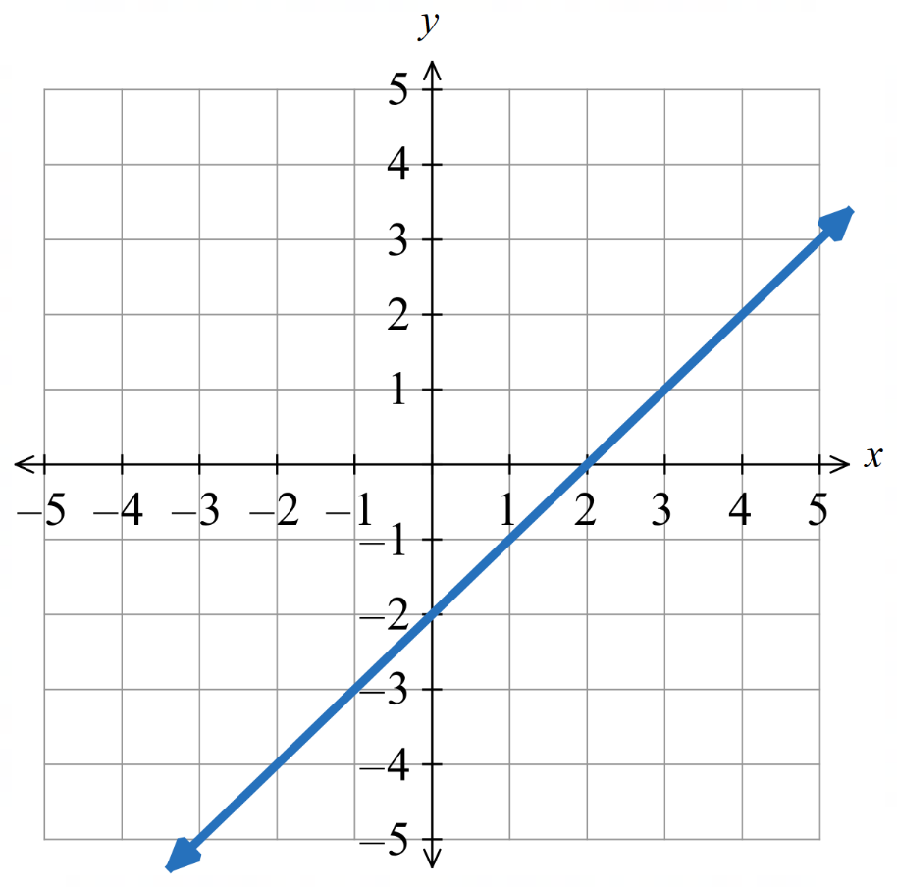 | Solve $3=x-2$ using the graph.  Solve $-3=x-2$ using the graph

- Solving Equations Graphically
When you are asked to solve $mx+c=k$
You need the graph of $y=mx+c$
And you need a horizontal line at $y=k$

- Interpret Solving an equation graphically
Solve $x+4=9$  We need the line $y=x+4$  We need the horizontal line at $y=9$ | Solve $2x+4=9$  We need the line $y=2x+4$  We need the horizontal line at $y=9$
Identify the two lines you need to draw to solve this problem.
- Solve $5x+2=12$  We need the line ………………  We need the horizontal line at …………… | - Solve $x-7=3$  We need the line ………………  We need the horizontal line at ……………
- Solve $-3x+1=2$  We need the line ………………  We need the horizontal line at …………… | - Solve $3x+4=-5$  We need the line ………………  We need the horizontal line at ……………
- Solve $7x-2=5$  We need the line ………………  We need the horizontal line at …………… | - Solve $6=4x-3$  We need the line ………………  We need the horizontal line at ……………

- Solving Equations Graphically
To solve $mx+c=k$:
1. Draw a horizontal line from the $y$ value indicated by the question.
2. Identify point of intersection.
3. Read off the $x$ value.

- Example Solve equations graphically
The graph of $y=2x+1$ is shown.
Use it to solve $7=2x+1$.
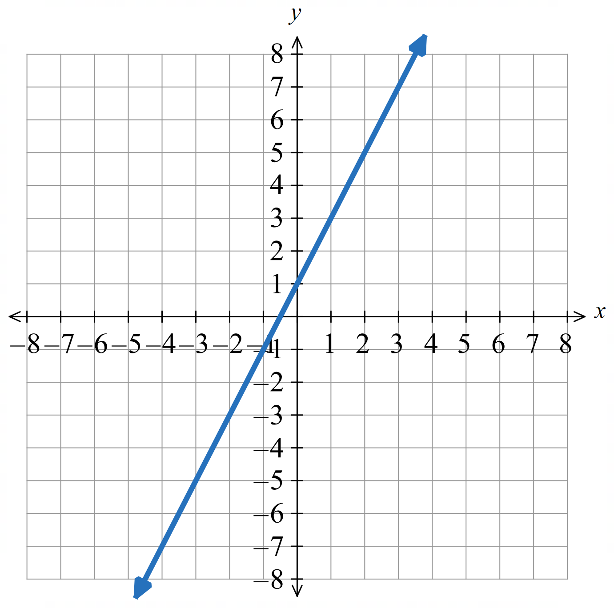  1. Horizontal line | 2. Point of intersection  $$\left(3,7\right)$$
3. The solution is $x=3$

- Guided Practice
Solve using the given graph.
- $3x+1=4$  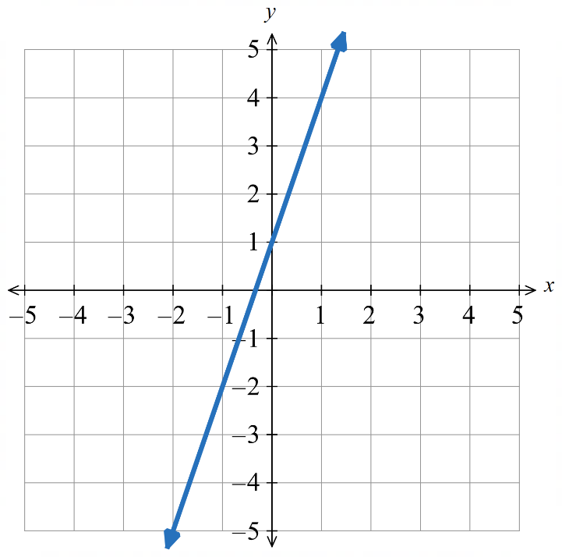  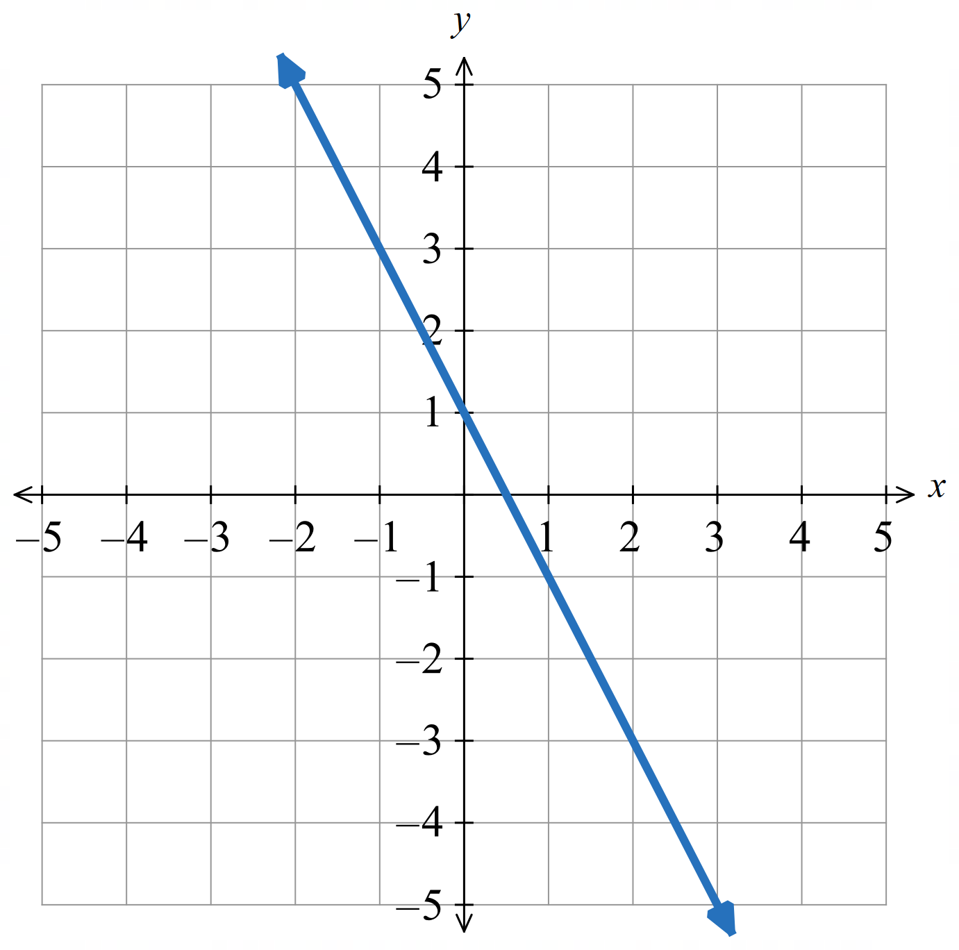  $$x=1$$ | - $3=-2x+1$  $$x=-1$$ | - $\frac{x}{2}$ $+1=3$  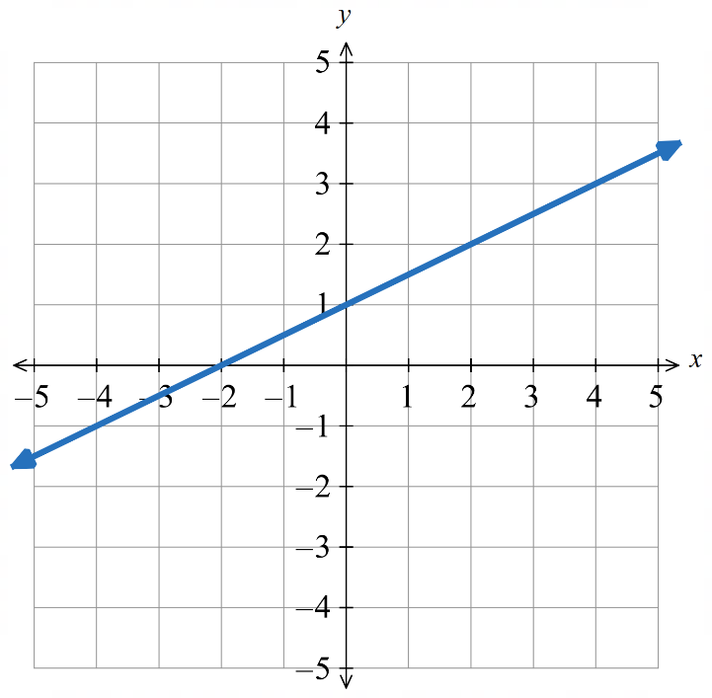  $$x=4$$

Foundation
- Solve using the given graph. Show your working.
- $x+1=4$  $$x=3$$ | - $2x+1=5$  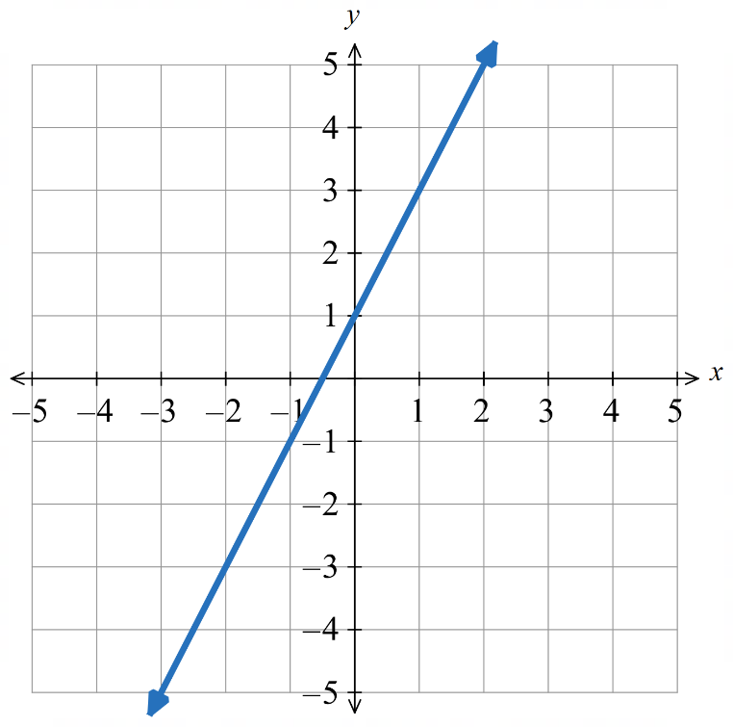  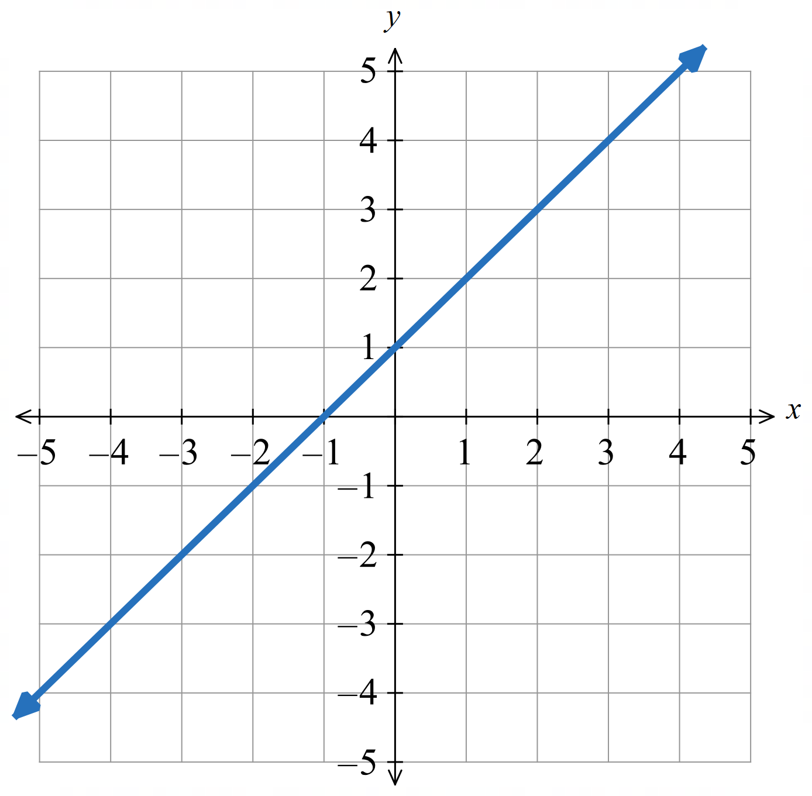  $$x=2$$ | - $3x-2=7$  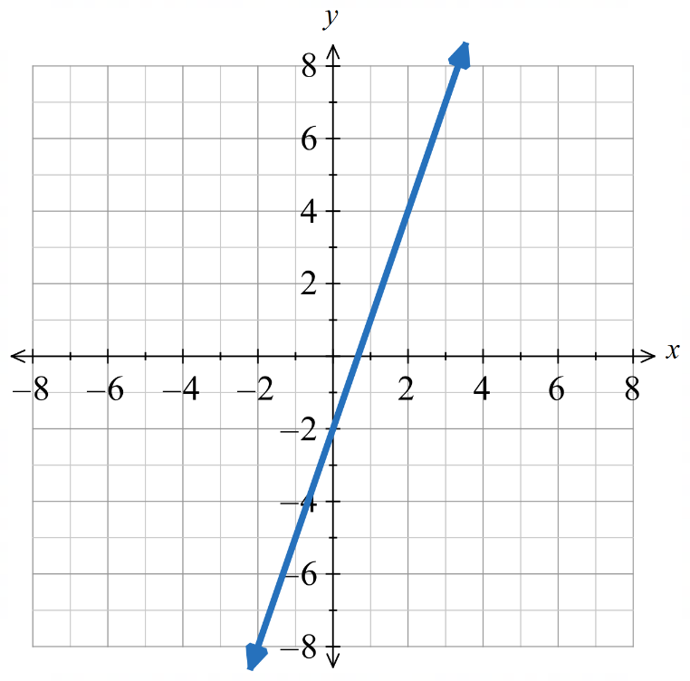  $$x=3$$
- $7=4x-1$  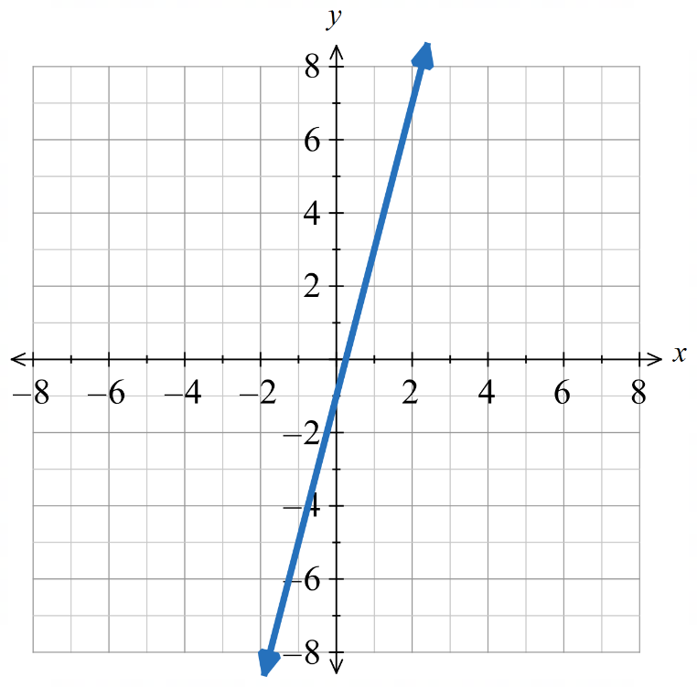  $$x=2$$ | - $3x+4=-5$  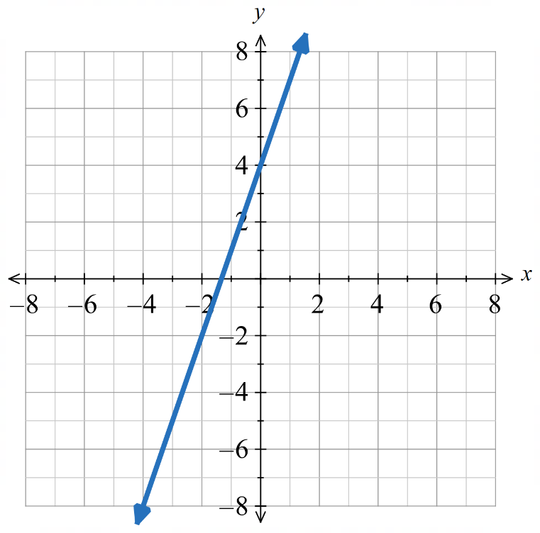  $$x=-3$$ | - $5x-2=3$  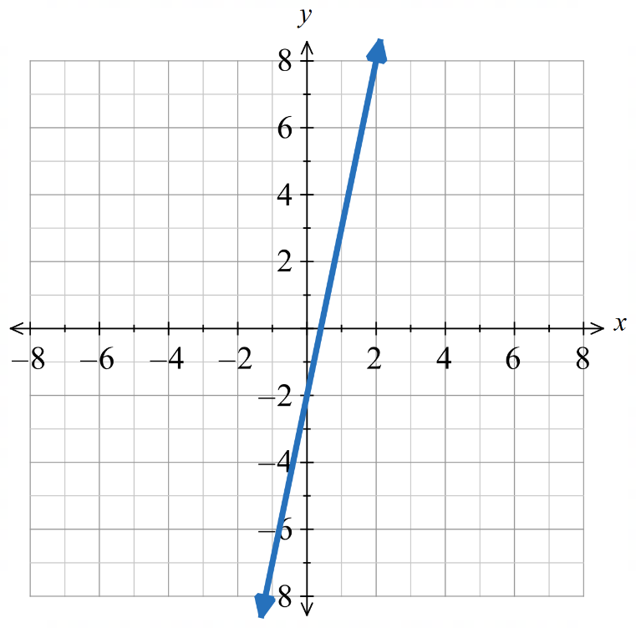  $$x=1$$
- $-2x+4=1$  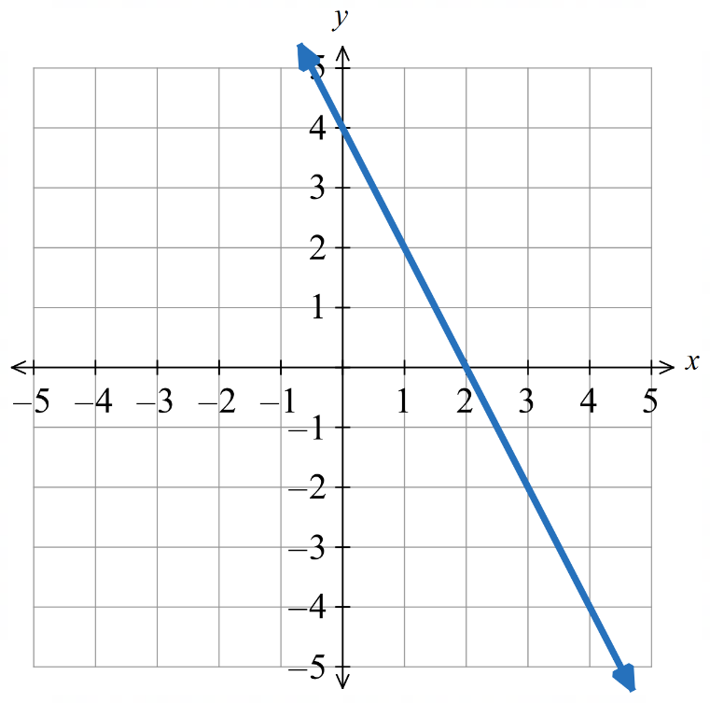  $$x=1.5$$ | - $0=-x+3$  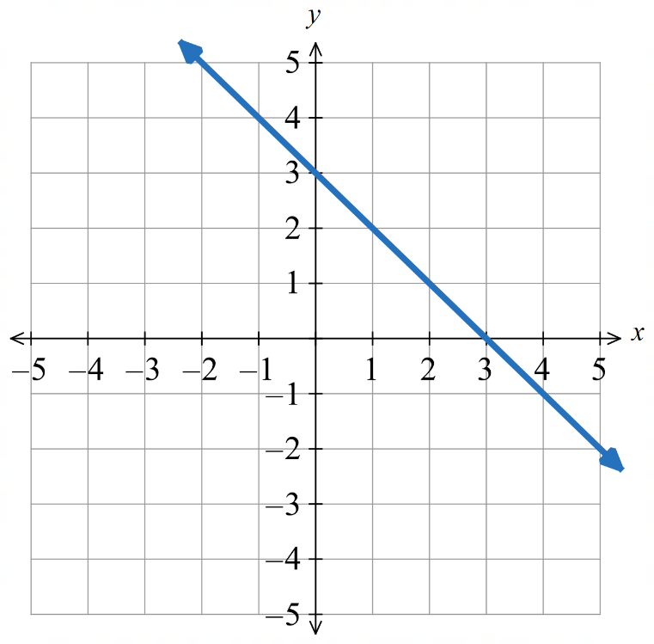  $$x=3$$ | - $-3x=3$  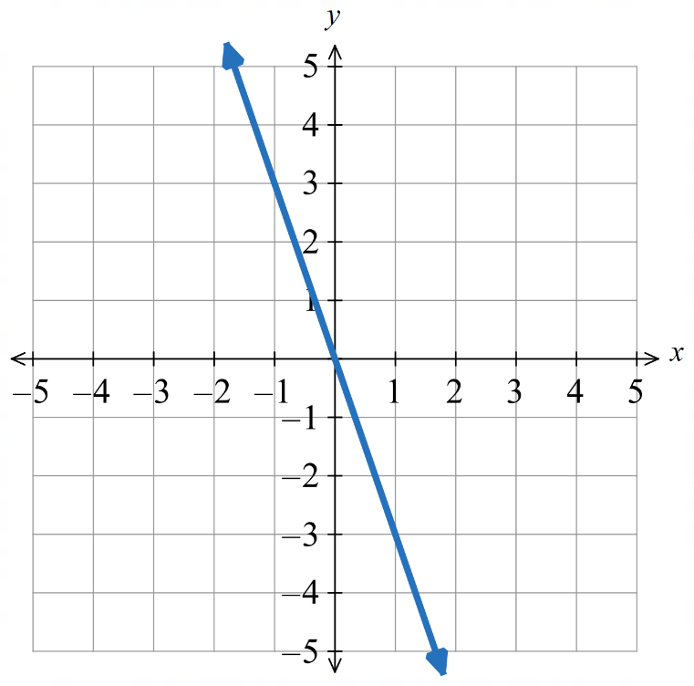  $$x=-1$$

Development
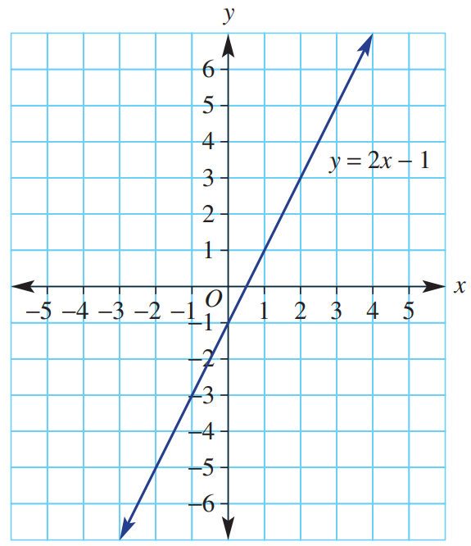
- Use the graph of $y=2x-1$ to find the solution to each of these equations.
  - $2x-1=3$ $x=$…………
$$x=2$$
  - $2x-1=0$ $x=$…………
$$x=\frac{1}{2}$$
  - $2x-1=5$ $x=$…………
$$x=3$$
  - $2x-1=-6$ $x=$…………
$$x=-\frac{5}{2}$$
  - $2x-1=-4$ $x=$…………
$$x=-\frac{3}{2}$$

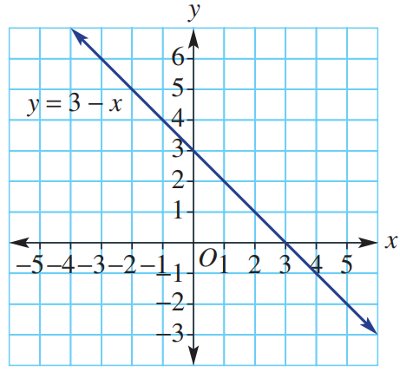
- Use the graph of $y=3-x$, shown here, to solve each of the following equations.
  - $3-x=6$ $x=$…………
$$x=-3$$
  - $3-x=0$ $x=$…………
$$x=3$$
  - $3-x=3.5$ $x=$…………
$$x=-0.5$$
  - $3-x=-1$ $x=$…………
$$x=4$$
  - $3-x=-2$ $x=$…………
$$x=5$$

Mastery
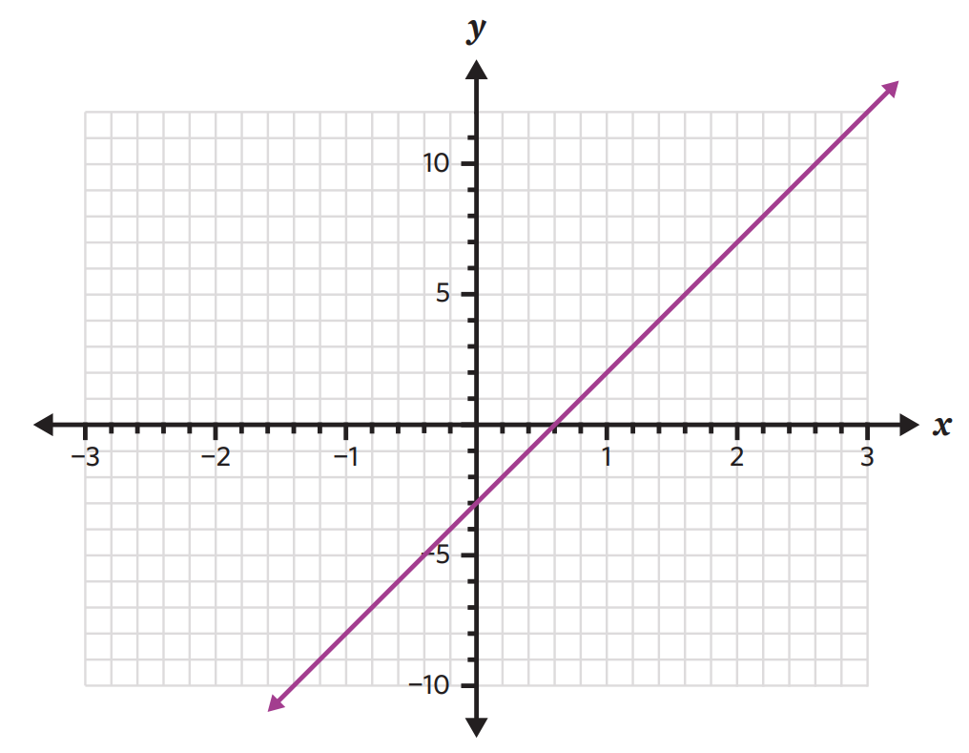
- Use the given graph of $y=5x-3$ to solve these equations.
Pay attention to the axis scale.
  - $5x-3=2$ …………
$$x=1$$
  - $5x-3=7$ …………
$$x=2$$
  - $5x-3=12$ …………
$$x=3$$
  - $5x-3=-3$ …………
$$x=0$$
  - $5x-3=4$ …………
$$x=1.4$$
  - $5x-3=-7$ …………
$$x=-0.8$$
  - $5x-3=0$ …………
$$x=0.6$$

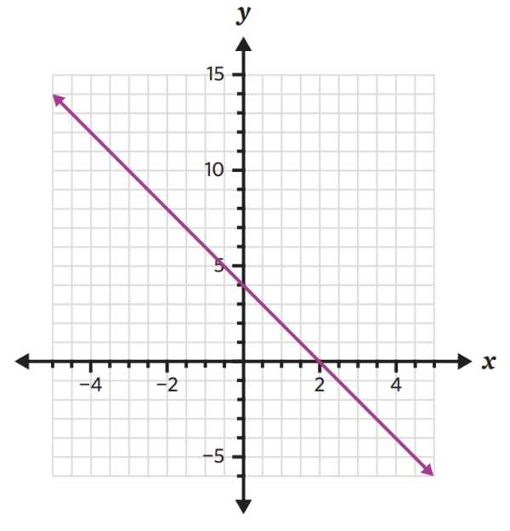
- Use the given graph of $y=-2x+4$ to solve these equations. Pay attention to the axis scale.
  - $-2x+4=2$ …………
$$x=1$$
  - $-2x+4=0$ …………
$$x=2$$
  - $-2x+4=3$ …………
$$x=0.5$$
  - $-2x+4=-2$ …………
$$x=3$$
  - $-2x+4=6$ …………
$$x=-1$$
  - $-2x+4=4$ …………
$$x=0$$
  - $-2x+4=12$ …………
$$x=-4$$
  - $-2x+4=13$ …………
$$x=-4.5$$

Identifying the Simultaneous Solution

- Investigation Simultaneous solution
- Consider $y=x+1$.
What values of $x$ and $y$ satisfy this equation?
$$x$$
$$y$$

- Consider $y=-x+5$.
What values of $x$ and $y$ satisfy this equation?
$$x$$
$$y$$

- What are the values of $x$ and $y$ that will satisfy both equations at the same time?

If we graph both linear equations on the same axis,
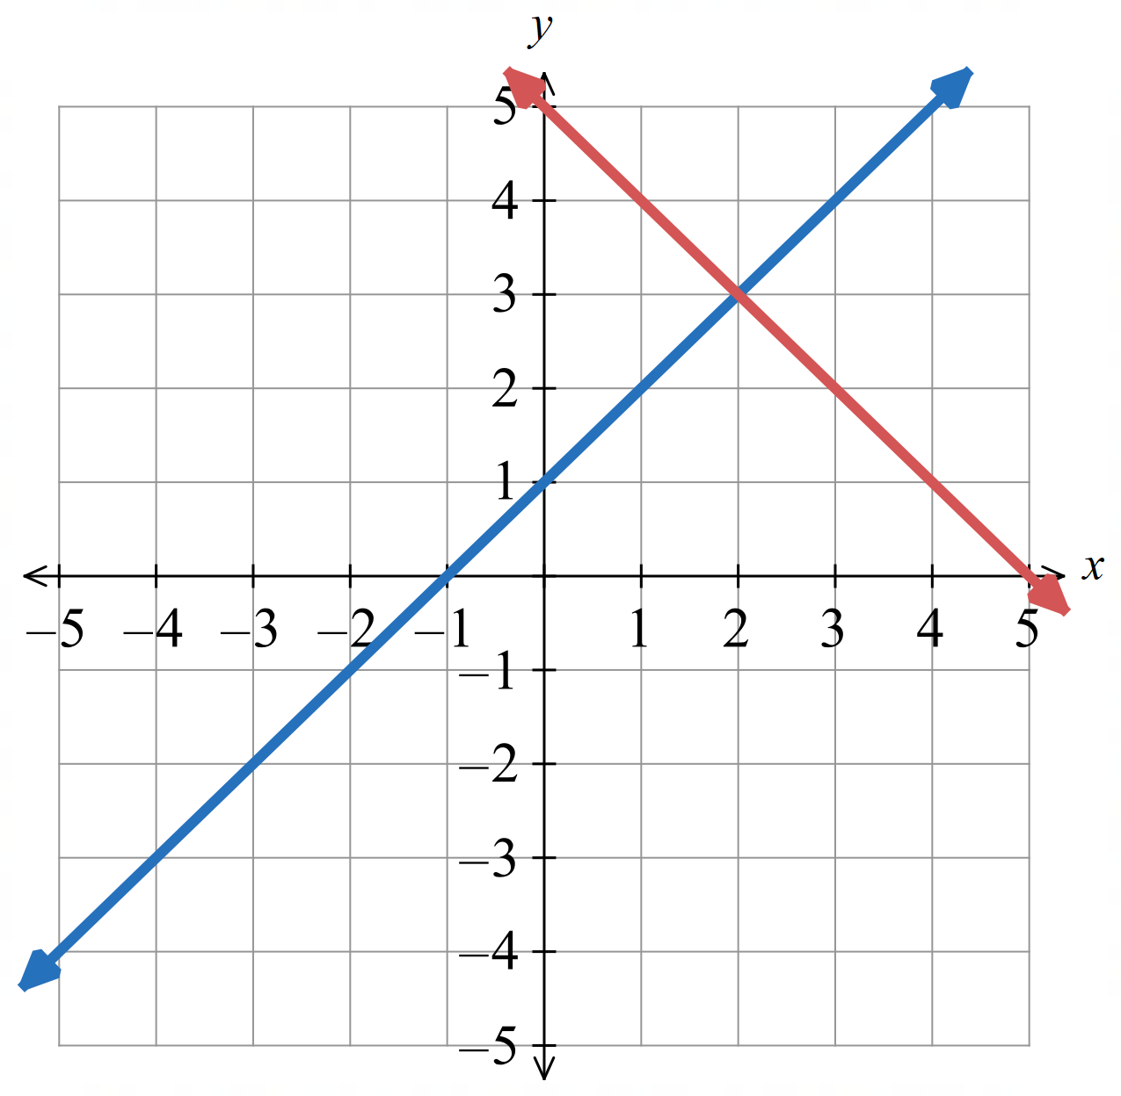
the coordinates of the point of intersection
satisfy both equations at the same time.
$x=2$, $y=3$

- Identifying the Simultaneous Solution
Solving equations simultaneously means finding the $x$ and $y$ values that make two equations true at the same time.
The $x$ and $y$ coordinates where the two lines meet solves both equations.
To find the simultaneous solution:
- Identify point of intersection.
- State the $x$ and $y$ values at the point of intersection.

- Identify simultaneous solution
- Find the values of $x$ and $y$ that solve $y=6-3x$ and $y=2x+1$ simultaneously  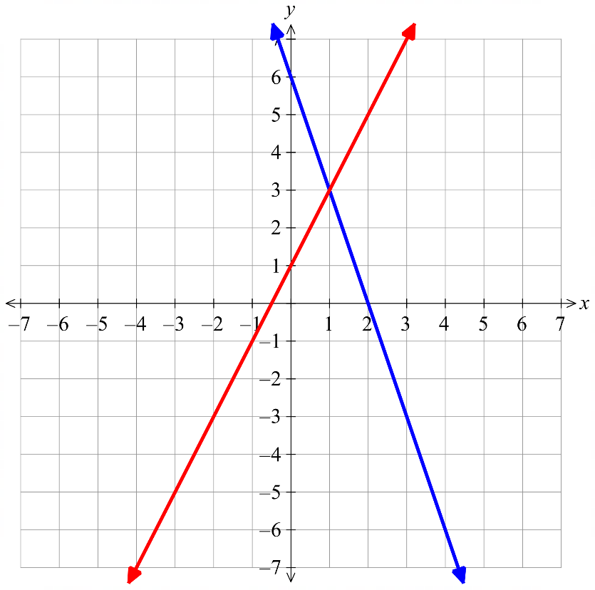  $$\left(1,3\right)$$  $$y=6-3x$$  $$y=2x+1$$  The point of intersection is: …………  The solution to both equations is:  $x=$ ………… $y=$ ……… | 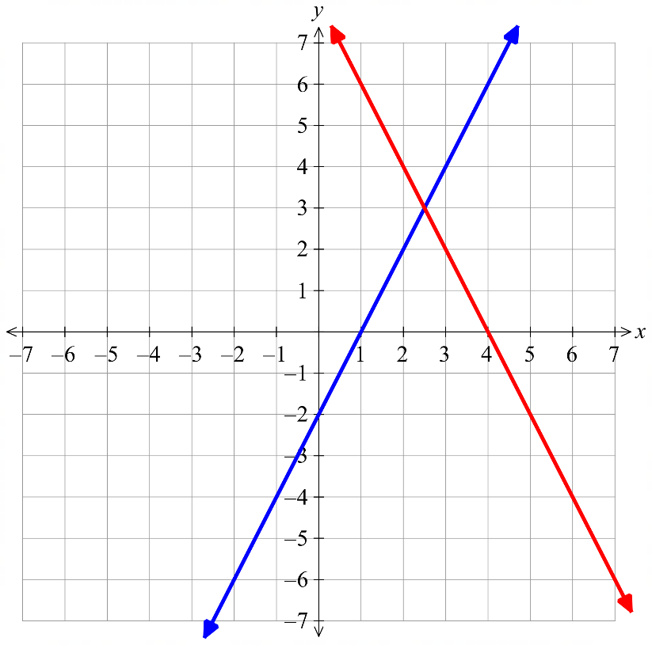  - Find the values of $x$ and $y$ that solve  $y=2x-2$ and $y=8-2x$ simultaneously  $$y=2x-2$$  $$y=8-2x$$  The point of intersection is: …………  The solution to both equations is:  $x=$ ………… $y=$ ………

- Key Ideas
- To solve two equations simultaneously means to find the values of $x$ and $y$ that make both equations …………… at the same time.
- Every point on a line is a ………………… to the equation.
- The point of ……………… of two lines solves both equations, as it lies on ……… the lines

Foundation
- Determine the point of intersection and hence solve these equations simultaneously.
The point of intersection is: …………………  The solution to both equations is:  $x=$ …… $y=$ ……  $$x=-1, y=2$$ | 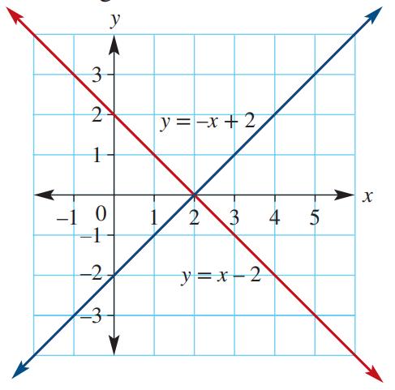  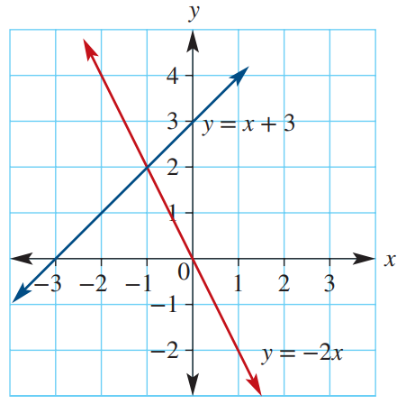  The point of intersection is: …………………  The solution to both equations is:  $$x=2, y=0$$
The point of intersection is: …………………  The solution to both equations is:  $$x=4,y=3$$ | 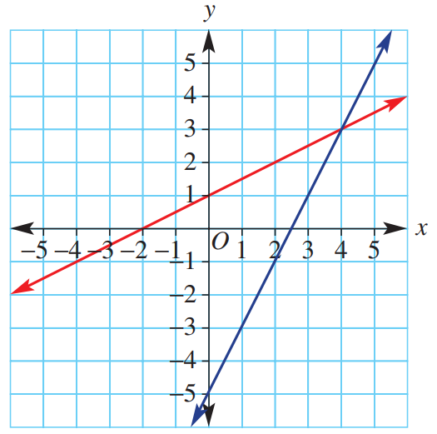  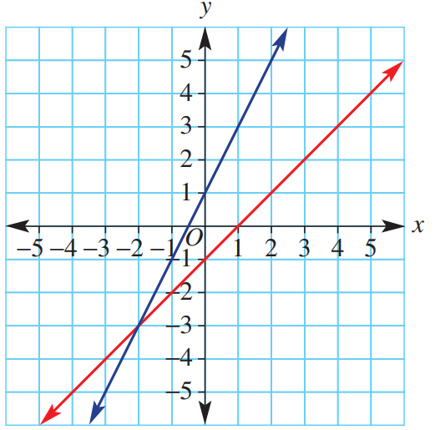  The point of intersection is: …………………  The solution to both equations is:  $$x=-2, y=-3$$
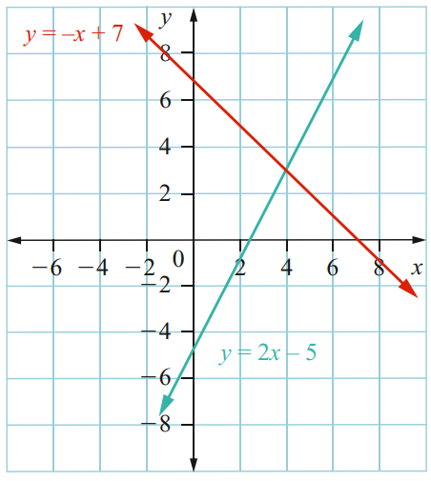  The point of intersection is: …………………  The solution to both equations is:  $$x=4, y=3$$ | 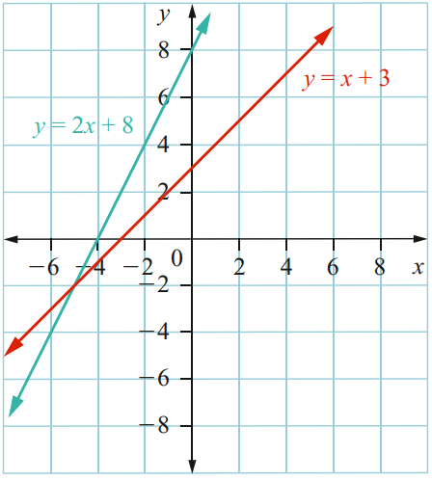  The point of intersection is: …………………  The solution to both equations is:  $$x=-5, y=-2$$

Development
- Verify that the point of intersection solves both equations simultaneously.
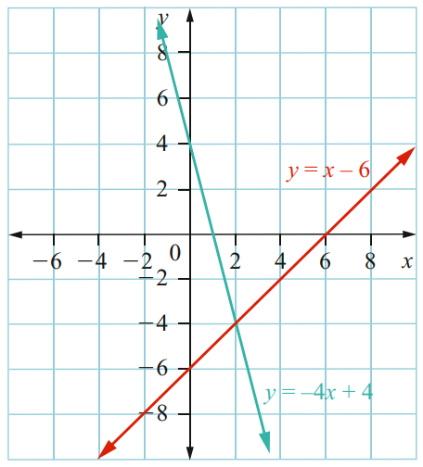  Point of intersection is: ………………  $$(2,-4)$$  Verify: | 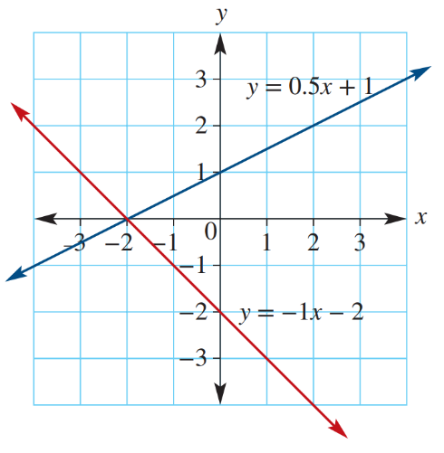  Point of intersection is: ………………  $$\left(-2,0\right)$$  Verify:
  $$y=x-6$$ | $$y=-4x+4$$
  $$y=0.5x+1$$ | $$y=-x-2$$

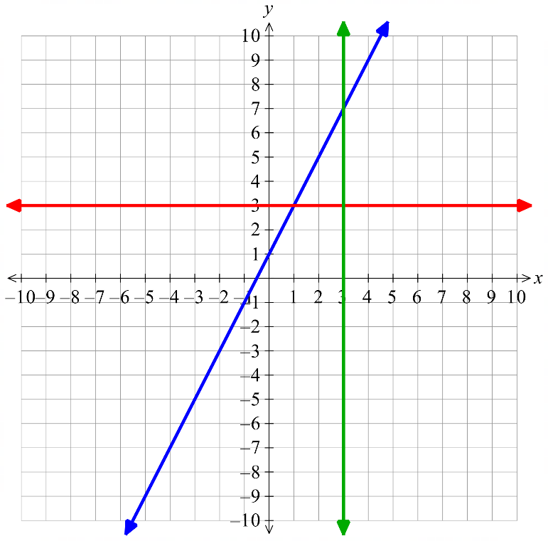
- Here are the graphs of
$y=2x+1$
$x=3$
$y=3$
$$y=2x+1$$
$$y=3$$

$$x=3$$

- Identify the coordinates of the point of intersection of $y=2x+1$ and $x=3$  $$\left(3, 7\right)$$ | - Substitute $x=3$ into the equation  $y=2x+1$ and evaluate $y$.  $$y=7$$
- Identify the coordinates of the point of intersection of $y=2x+1$ and $y=3$  $$\left(1,3\right)$$ | - Substitute $y=3$ into the equation  $y=2x+1$ and solve for $x$.  $$x=1$$

Mastery
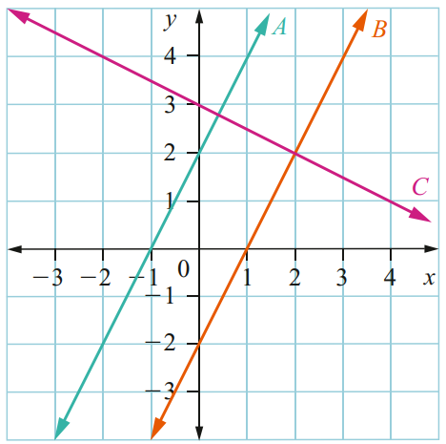
- Consider the straight lines A, B and C shown on this graph.
  - Write the coordinates of the point of intersection of lines B and C and hence give the solution to the simultaneous equations for these lines.

$$\left(2,2\right)$$
  - Use the graph to solve the equations for lines A and C simultaneously (give an estimate).

$$≈\left(0.4, 2.8\right)$$
  - Can the equations for lines A and B be solved simultaneously? Explain why or why not.

No, they are parallel so will never meet. There’s no pair of $x$ and $y$ values that will solve both equations.
- When two different lines have the same gradient, there will be no intersection point.
Use this idea to decide if these pairs of simultaneous equations will have a solution.
- $y=3x-1$  $y=3x+1$  No solution | - $y=7x+2$  $y=7x+6$  No solution | - $y=2x-6$  $y=-2x+1$  Solution possible
- $y=-x+7$  $y=2x-1$  Solution possible | - $2x-y=4$  $y=2x+1$  No solution | - $7x-y=1$  $y=-7x+2$  Solution possible
- $2y-3x=0$  $$y=-\frac{3x}{2}-1$$  Solution possible | - $y=$ $\frac{x}{2}$ $+3$  $$\frac{x-2y}{4}=0$$  No solution

- For what value of $k$ will these pairs of simultaneous equations have no solution?
- $y=-4x-7$  $y=kx+2$  $$k=-4$$ | - $y=kx+4$  $3x-2y=5$  $$k=\frac{3}{2}$$ | - $kx-3y=k$  $y=4x+1$  $$k=12$$

